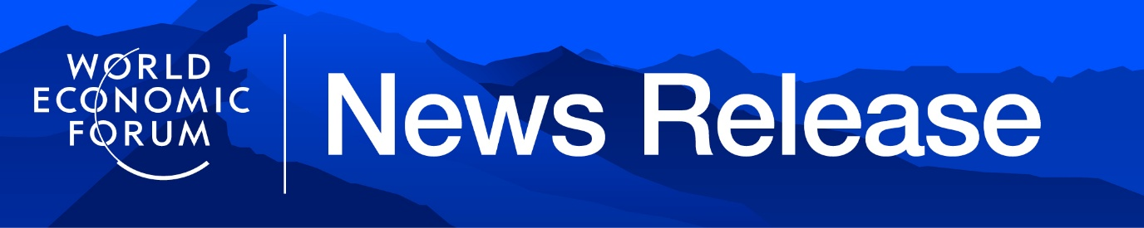
World Economic Forum, public.affairs@weforum.org

Global Risks Report 2026: Geopolitical and Economic Risks Rise in New Age of Competition
- Geoeconomic confrontation emerges as the top global risk for 2026, climbing eight positions in the two-year outlook, as economic risks rise fastest in the short term – with downturn and inflation both surging eight positions year-on-year.
- AI anxiety soars while environmental risks are deprioritized in the short term.
- Global outlook remains uncertain: half of experts expect a turbulent or stormy global outlook; only 1% anticipate calm.
- Read the Global Risks Report 2026 here and join the conversation using #Risks26. Follow the Annual Meeting 2026 here and on social media using #WEF26.
Geneva, Switzerland, 14 January 2026 – The World Economic Forum's Global Risks Report 2026, published today, finds geoeconomic confrontation emerges as the top risk for the year, followed by interstate conflict, extreme weather, societal polarization and misinformation and disinformation.

The outlook from leaders and experts shows deep concern. Half of those surveyed anticipate a turbulent or stormy world over the next two years, up 14 percentage points from last year. A further 40% expect the two-year outlook to be unsettled at the very least, while 9% expect stability and 1% predict calm. When it comes to the outlook for the next 10 years, 57% expect a turbulent or stormy world, 32% expect things to be unsettled, 10% predict stability and, once again, only 1% anticipate calm.

“A new competitive order is taking shape as major powers seek to secure their spheres of interest. This shifting landscape, where cooperation looks markedly different than it did yesterday, reflects a pragmatic reality: collaborative approaches and the spirit of dialogue remain essential,” said Borge Brende, President and CEO, World Economic Forum. “Our Annual Meeting in Davos will serve as a vital platform for understanding risks and opportunities and for building the bridges needed to address them.”

“The Global Risks Report offers an early warning system as the age of competition compounds global risks – from geoeconomic confrontation to unchecked technology to rising debt – and changes our collective capacity to address them. But none of these risks are a foregone conclusion,” said Saadia Zahidi, Managing Director, World Economic Forum. “The challenges highlighted in the report underscore both the scale of the potential perils we face and our shared responsibility to shape what comes next.”

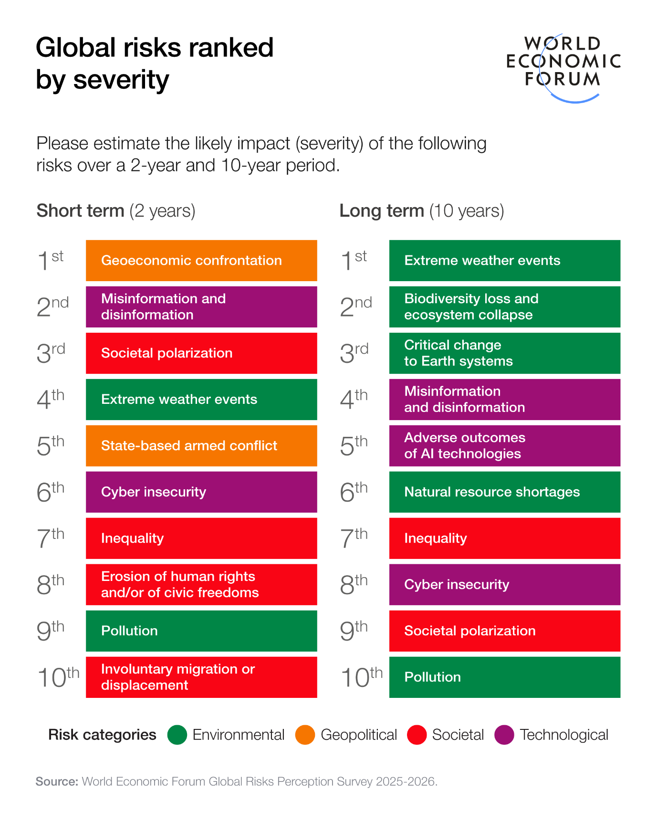
The report analyses risks across three timeframes: immediate (2026); short-to-medium term (the next two years); and long term (the next 10 years). In the near term, armed conflict, the weaponization of economic tools and societal fragmentation are colliding. As these immediate risks intensify, longer-term challenges from technological acceleration to environmental decline are also creating knock-on effects.

Geopolitical, economic and geoeconomic risks surge

Geoeconomic confrontation tops the near-term rankings, with 18% of respondents viewing it as the risk most likely to trigger a material global crisis in 2026, as well as being ranked 1st for severity over the next two years, up eight positions from last year. State-based armed conflict follows in 2nd position for 2026, dropping to 5th position in the two-year timeframe.

In a world of rising rivalries and prolonged conflicts, confrontation threatens supply chains and broader global economic stability as well as the cooperative capacity required to address economic shocks. When it comes to the geopolitical outlook, 68% of respondents expect a "multipolar or fragmented order" over the next decade, up four points from last year.

Economic risks show the largest collective increase in the two-year outlook. Economic downturn and inflation risks both surged eight positions, to 11th and 21st respectively, while asset bubble burst rose seven to 18th position. Mounting debt concerns and potential asset bubbles, amid geoeconomic tensions, could trigger a new phase of volatility.

Technology, societies and the environment

Misinformation and disinformation ranks 2nd on the two-year outlook while cyber insecurity ranks 6th. Adverse outcomes of AI show the starkest trajectory, climbing from 30th in the two-year horizon to 5th in the 10-year horizon, reflecting anxiety about implications for labour markets, societies and security.

Societal polarization ranks 4th in 2026 and 3rd by 2028. Inequality is in 7th position in the two- and 10-year outlooks. Inequality was also selected as the most interconnected risk for a second consecutive year, fuelling other risks as social mobility falters. Economic downturn is the second-most interconnected. Underlying these interconnections are concerns about cost-of-living pressures and K-shaped economies becoming entrenched.

With short-term concerns overtaking long-term objectives, environmental risks are being deprioritized in the two-year outlook. Extreme weather dropped from 2nd to 4th, pollution from 6th to 9th, while critical change to Earth systems and biodiversity loss fell seven and five positions respectively. All environmental risks declined in severity score, representing an absolute shift, not just a relative one. Yet over the 10-year period, they remain the most severe – the top three are extreme weather, biodiversity loss, and critical change to Earth systems. Three-quarters of respondents expect a turbulent or stormy environmental outlook, the most negative of any category.

About the Global Risks Report
The Global Risks Report is the World Economic Forum's flagship publication on global risks, now in its 21st edition. The report leverages insights from the Global Risks Perception Survey, which draws on the views of over 1,300 global leaders and experts from academia, business, government, international organizations and civil society, as well as the Global Risks Report Advisory Board, the Global Future Councils Network and the Forum’s C-suite communities. The report identifies and analyses the most pressing risks across immediate, short- and long-term horizons, aiming to equip leaders with foresight to address emerging challenges and foster collective action to build a more resilient future. For more information, visit the Global Risks Initiative and read the full report here.

The Forum's Scenarios for the Global Economy Dialogue Series complements this approach to building foresight. Two recent publications explore the strategic implications for businesses of different trajectories for the global economy to 2030. Four Futures for the New Economy examines the interaction of geopolitical and technology drivers, while Four Futures for Jobs in the New Economy focuses on critical uncertainties on AI and talent trends. Both offer tools to navigate uncertainty, identifying indicators to watch, implications of each scenario and no-regret moves to prepare for multiple futures.

About the Annual Meeting 2026
The World Economic Forum’s 56th Annual Meeting, taking place 19-23 January 2026 in Davos-Klosters, Switzerland, will convene leaders from business, government, international organizations, civil society and academia under the theme, A Spirit of Dialogue. Click here to learn more.

Notes to editors
Read Forum Stories also in Spanish | Mandarin | Japanese
Learn about the Forum’s impact
Follow the Forum on social media: X | Instagram | LinkedIn | Facebook | TikTok | Weibo | Threads | WhatsApp | YouTube | WeChat
Check out the Forum’s Strategic Intelligence Platform and Transformation Maps
Watch Forum videos at wef.ch/videos | YouTube
Get Forum podcasts at wef.ch/podcasts | YouTube
Subscribe to Forum news releases

The World Economic Forum provides a global, impartial, not-for-profit platform and insights to support meaningful connections between political, business, academic, civil society and other leaders. (www.weforum.org).

