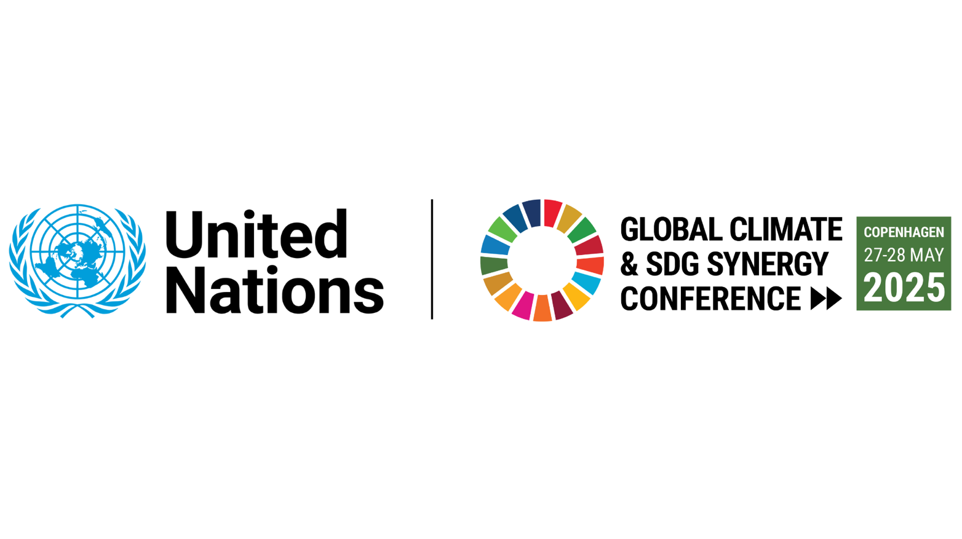

MEDIA ADVISORY

Leaders to tackle climate and development crises
with integrated solutions at UN Conference in Copenhagen

When: 27-28 May 2025

Where: UN City, Copenhagen, Denmark

What: Sixth Global Conference on Climate and SDG Synergy

This global conference will offer an important opportunity to strategize on how to achieve greater impact by tackling multiple crises with integrated solutions, driving climate action and broader changes in sustainability and finance systems. Sessions will show:

- How strengthened national climate commitments (NDCs) under the Paris Agreement can spur action on the Sustainable Development Goals (SDGs);
- How climate and development financing can be scaled up and aligned more effectively, including by seeking greater synergies between the latest climate investment targets agreed under the UN climate treaty and the outcomes of the upcoming Fourth International Conference on Financing for Development;
- How nature-based climate solutions can be designed to improve sustainable food production and healthy ecosystems;
- How cities can promote climate action that benefits the health and quality of life of their citizens.

Who: Government Ministers and climate envoys from around the world; senior officials and experts from the UN and research organizations; NGOs, climate activists and youth groups. Opening speakers include:
- Jeppe Bruus, Minister for Green Transition, Denmark
- Navid Hanif, UN Assistant Secretary-General for Economic Development, United Nations Department of Economic and Social Affairs (UN DESA)
- Simon Stiell, Executive Secretary, United Nations Framework Convention on Climate Change (UNFCCC)

The Conference is co-convened by the United Nations Department of Economic and Social Affairs (UN DESA) and UN Climate Change (UNFCCC), hosted by the Government of Denmark, in collaboration with the UN Development Programme (UNDP), the International Institute for Environment and Development (IIED), the Danish climate think tank CONCITO, and the UN Environment Programme (UNEP).

Details for media:

The conference livestream link, programme, speakers and background information are available on the conference website.
Follow on X.com: @SustDev and @IISD_ENB

Media wishing to attend the conference should contact the Head of UN City Communications, Mr. Noa Valentin Katz Sogaard (E-mail: noa.valentin.katz.sogaard@undp.org) for accreditation.

For more information and interviews:
In Copenhagen: Noa Valentin Katz Sogaard, UNDP, E-mail: noa.valentin.katz.sogaard@undp.org
In New York: Pragati Pascale, UN DESA, E-mail: pascale@un.org
In Vienna: Veronika Ruskova, UN DESA, E-mail: veronika.ruskova@un.org
In Bonn: press@unfccc.int

“We must solve the climate emergency and sustainable development
challenges together, or we will not solve them at all.”
~Expert Group on Climate and SDG Synergies

