
THE WEEKND’S HISTORIC 2026 EUROPE & STADIUM TOUR ENDS WITH 2.3M+ FANS ACROSS 11 COUNTRIES
42-DATE SOLD-OUT RUN GROSSES $345 MILLION AND OVER $618M ECONOMIC IMPACT IN UK & FRANCE ALONE
$2.2 MILLION DONATED TO UNITED NATIONS WORLD FOOD PROGRAMME & GLOBAL CITIZEN
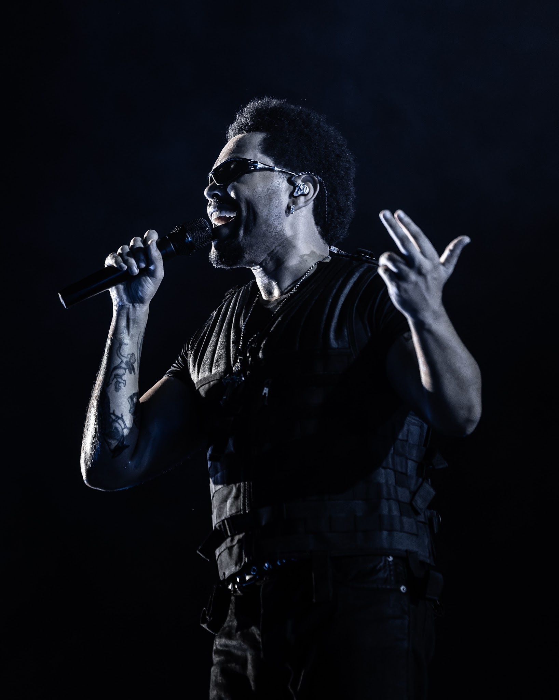
Photo Credit: Sebastien Nagy

APPROVED PHOTOS (FREE OF USE) HERE - Credit: Sebastien Nagy
APPROVED VIDEO (FREE OF USE) HERE - Credit: Evan Larsen
APPROVED PORTRAITS HERE - Credit: Hyghly Alleyne

September 7, 2026 (Lisbon, PT) - Last night, diamond-certified global superstar The Weeknd wrapped the sold-out 2026 Europe and UK leg of his record-breaking After Hours Til Dawn Stadium Tour, culminating with back-to-back shows at Estádio do Restelo in Lisbon, Portugal. The 42-date run marked The Weeknd’s second time bringing the tour to the region, following its first Europe and UK leg in 2023.
The 2026 leg grossed more than $345 million and welcomed more than 2 million fans, with multi-night runs in nearly every market, including Manchester, Munich, Milan, Stockholm, Madrid, Dublin, Paris, London and more. Throughout the run, the tour also raised more than $2.2 million USD in charitable donations benefiting the United Nations World Food Programme (WFP) and Global Citizen. Notably, the After Hours Til Dawn Stadium Tour topped Billboard’s July Boxscore, grossing more than $120 million and selling nearly 900,000 tickets in the month alone.
The tour also delivered a major economic boost across Europe, with newly released figures from the UK and France alone showing more than $618 million in economic impact — nearly €532 million.
Kicking off June 11 with two nights at Manchester’s Etihad Stadium, the run included a historic five-night stand at London’s Wembley Stadium. Across Manchester and London, The Weeknd performed seven sold-out UK stadium shows for more than 450,000 fans, including ticket buyers from nearly 150 countries.
The Weeknd also made history in France, becoming the first artist ever to sell out six nights at Stade de France in Paris on a single tour. His 2026 performances drew more than 500,000 fans across France this summer alone. Across the full After Hours Til Dawn Stadium Tour, The Weeknd has now sold out 13 stadium shows in France, further demonstrating the scale of his success in the market.

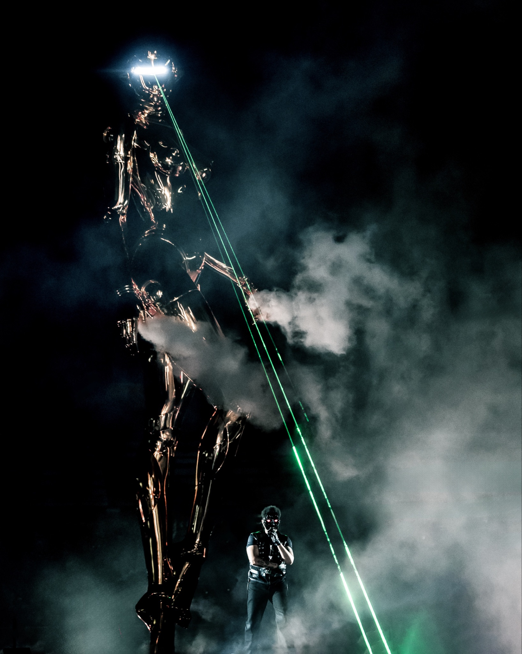
Photo Credit: Sebastien Nagy
Since launching in 2022, the After Hours Til Dawn Stadium Tour has traveled across North America, Europe, the UK, Latin America and Australia, with The Weeknd returning for second runs across nearly every territory.
Last year, the record-breaking tour surpassed $1 billion in global gross following the addition of 2026 dates across Europe, the UK and Latin America. With more than 7.5 million tickets sold across 153 shows, After Hours Til Dawn became the highest-grossing tour ever by a male solo artist, cementing its place among the biggest global tours in history.
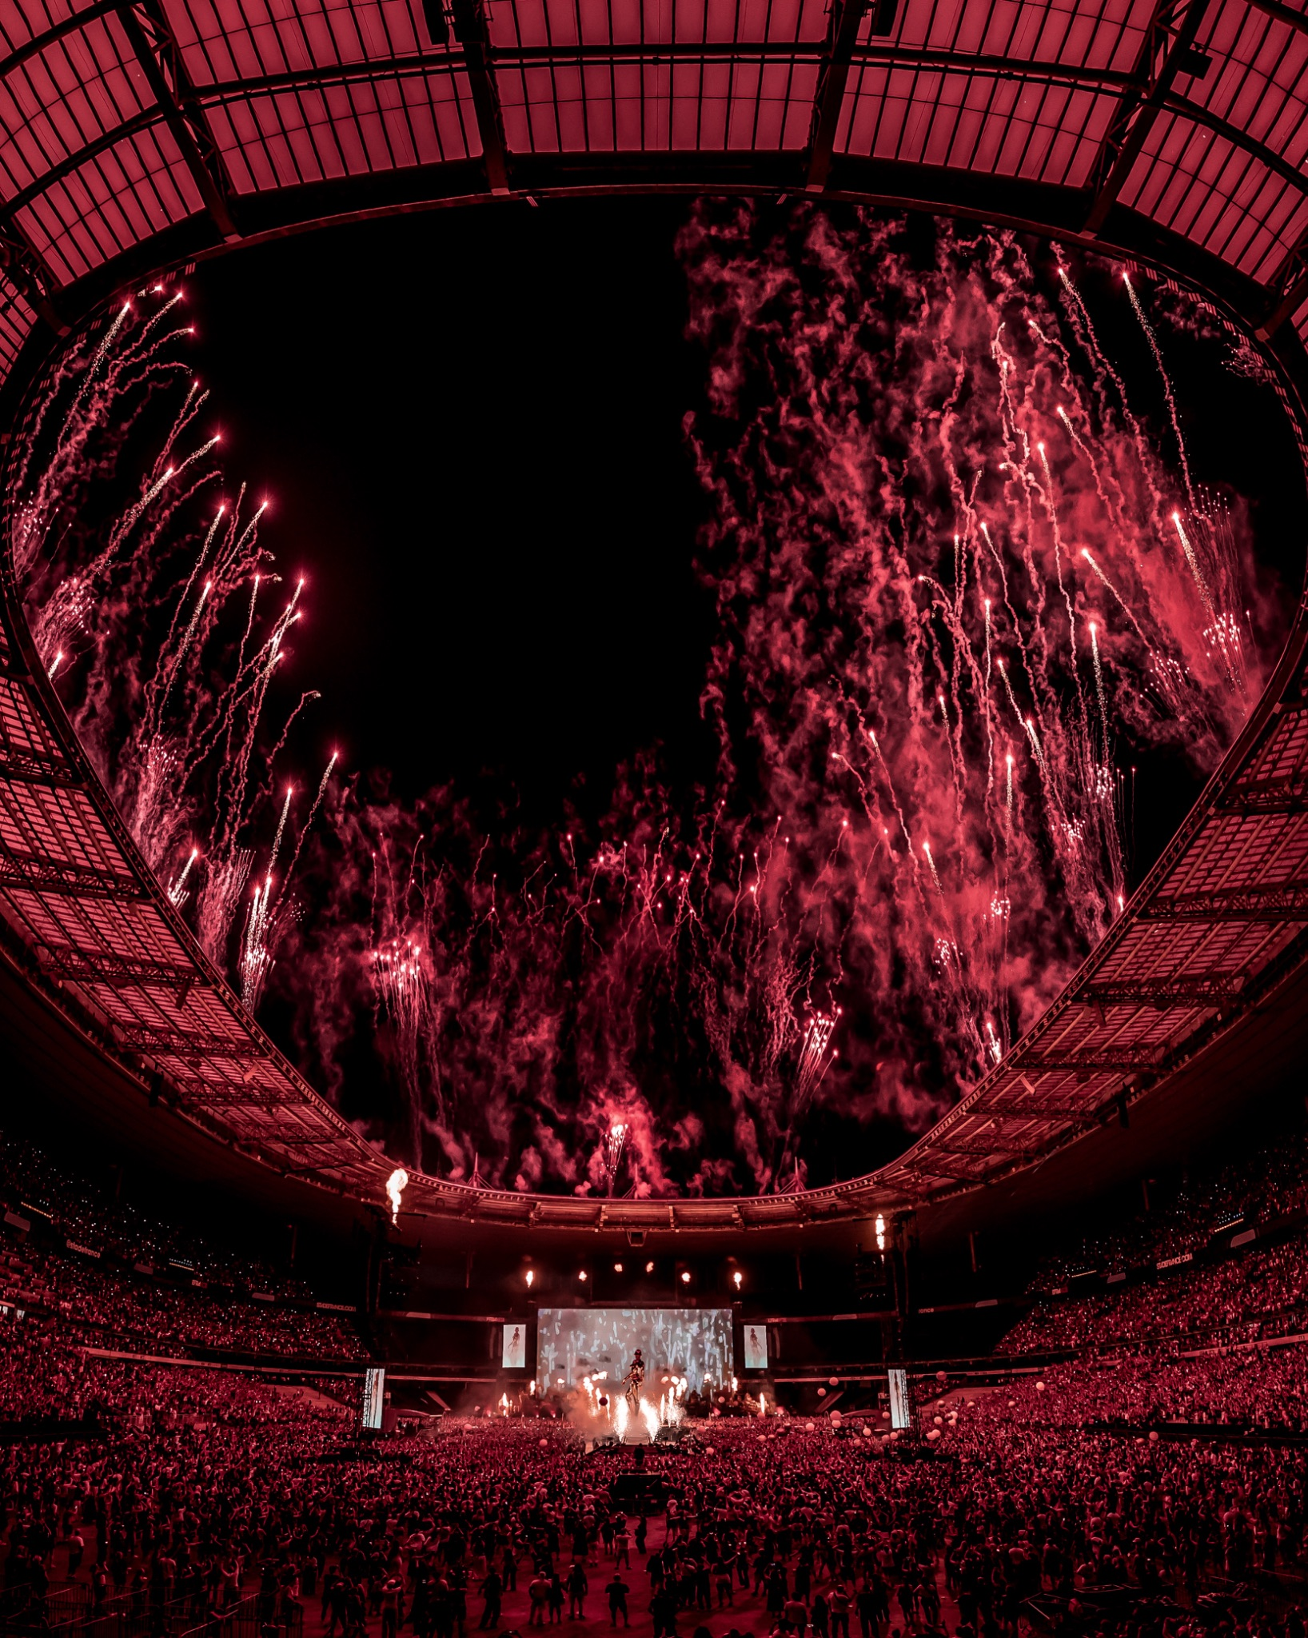
Photo Credit: Sebastien Nagy
This leg of the tour featured a brand new 40-foot art sculpture designed by Hajime Sorayama, over 2x the size of the statue showcased in previous legs. First hand-carved from polystyrene and cast in Toyama by Japanese craftsmen, this unique one-of-one sculpture was finished in gold through a meticulous hand-coating process using multiple layers of high-gloss aluminum paint to achieve a luminous metallic surface. Created exclusively for The Weeknd’s After Hours Til Dawn Stadium Tour, the sculpture was further customized with laser illumination embedded in the eyes and theatrical smoke effects emerging from the palm, transforming it into a living stage presence.
The After Hours Til Dawn Stadium Tour heads to Asia for its final leg in just a few weeks, kicking off on Saturday, September 19 in Tokyo, before making stops in Jakarta, Singapore, Seoul, Bangkok, Hong Kong and Kuala Lumpur. Originally announced with 11 stadium shows, the run quickly expanded to 17 dates due to overwhelming demand, including additional performances in Tokyo, Kuala Lumpur and Bangkok.
As part of the After Hours Til Dawn 2026 Tour, The Weeknd is again partnering with Global Citizen to raise funds to provide access to quality education for children around the world through the FIFA Global Citizen Education Fund. He has continued to partner with the United Nations World Food Programme (WFP) to provide funds to the XO Humanitarian Fund, which supports the organization’s response to the unprecedented global hunger crisis. €1 from each ticket sold across Europe and £1 in the UK has been donated to these two organizations. Fans have also had the opportunity to earn one pair of free tickets to each tour date by taking action to end extreme poverty with Global Citizen. For more information, visit www.globalcitizen.org.

For more information, visit theweeknd.com/tour.

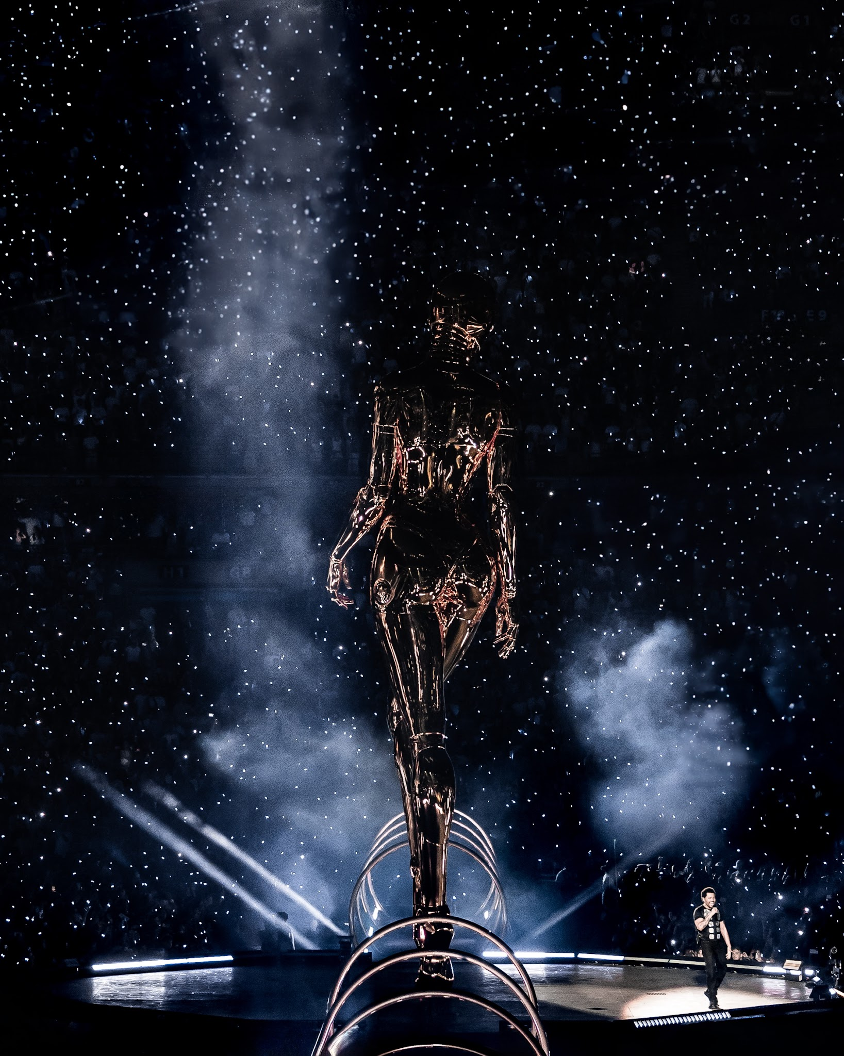
Photo by Sebastien Nagy

THE WEEKND AFTER HOURS TIL DAWN STADIUM TOUR 2026 EU/UK DATES:
Thu Jun 11 – Manchester, UK – Etihad Stadium
Fri Jun 12 – Manchester, UK – Etihad Stadium
Fri Jun 19 – Copenhagen, Denmark – Parken
Sat Jun 20 – Copenhagen, Denmark – Parken
Thu Jun 25 – Munich, Germany – Allianz Arena
Fri Jun 26 – Munich, Germany – Allianz Arena
Sat Jun 27 – Munich, Germany – Allianz Arena
Fri Jul 3 – Lille, France – Stade Pierre Mauroy
Sat Jun 4 – Lille, France – Stade Pierre Mauroy
Wed Jul 8 – Paris, France – Stade De France
Fri Jul 10 – Paris, France – Stade de France
Sat Jul 11 – Paris, France – Stade de France
Sun Jul 12 – Paris, France – Stade de France
Thu Jul 16 – Amsterdam, Netherlands – Johan Cruijff ArenA
Fri Jul 17 – Amsterdam, Netherlands – Johan Cruijff ArenA
Sat Jul 18 – Amsterdam, Netherlands – Johan Cruijff ArenA
Tue Jul 21 – Nice, France – Allianz Riviera
Wed Jul 22 – Nice, France – Allianz Riviera
Fri Jul 24 – Milan, Italy – San Siro Stadium
Sat Jul 25 – Milan, Italy – San Siro Stadium
Sun Jul 26 – Milan, Italy – San Siro Stadium
Thu Jul 30 – Frankfurt, Germany – Deutsche Bank Park
Fri Jul 31 – Frankfurt, Germany – Deutsche Bank Park
Sat Aug 01 – Frankfurt, Germany – Deutsche Bank Park
Tue Aug 04 – Warsaw, Poland – PGE Narodowy
Wed Aug 05 – Warsaw, Poland – PGE Narodowy
Sat Aug 08 – Stockholm, Sweden – Strawberry Arena
Sun Aug 09 – Stockholm, Sweden – Strawberry Arena
Mon Aug 10 – Stockholm, Sweden – Strawberry Arena
Fri Aug 14 – London, UK – Wembley Stadium
Sat Aug 15 – London, UK – Wembley Stadium
Sun Aug 16 – London, UK – Wembley Stadium
Tue Aug 18 – London, UK – Wembley Stadium
Wed Aug 19 – London, UK – Wembley Stadium
Sat Aug 22 – Dublin, Ireland – Croke Park
Sun Aug 23 – Dublin, Ireland – Croke Park
Fri Aug 28 – Madrid, Spain – Riyadh Air Metropolitano
Sat Aug 29 – Madrid, Spain – Riyadh Air Metropolitano
Sun Aug 30 – Madrid, Spain – Riyadh Air Metropolitano
Tue Sep 1 – Barcelona, Spain – Estadi Olímpic Lluís Companys
Sat Sep 5 – Lisbon, Portugal – Estadio do Restelo
Sun Sep 6 – Lisbon, Portugal – Estadio do Restelo

THE WEEKND AFTER HOURS TIL DAWN STADIUM TOUR ASIA DATES:
Sat Sep 19 — Tokyo — Belluna Dome
Sun Sep 20 — Tokyo — Belluna Dome
Sat Sep 26 — Jakarta — Jakarta International Stadium
Sun Sep 27 — Jakarta — Jakarta International Stadium
Fri Oct 2 — Singapore — National Stadium
Sat Oct 3 — Singapore — National Stadium
Wed Oct 7 — Seoul — Goyang Stadium
Thu Oct 8 — Seoul — Goyang Stadium
Sun Oct 11 — Bangkok — Rajamangala Stadium
Mon Oct 12 — Bangkok — Rajamangala Stadium
Tue Oct 13 — Bangkok — Rajamangala Stadium
Sat Oct 24 — Hong Kong — Kai Tak Stadium
Sun Oct 25 — Hong Kong — Kai Tak Stadium
Fri Oct 30 — Hong Kong — Kai Tak Stadium
Sat Oct 31 — Hong Kong — Kai Tak Stadium
Wed Nov 4 — Kuala Lumpur — TM Stadium National
Thu Nov 5 — Kuala Lumpur — TM Stadium National

ABOUT THE WEEKND:
The Weeknd is a multi-platinum, 7x Diamond-certified artist who reshaped R&B and pop, making him one of the most listened-to, most compelling, and significant artists of the 21st century with 115 million monthly Spotify listeners and the first artist to have 31 songs each with over a billion streams. In 2025 his After Hours Til Dawn tour became the most successful tour in history for a male solo artist and has surpassed $1 billion in ticket sales and is still ongoing in 2026. Named “The Most Popular Artist in the World” by Guinness World Records in 2023, his album After Hours is the most streamed R&B album of all time, while “Blinding Lights” is the Diamond-certified Billboard Hot 100 song of all time. In January 2025, he released Hurry Up Tomorrow, the final and most personal chapter in his acclaimed trilogy following After Hours (2020) and Dawn FM (2022).

Alongside impressive music stats, he’s Emmy and Oscar nominated and has graced the covers of TIME, Vanity Fair, W, Forbes, Variety, Rolling Stone, Esquire, Harper’s Bazaar, and GQ. His television performances include SNL, the 2020 Super Bowl, Jimmy Kimmel Live, Stephen Colbert, Jimmy Fallon, the MTV VMAs, the Grammys, and the AMAs. In 2022, he launched his first of three menacing mazes at Universal Studios Halloween Horror Nights.

Global Ambassador for the U.N. World Food Programme (WFP) and named Humanitarian of the Year by BMAC, he has donated over $12.6 million to various charities from 2020 to now. This includes $2 million to support WFP’s emergency food and nutrition assistance in the most food-insecure regions of Ethiopia and $4.5 million to help WFP provide over 18 million loaves of bread to feed families in Gaza through the XO Humanitarian Fund.

His continuous record-breaking charts, sales, and streams, headlining the biggest festivals and selling out stadiums globally, including the 2020 Super Bowl, along with his mysterious public persona, solidify The Weeknd as one of the most compelling and significant artists of the 21st century.

MEDIA CONTACTS:
The Weeknd
Kathryn Frazier | kathryn@biz3.net
Beau Benton | Beau.Benton@umusic.com

Live Nation Concerts
Maya Sarin | mayasarin@livenation.com

