

2x GRAMMY-AWARD WINNING GLOBAL SINGER & SONGWRITER TYLA ANNOUNCES GLOBAL RUN WITH ‘THE A*POP WORLD TOUR’
MARKING HER FIRST FULL HEADLINE TOUR ACROSS NORTH AMERICA, EUROPE, THE UK, AND AFRICA
SOPHOMORE STUDIO ALBUM A*POP OUT NOW
Tickets Available Starting Wednesday, July 29 at 10am Local via Artist Presale

General Onsale Begins Friday, July 31 at 10am Local at TylaWorld.com

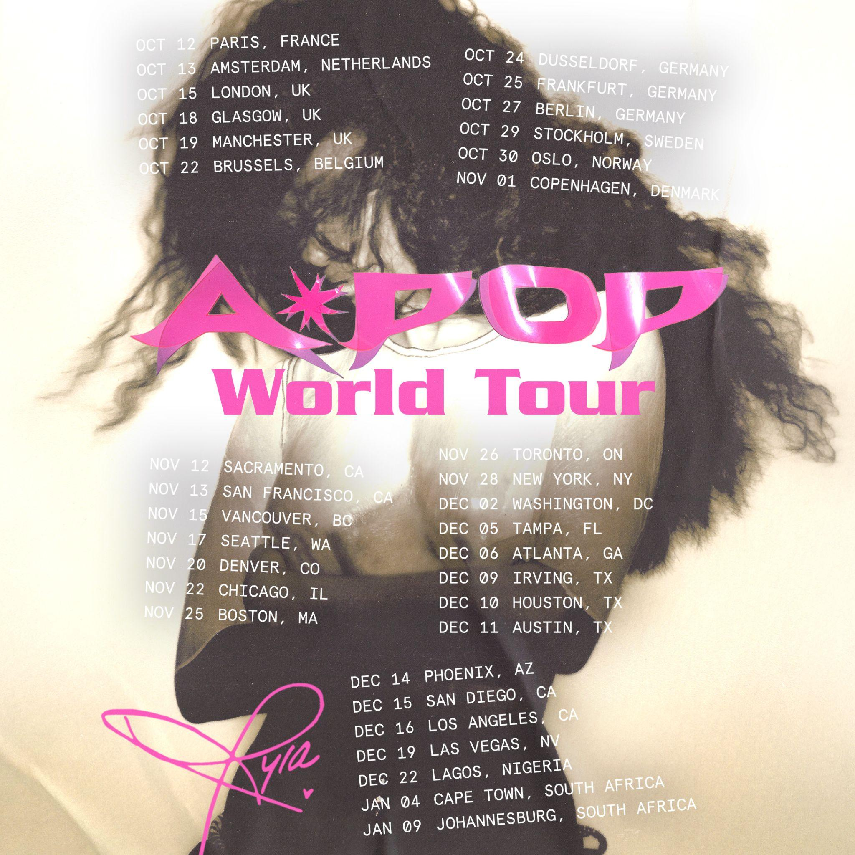

For approved artist images and hi-res tour art, please download HERE
Today, 2x GRAMMY-award winning global singer and songwriter Tyla announced THE A*POP WORLD TOUR, in support of her highly anticipated sophomore studio album, A*POP which was released July 24 via FAX and Epic Records.
The 34-date global tour, presented by Live Nation, kicks off on Monday, October 12 in Paris at Zenith before making stops across Europe and the UK, including Amsterdam, London, Brussels, Stockholm, and more. The North American leg begins on Thursday, November 12 at Hard Rock Live in Wheatland, CA, with stops in Vancouver, Chicago, Boston, Brooklyn, San Diego, and more before wrapping on Saturday, December 19 at Fontainebleau Las Vegas. Tyla will then head to Africa for select performances in Lagos, Cape Town, and Johannesburg throughout December and January.
The upcoming tour follows Tyla’s 2025 We Wanna Party Tour across Asia, which included sold-out performances in Japan, and the UAE. THE A*POP WORLD TOUR marks her first full headline tour across North America, Europe, the UK, and Africa.
A*POP, is the highly-anticipated second studio album from Tyla has arrived. The 14-track album, which has been teased and coveted for well over a calendar year, and sports the bonafide hits “CHANEL,” “IS IT,” “SHE DID IT AGAIN,” and “IS IT LOVE,” is available now. Stream it HERE.
This past Friday, Tyla took over Rockefeller Plaza with a headlining performance for the The Today Show’s Citi Summerstage® , bringing A*POP to fans live just hours after its’ release. She lit up the plaza with performances of “WATER,” “IS IT LOVE,” “THAT GIRL,” and “CHANEL”.

Tyla also sat down with the Today Show hosts to talk about the new album and the global rollout surrounding its release, while giving viewers a closer look at her newly released Bratz doll.

She then took over center court at the 2026 AT&T WNBA All-Star Game in Chicago for show-stopping halftime performances of “CHANEL,” “WATER,” and “SHE DID IT AGAIN.”. Tyla made history as the first international artist to headline the WNBA All-Star Game halftime show in its 30-year history.
Tyla also recently teamed up with Vevo for the Official Live Performance of “IS IT LOVE,” released last week, with more performances from the series set to roll out soon. Watch her performance HERE. You can also watch the Vevo music video for the hit single “SHE DID IT AGAIN” featuring Zara Larsson HERE.
TICKETS: Tickets will be available starting with an artist presale beginning on Wednesday, July 29 at 10AM local time via Laylo. Fans can sign up now at Laylo.com/tyla/m/A-POPWORLDTOUR. General on sale starting Friday, July 31 at 10AM local at TylaWorld.com.

MASTERCARD PRESALE (EUROPE): Mastercard cardholders have special access to presale tickets in France, the Netherlands, Belgium, Sweden, Norway and Denmark. Mastercard Presale starts Wednesday, July 29 at 10AM local. Preferred ticket access to some of the best tickets are available in the countries listed and the UK from Friday, July 31 at 10AM local. Check out priceless.com/music for details.

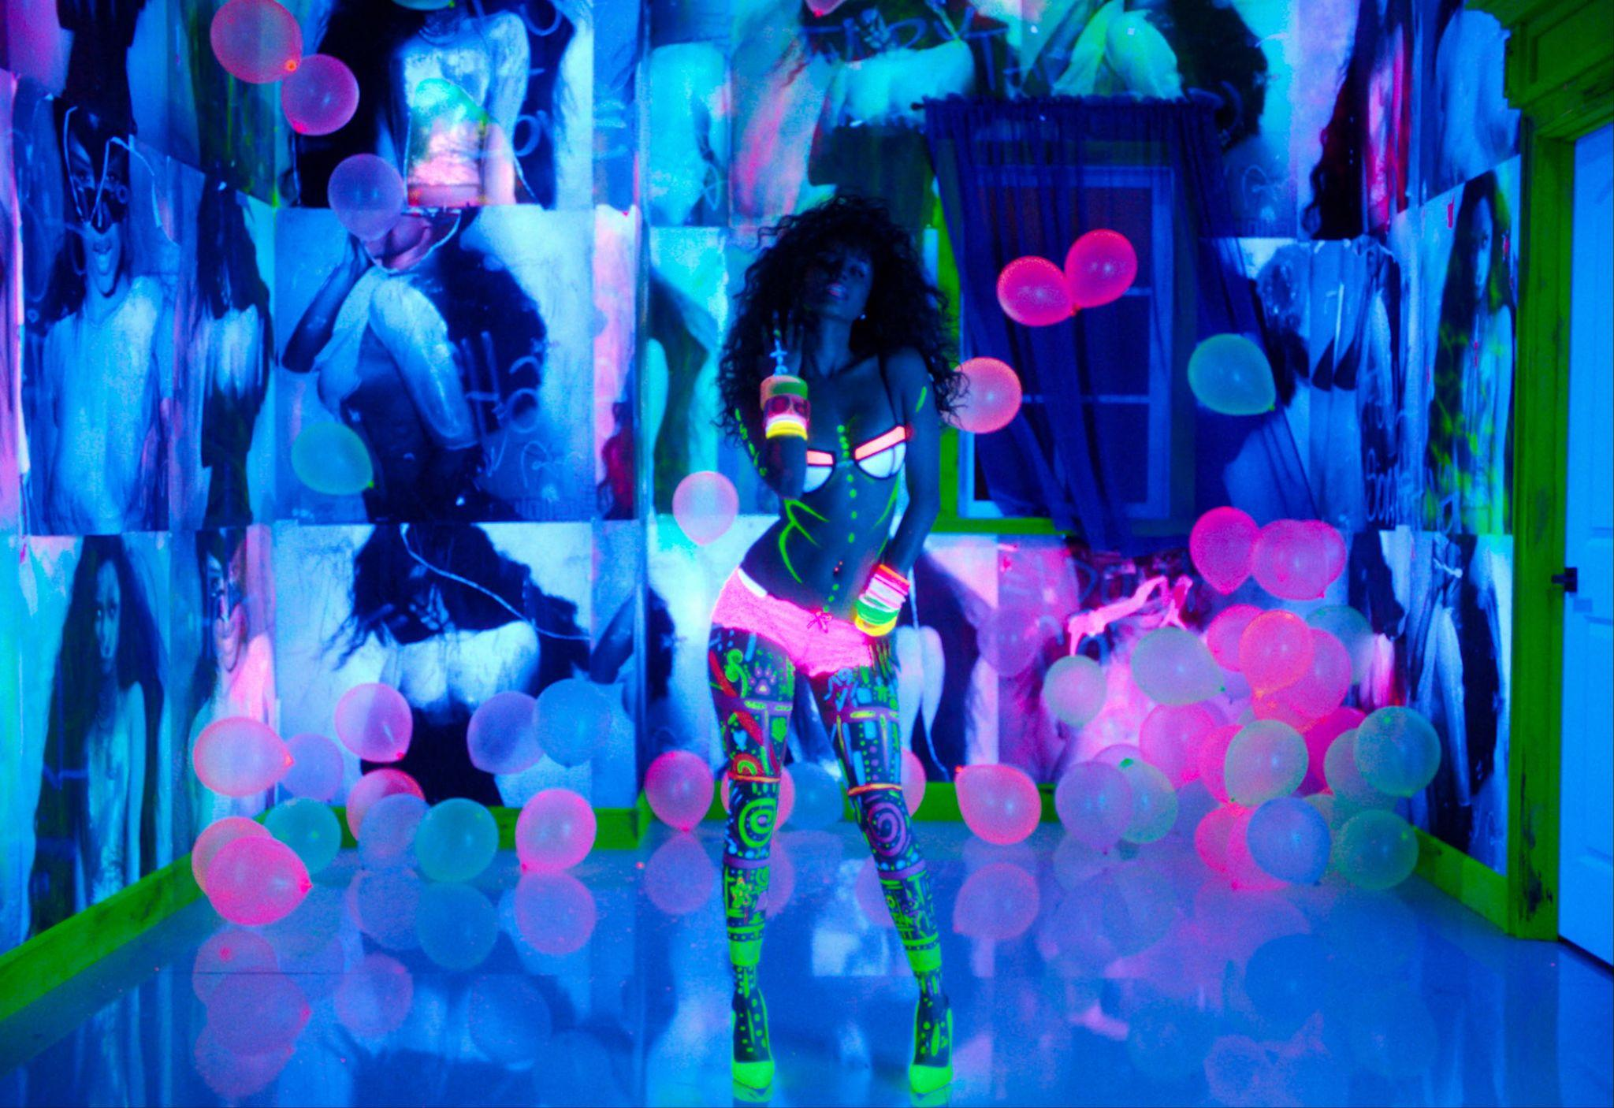
Photo Credit: Russ Fraser

TYLA - THE A*POP WORLD TOUR EUROPE/UK DATES:
Mon Oct 12 — Paris, FR — Zenith Paris
Tue Oct 13 — Amsterdam, NL — AFAS Live
Thu Oct 15 — London, UK — O2 Academy Brixton
Sun Oct 18 — Glasgow, UK — O2 Academy Glasgow
Mon Oct 19 — Manchester, UK — O2 Apollo Manchester
Thu Oct 22 — Brussels, BE — Forest National
Sat Oct 24 — Dusseldorf, DE — Mitsubishi Electric HALLE
Sun Oct 25 — Frankfurt, DE — Stadthalle Offenbach
Tue Oct 27 — Berlin, DE — Uber Eats Music Hall
Thu Oct 29 — Stockholm, SE — Annexet
Fri Oct 30 — Oslo, NO — Oslo Spektrum
Sun Nov 1 — Copenhagen, DK — K.B. Hallen
TYLA - THE A*POP WORLD TOUR NORTH AMERICA DATES:
Thu Nov 12 — Wheatland, CA — Hard Rock Live
Fri Nov 13 — San Francisco, CA — Bill Graham Civic Auditorium*
Sun Nov 15 — Vancouver, BC — Doug Mitchell Thunderbird Sports Centre
Tue Nov 17 — Seattle, WA — WAMU Theater @ Lumen Field
Fri Nov 20 — Denver, CO — Fillmore Auditorium
Sun Nov 22 — Chicago, IL — Aragon Ballroom
Wed Nov 25 — Boston, MA — MGM Music Hall at Fenway
Thu Nov 26 — Toronto, ON — Coca-Cola Coliseum
Sat Nov 28 — Brooklyn, NY — Brooklyn Paramount
Wed Dec 2 — Washington, DC — The Anthem*
Sat Dec 5 — Tampa, FL — Yuengling Center
Sun Dec 6 — Atlanta, GA — Coca-Cola Roxy
Wed Dec 9 — Irving, TX — The Pavilion at Toyota Music Factory
Thu Dec 10 — Houston, TX — 713 Music Hall
Fri Dec 11 — Austin, TX — Moody Center
Mon Dec 14 — Phoenix, AZ — Arizona Financial Theatre
Tue Dec 15 — San Diego, CA — Viejas Arena
Wed Dec 16 — Los Angeles, CA — YouTube Theater
Sat Dec 19 — Las Vegas, NV — Fontainebleau Las Vegas
TYLA - THE A*POP WORLD TOUR AFRICA DATES:
Tue Dec 22 — Lagos, Nigeria^*
Mon Jan 4 — Cape Town, South Africa - Green Point Track*
Sat Jan 9 — Johannesburg, South Africa - Expo Centre, Nasrec*
*Non-Live Nation Date
^Venue TBA
ABOUT TYLA
In an era where niche culture has taken priority over monoculture, two-time GRAMMY® winner TYLA has ascended to true and unequivocal global superstar status. With A*POP, asserted and fully aware of her presence in pop music, she presents a project that refuses containment or dismissal. It’s confrontational, candid but fun, and spills authenticity rooted in where she’s from: a country that has always spoken in more than one musical language. Through this language, she reveals her range not just as an African artist, but as a global pop star with an entire world behind her.
TYLA’s journey got off to a historic beginning in 2024, when she won her first GRAMMY® Award, and made Billboard chart history with the three-time RIAA® Platinum smash hit “WATER,” and the release of her seminal debut albums, TYLA and TYLA+. The set produced another Hot 100 and GRAMMY®-winning hit, “PUSH 2 START,” and sent seven songs to the U.S. Afrobeats chart, including two no. 1s. The campaign made TYLA the highest-charting African female soloist on the Billboard 200. With her highly-anticipated second go-round, A*POP, TYLA picked up where she left off. “CHANEL,” one of the album’s standout singles, was an immediate pop sensation. It topped the U.S. Afrobeats chart and earned over 150 million video views, while TYLA’s follow-up effort, the Zara Larsson-assisted, Y2K-inspired “SHE DID IT AGAIN,” became a disruptive moment, and amplified TYLA’s commitment to the pop star realm. “IS IT LOVE?,” the album’s third single, earned TYLA her record fourth no. 1 on the Billboard U.S. Afrobeats chart. A*POP is available now.
Follow Tyla:
Website | Facebook | X | Instagram | YouTube | TikTok

