
KALEO BRINGS THE WAY DOWN WE GO TOUR TO EUROPE ANNOUNCES DATES FOR EU/UK TOUR
CELEBRATING THE 10-YEAR ANNIVERSARY OF A/B
SPRING 2027 SEE DATES
TICKETS GO ON SALE FRIDAY, JULY 3 AT 10 AM LOCAL ARTIST PRESALE BEGINS WEDNESDAY, JULY 1 AT 10 AM LOCAL
KALEO'S WAY DOWN WE GO NORTH AMERICAN TOUR KICKED OFF LAST WEEKEND
CONTINUES THROUGHOUT THE SUMMER SEE DATES
KALEO's 10-YEAR ANNIVERSARY DELUXE EDITION OF 2016 BREAKOUT ALBUM A/B
OUT EVERYWHERE NOW
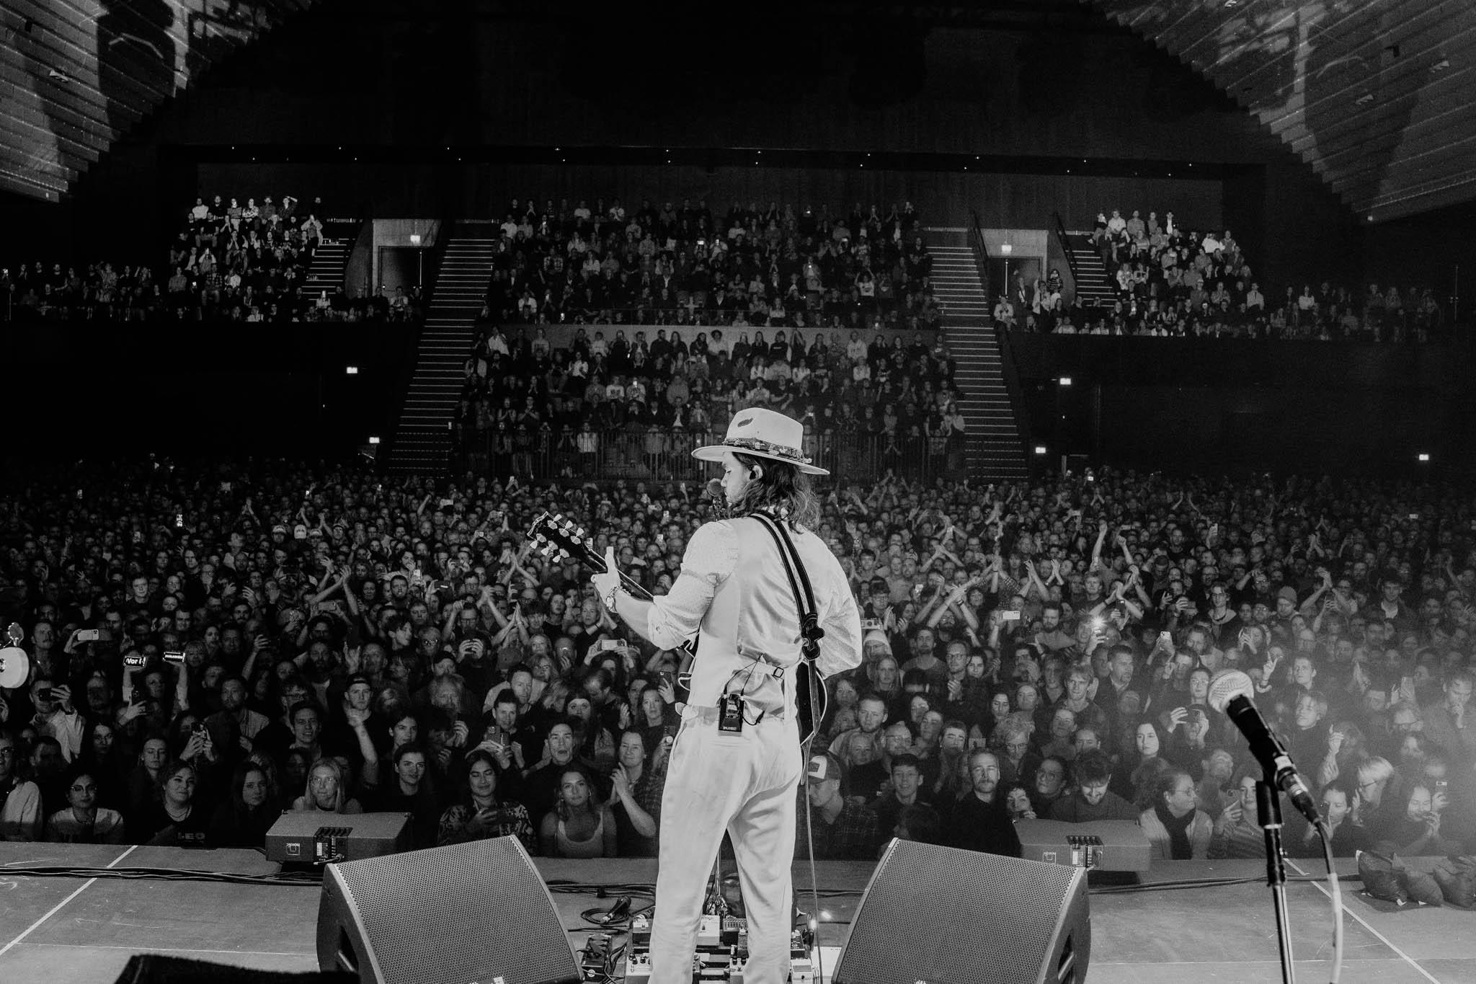

Photo credit: Justin Pagano / @thecontentgod / Download hi-res image

Today, Icelandic rock band KALEO announce dates for the EU/UK leg of their Way Down We Go tour. The band will be heading to several cities in Europe and The UK in March 2027. Extending the much-anticipated North American tour — which kicked off last weekend in Los Angeles, CA — the European/UK leg will continue celebrating the 10th anniversary of the breakout record, A/B, as well as the A/B (deluxe anniversary edition) double-LP, out now via Rhino Records.

Tickets for the Europe/UK leg of the Way Down We Go tour will go on sale this Friday, July 3 at 10 am local time. Artist and album preorder presale will begin Wednesday, July 1 at 10 am local time. More information about the tour is available here.

MASTERCARD TICKET ACCESS: Mastercard cardholders have special access to presale tickets in Norway, Sweden, Denmark, Belgium, Italy, Poland, Czech Republic, Netherlands, France. Mastercard Presale starts Wednesday July 1 at 10AM local. Preferred ticket access to some of the best tickets are available in the countries listed and the UK from Friday Jul 3 at 10AM local. Check out priceless.com/music for details.

SEE DATES FOR THE WAY DOWN WE GO EU/UK TOUR

News of the EU/UK tour comes after KALEO began their extensive North American Way Down We Go tour on June 27 at Los Angeles, CA's The Novo. This summer, they'll be joined by very special guests Dawes, Darren Kiely, Geoffroy, Vincent Lima, Dogpark, and 4x GRAMMY®-nominee, singer-songwriter Elle King as they make their way up the West Coast, through the Rocky Mountains then into the Midwest and Canada before finishing on the East Coast in August. Notable stops include Colorado's famed Red Rocks, NYC's Pier 17, and Nashville’s Pinnacle. See all dates below and more information here.
On June 12th, the band released their much-anticipated A/B (deluxe anniversary edition) double-LP, out now via Rhino Records. As well as commemorating their breakout record — which spawned hits like “All The Pretty Girls,” “No Good,” and the universal sensation “Way Down We Go,” which has nearly 4 billion streams and has been featured in over 3 million TikToks, cementing it as one of the most viral tracks in the history of the platform — with a digital deluxe edition, KALEO will be pressing the album, alongside never-before-heard recordings and iconic live performances of original songs, into a limited edition vinyl double-LP.

ORDER A/B (Deluxe Anniversary Edition)

The deluxe anniversary 2LP highlights the vinyl debut of the “Way Down We Go” stripped version, “Up In The Sky,” a studio track previously unreleased outside of Iceland, and the premiere of a new spin on an old classic, “Still No Good," which features an accompanying music video filmed at United Record Pressing, the same location they filmed the original "No Good" video. Transforming an intimate, live studio session into a reflection on time, artistic evolution, and legacy, the "Still No Good" music video looks back at an electric time in KALEO's history with fondness and learned insight.
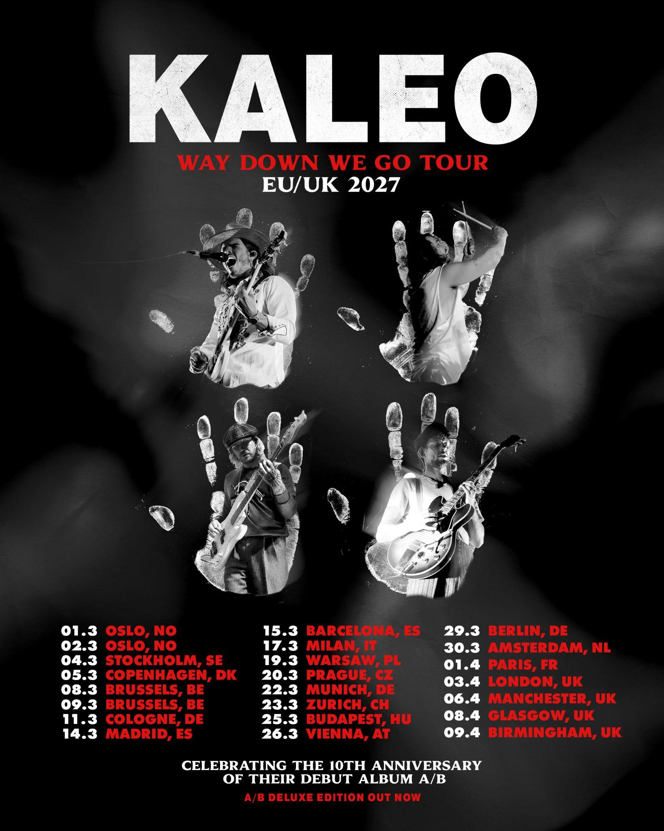

Official Way Down We Go EU/UK poster | Download hi-res image

KALEO LIVE

WAY DOWN WE GO TOUR

EUROPE/THE UK SPRING 2027

MARCH
1 - Oslo, NO - Sentrum Scene
2 - Oslo, NO - Sentrum Scene
4 - Stockholm, SE - Annexet
5 - Copenhagen, DK - KB Hallen
8 - Brussels, BE - Cirque Royal
9 - Brussels, BE - Cirque Royal
11 - Cologne, DE - Palladium
14 - Madrid, ES - Live Las Ventas
15 - Barcelona, ES - Razzmatazz
17 - Milan, IT - Fabrique
19 - Warsaw, PO - COS Torwar
20 - Prague, CZ - Forum Karlin
22 - Munich, DE - Zenith
23 - Zurich, CH - Halle 622
25 - Budapest, HU - Budapest Sportarena
26 - Vienna, AT - Gasometer
29 - Berlin, DE - Uber Eats Music Hall
30 - Amsterdam, NL - Ziggo Dome

APRIL
1 - Paris, FR - Zenith Paris La Villette
3 - London, UK - O2 Academy Brixton
6 - Manchester, UK - O2 Apollo Manchester
8 - Glasgow, UK - O2 Academy Glasgow
9 - Birmingham, UK - O2 Academy Birmingham
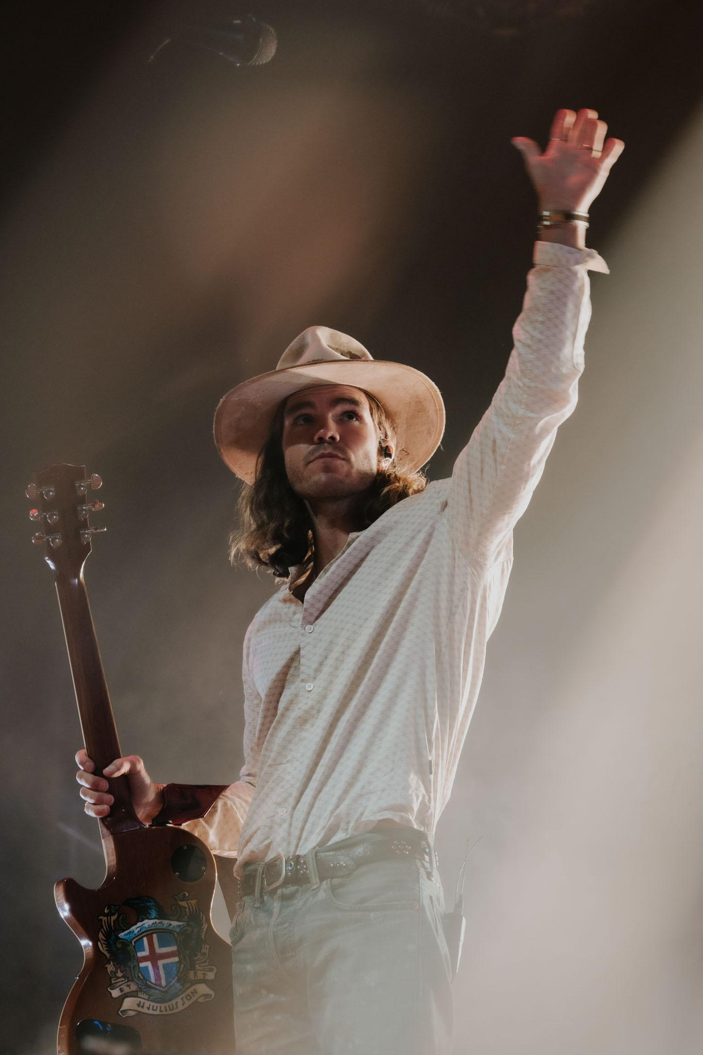

Photo credit: Justin Pagano / @thecontentgod
Download hi-res image

ABOUT KALEO

Emerging from Mosfellsbær, a small town in the suburbs of Reykjavik, Iceland, KALEO formed as childhood friends in 2012. Made up of JJ Julius Son (vocals/guitar), David Antonsson (drums), Daniel Kristjansson (bass) and Rubin Pollock (guitar), the group has gone on to global success, amassing over 6+ billion global streams, 70+ international gold, platinum, and diamond certifications, countless sold-out headlining shows, plus appearances at noteworthy festivals including Coachella, Lollapalooza, Bonnaroo and more.

In addition, they are one of the most synced bands of all-time with their music appearing in a multitude of notable TV shows like Yellowstone, The Morning Show, Law & Order, Grey's Anatomy and Suits, EA Sports video games including Madden NFL, NHL, and FIFA, innumerable brand commercials and campaigns for practically every major professional sports league across the globe.

On June 12th, the band released the 10-year Anniversary Deluxe Edition of their debut album, A/B which spawned hits like “All The Pretty Girls,” “No Good,” and the universal sensation “Way Down We Go,” which has nearly 4 billion streams and has been featured in over 3 million TikToks, cementing it as one of the most viral tracks in the history of the platform. The double vinyl will spotlight some of the band’s iconic live performances plus a few rare studio recordings. To celebrate they will embark on their Way Down We Go Tour this summer.

CONNECT WITH KALEO

WEBSITE | INSTAGRAM | YOUTUBE | TIKTOK | TWITTER | FACEBOOK

