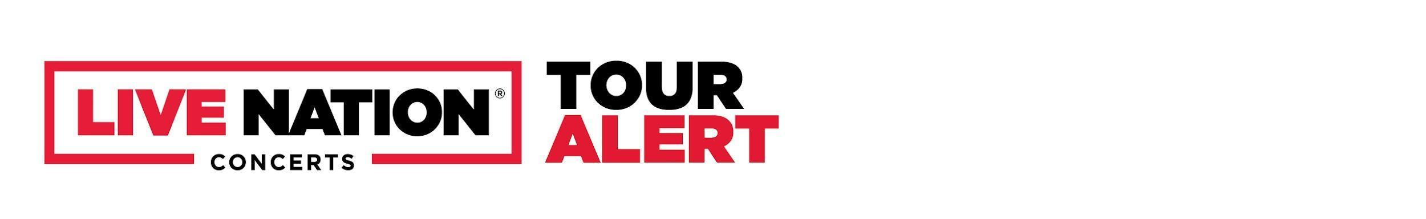

# **SABRINA CLAUDIO ANNOUNCES 2026 UK & EUROPEAN TOUR**

### **GENERAL ONSALE BEGINS THIS FRIDAY, OCTOBER 3 AT 9AM LOCAL**

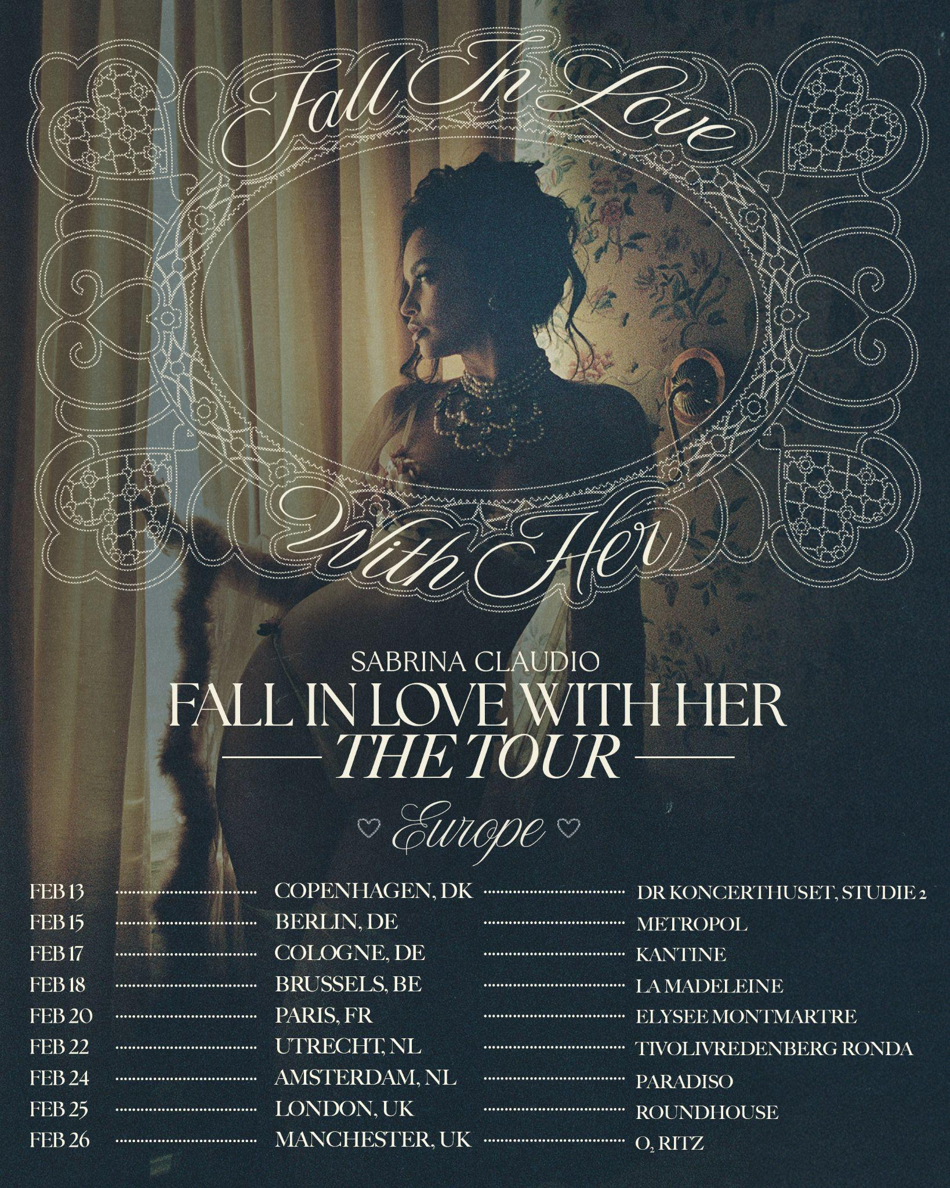

*Download Hi-res images and tour art* [*HERE*](https://lne.box.com/s/f8tmtr9doxi5k7cmsm8lr3cjo1tituqk)

(*September 29, 2025*) — Grammy-winning singer, songwriter, and producer Sabrina Claudio has announced her highly anticipated return to the UK and Europe in 2026. Following a string of celebrated collaborations and her continued evolution as one of R&B’s most alluring voices, Sabrina will bring her intimate, soul-stirring performances across 9 dates this February.

Tickets will be available starting with an artist presale on Tuesday, September 30 at 9AM local time. Fans can sign up now at [sabrinaclaudio.co](http://sabrinaclaudio.com). Additional presales will run throughout the week ahead of the general on-sale beginning Friday, October 3 at 9AM local time.

EU/UK TICKET ACCESS: Mastercard cardholders have special access to presale tickets in France. Mastercard Presale starts Wednesday October 1 at 9AM local. Preferred ticket access to some of the best tickets are available in France and the UK from Friday October 3 at 9AM local. Check out [priceless.com/music](http://priceless.com/music) for details.

VIP: In select cities, the shows will also offer a variety of different VIP packages and experiences for fans to take their concert experience to the next level. For more information, visit <https://www.vipnation.eu/>

This announcement follows the release of Sabrina’s celebrated fifth studio album ‘Fall in Love with Her’, as well as recent work penning Grammy-winning tracks for Beyoncé (Plastic Off The Sofa) and Chris Brown (Best Ever feat. Maeta). Further recent work includes collaborations with Marshmello, ZHU, Tyga, Alicia Keys, and The Weeknd. With each project, Claudio continues to expand her artistry while staying true to her emotive storytelling.

## **Tour Dates**

**Feb 13** – Copenhagen, DK @ DR Koncerthuset, Studie 2  
**Feb 15** – Berlin, DE @ Metropol  
**Feb 17** – Cologne, DE @ Die Kantine Kulturbetrieb GmbH  
**Feb 18** – Brussels, BE @ La Madeleine  
**Feb 20** – Paris, FR @ Elysee Montmartre  
**Feb 22** – Utrecht, NL @ TivoliVredenburg Ronda  
**Feb 24** – Amsterdam, NL @ Paradiso  
**Feb 25** – London, UK @ Roundhouse  
**Feb 26** – Manchester, UK @ O2 Ritz

### **Connect with Sabrina Claudio**

[**Instagram**](https://www.instagram.com/sabrinaclaudio/) **|** [**TikTok**](https://www.tiktok.com/@sabrina?lang=en) **|** [**X (Twitter)**](https://x.com/sabrinaclaudio?lang=en) **|** [**Website**](https://sabrinaclaudio.co/)