**RAYE RETURNS WITH EPIC NEW SINGLE AND VIDEO**

**“WHERE IS MY HUSBAND!”**[**LISTEN HERE**](https://raye.orcd.co/wimh)

**ANNOUNCES *THIS TOUR MAY CONTAIN NEW MUSIC* – 40-DATE 2026 HEADLINE TOUR FEATURING SUPPORT FROM SISTERS ABSOLUTELY AND AMMA –** [**TICKETS HERE**](https://drop.cobrand.com/d/RAYE/thistourmaycontainnewmusic) **LEAD TRACK FROM GRAMMY-NOMINATED SUPERSTAR’S   
SOPHOMORE ALBUM DUE IN 2026 –** [**PRE-ORDER HERE**](https://uk-eur-shop.rayeofficial.com/)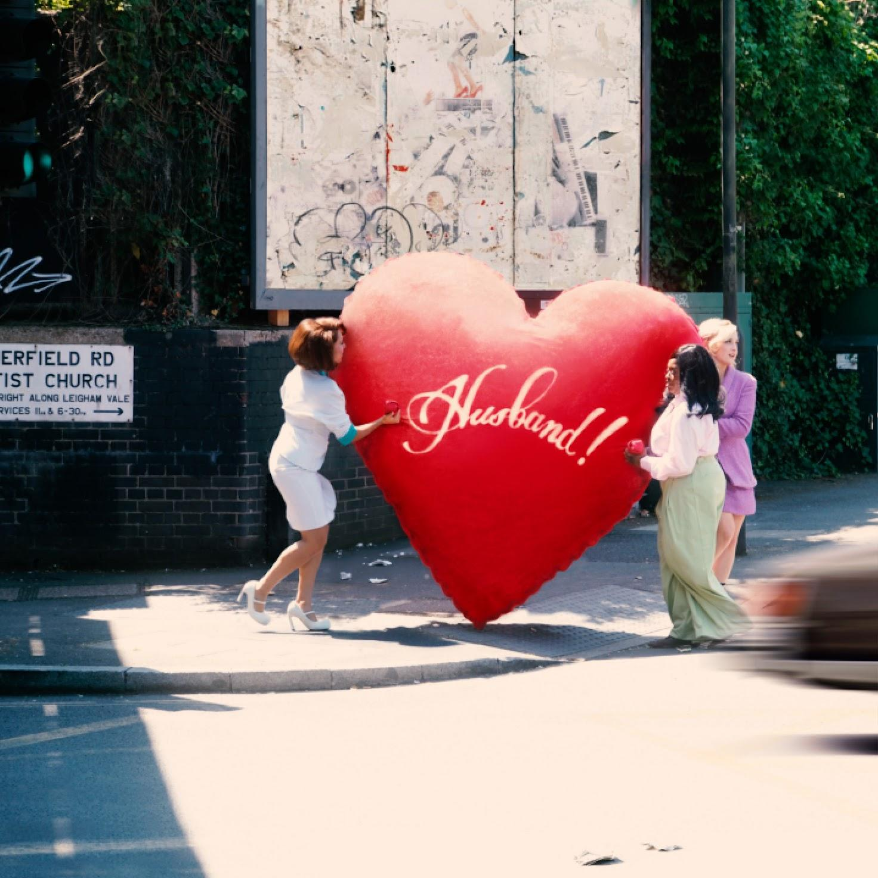

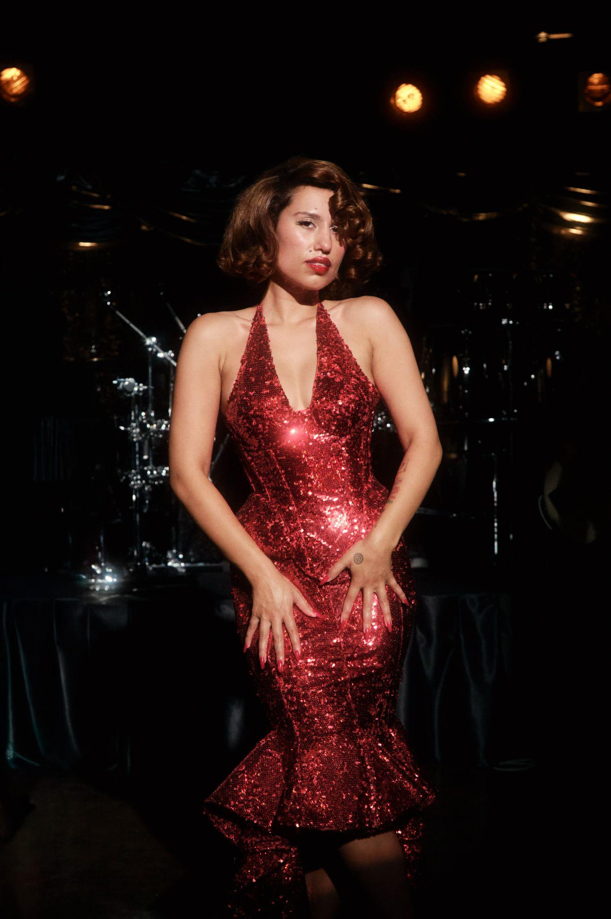  
**CREDIT: Aliyah Otchere //** [**DOWNLOAD PRESS ASSETS HERE**](https://drive.google.com/drive/folders/1Gw92ixdcFvX6hJdf0y8s8TDcK62Rutcn?usp=sharing)

**RAYE COVERS *BRITISH VOGUE*’S OCTOBER 2025 ISSUE –** [**SEE FEATURE HERE**](https://www.vogue.co.uk/article/raye-british-vogue-interview)

**GUEST STARS IN NETFLIX’S *BLACK RABBIT* NOW STREAMING,  
 FEATURING HER RENDITION OF “WHAT A DIFFERENCE A DAY MAKES” –** [**LISTEN HERE**](https://netflixmusic.ffm.to/wadadm)

**RAYE TO PERFORM “WHERE IS MY HUSBAND!” AND MORE LIVE ON**

**THE *TODAY* SHOW’S CITI CONCERT SERIES TOMORROW – SEPTEMBER 19TH**

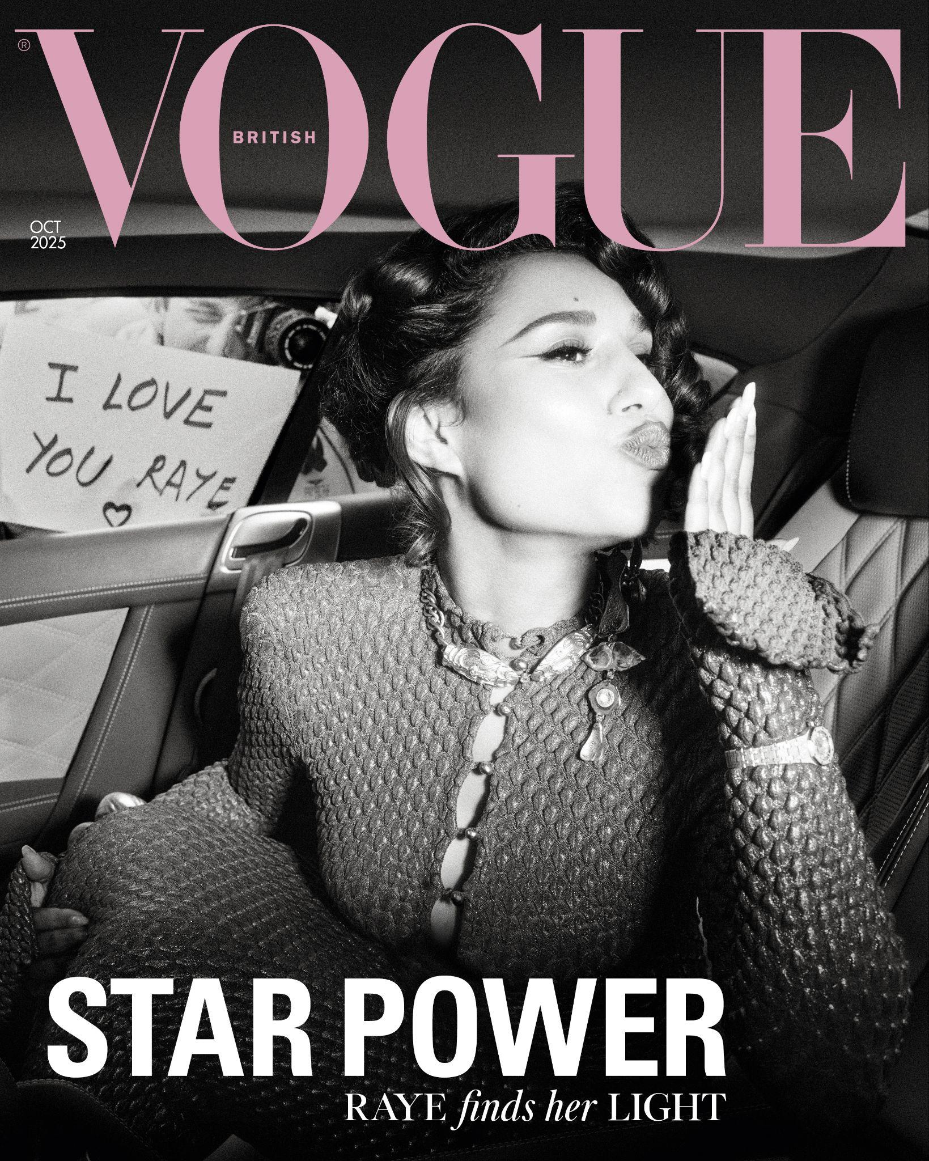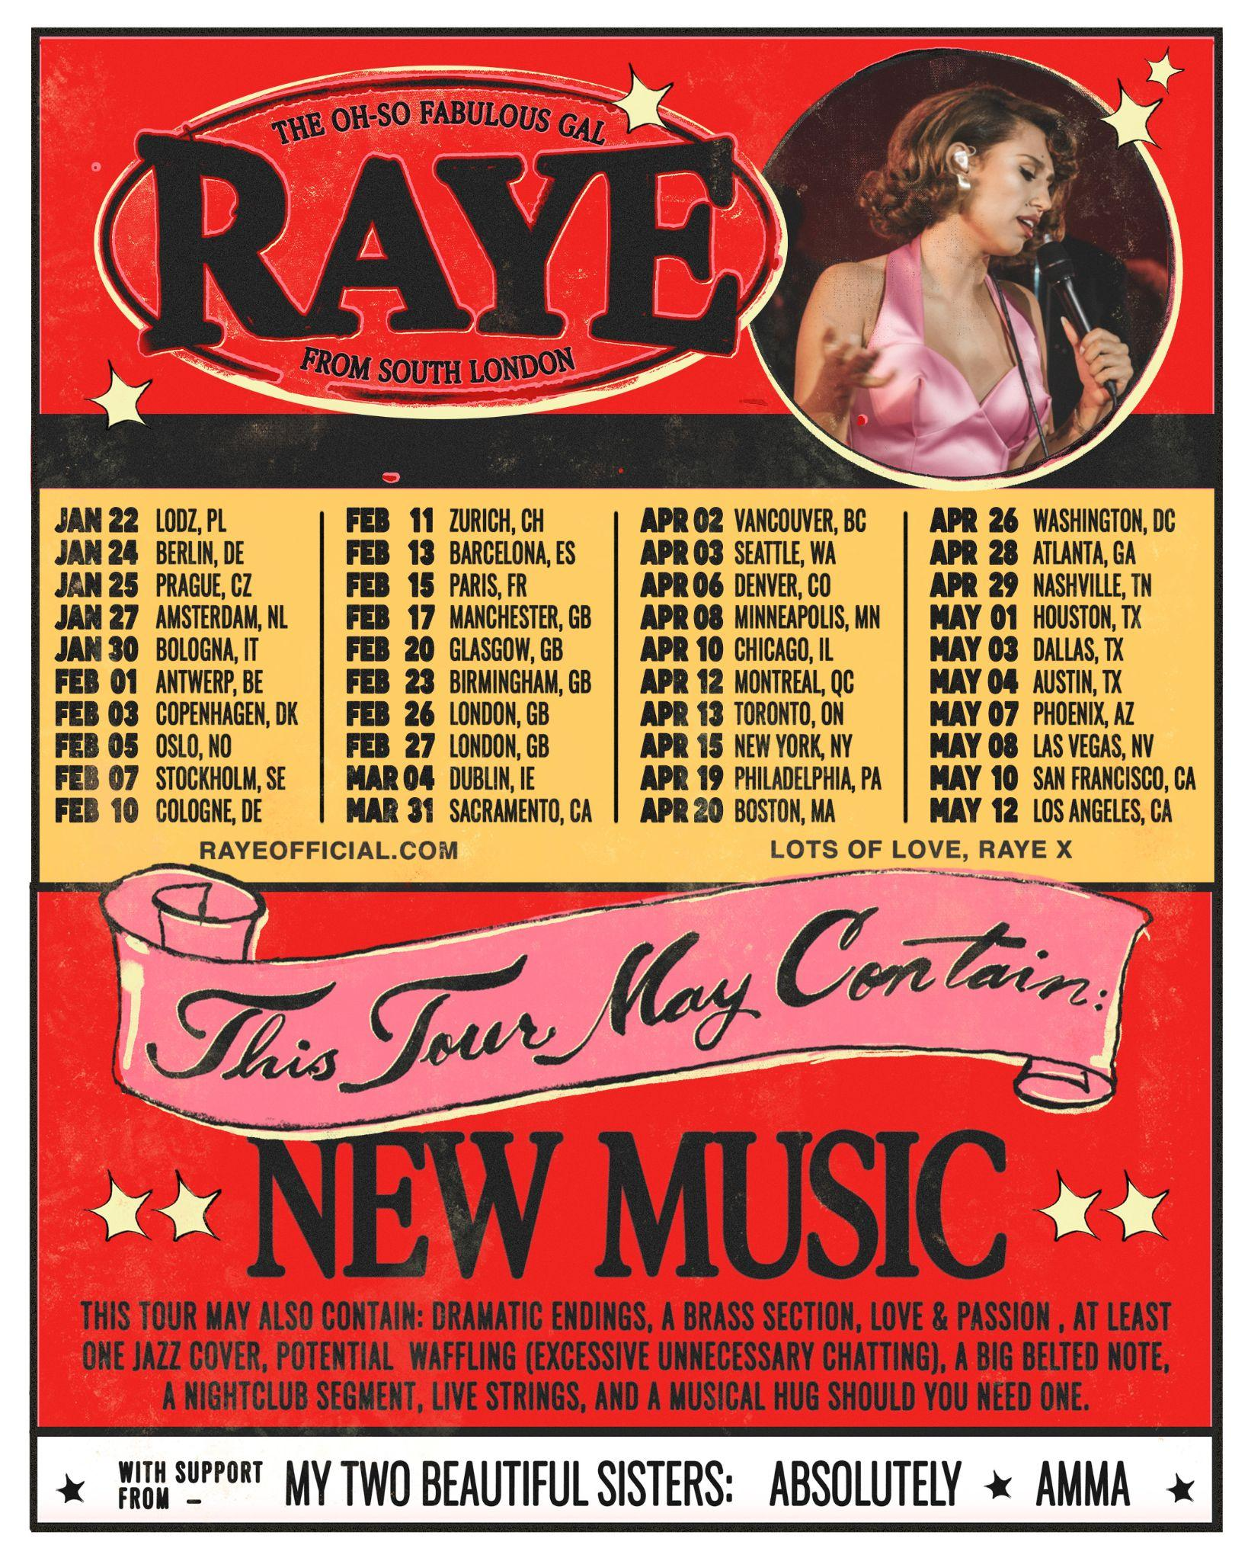

*****

(*New York, NY – September 18, 2025)* – Currently featured on the October cover of ***British Vogue*** ([**read here**](https://www.vogue.co.uk/article/raye-british-vogue-interview)), three-time GRAMMY-nominated global music superstar [**RAYE**](https://www.instagram.com/raye/?hl=en) returns today with the new single “[**WHERE IS MY HUSBAND!**](https://raye.orcd.co/wimh)” out now on all digital streaming platforms via **Human Re Sources/The Orchard**. Co-written and produced with longtime collaborator **Mike Sabath**, the track marks the first release off her highly-anticipated sophomore album, due to arrive in 2026 –[**LISTEN HERE**](https://raye.orcd.co/wimh) **//** [**PRE-ORDER ALBUM HERE**.](https://uk-eur-shop.rayeofficial.com/)

“**WHERE IS MY HUSBAND!**” is a sassy yet sincere ode to RAYE’s search for her life partner. Fusing funky brass, syncopated R&B beats, and glossy soul-pop production, the track showcases RAYE's signature soaring vocals and layered harmonies. Fans first heard the song as the opening number of her acclaimed **Glastonbury** set this summer, with subsequent performances at **All Points East** and the **Montreux Jazz Festiva**l.

To coincide with today’s release, RAYE has announced [***THIS TOUR MAY CONTAIN NEW MUSIC***](https://drop.cobrand.com/d/RAYE/thistourmaycontainnewmusic) — a massive **40-date headline tour** running from **January 22 to May 12, 2026**. The **Live Nation-produced** trek will feature arena shows across the **UK and Europe**, followed by a North American leg with stops at iconic venues such as New York City’s Radio City Music Hall**.** Providing direct support throughout the entire tour are her younger sisters, **ABSOLUTELY** and **AMMA**, who recently joined RAYE at **All Points East**—offering fans an early glimpse of the powerful family dynamic they can expect live. Fans can sign up for presale ticket access now, presale begins **September 23 at 10 a.m. local time**. In the UK, France, and Germany, presale is available from **September 23 at 10 a.m. local time** for those who pre-order the album. General ticket sales open on **September 25 at 10 a.m. local time** **online** [**HERE**](https://drop.cobrand.com/d/RAYE/thistourmaycontainnewmusic)**.**

**Mastercard** cardholders have special access to presale tickets in Denmark, Netherlands, France, Belgium, Sweden, Norway and Italy. Mastercard Presale starts September 23 at 10 a.m. local time and ends ends Thursday 25th at 9 a.m.local. Plus, Preferred ticket access to some of the best tickets are available in the markets listed & UK from Thursday 25th at 10 a.m. local. Check out [priceless.com/music](http://priceless.com/music) for details.



**UK/EUROPE 2026 TOUR DATES**

January 22, 2026: Lodz, Poland - Atlas Arena

January 24, 2026: Berlin, Germany - Uber Arena (FKA Mercedes Benz Arena)

January 25, 2026: Prague, Czech Republic - O2 Arena

January 27, 2026: Amsterdam, Netherlands - Ziggo Dome

January 30, 2026: Bologna, Italy - Unipol Arena

February 1, 2026: Antwerp, Belgium - AFAS Dome

February 3, 2026: Copenhagen, Denmark - Royal Arena

February 5, 2026: Oslo, Norway - Unity Arena

February 7, 2026: Stockholm, Sweden - Avicii Arena

February 10, 2026: Cologne, Germany - Lanxess Arena

February 11, 2026: Zurich, Switzerland - Hallenstadion

February 13, 2026: Barcelona, Spain - Palau Saint Jordi

February 15, 2026: Paris, France - Accor Arena

February 17, 2026: Manchester, UK - Co-Op Live

February 20, 2026: Glasgow, UK - OVO Hydro

February 23, 2026: Birmingham, UK - bp pulse LIVE

February 26, 2026: London, UK - The O2

February 27, 2026: London, UK - The O2

March 4, 2026: Dublin, Ireland - 3Arena

**NORTH AMERICA 2026 TOUR DATES**

March 31, 2026: Sacramento, CA, USA - Channel 24

April 2, 2026: Vancouver, BC, CAN - Doug Mitchell Thunderbird Sports Center

April 3, 2026: Seattle, WA, USA - WAMU Theater @ Lumen Field

April 6, 2026: Denver, CO, USA - Fillmore Auditorium

April 8, 2026: Minneapolis, MN, USA - State Theatre

April 10, 2026: Chicago, IL, USA - Auditorium Theatre

April 12, 2026: Montreal, QC, CAN - Place Bell

April 13, 2026: Toronto, ON, CAN - Coca Cola Coliseum

April 15, 2026: New York, NY, USA - Radio City Music Hall

April 19, 2026: Philadelphia, PA, USA - The Met Presented by Highmark

April 20, 2026: Boston, MA, USA - MGM Music Hall at Fenway

April 26, 2026: Washington, DC, USA - The Anthem

April 28, 2026: Atlanta, GA, USA - Coca Cola Roxy

April 29, 2026: Nashville, TN, USA - Ryman Auditorium

May 1, 2026: Houston, TX, USA - 713 Music Hall

May 3, 2026: Dallas, TX, USA - South Side Ballroom

May 4, 2026: Austin, TX, USA - Moody Amphitheater at Waterloo Park

May 7, 2026: Phoenix, AZ, USA - Arizona Financial Theatre

May 8, 2026: Las Vegas, NV, USA - The Chelsea at the Cosmopolitan of Las Vegas

May 10, 2026: San Francisco, CA, USA - Bill Graham Civic Auditorium

May 12, 2026: Los Angeles, CA, USA - Greek Theatre

**ABOUT RAYE**

The multi-award-winning British artist [**RAYE**](https://www.instagram.com/raye/?hl=en) is redefining modern pop music through raw storytelling, genre-defying sound, and record-breaking success. The **three-time GRAMMY-nominated** singer, songwriter, and producer **made history at the 2025 GRAMMY Awards** as the **first artist ever nominated for both *“*Best New Artist”and “Songwriter of the Year (Non-Classical)” in the same year**. This milestone followed the South London singer’s record-breaking **sweep at the 2024 BRIT Awards**, where she took home six awards—the most by any artist in a single year—and became the **first woman ever honored as “Songwriter of the Year.”** With viral performances at the **2025 GRAMMYs** (“[**Oscar Winning Tears**](https://youtu.be/N4LWuM7pOf0?si=czXNUzKkKeBuAEWs)**.**”) and the **Academy Awards** (***James Bond* tribute**), RAYE has proven herself to be one of the industry’s most exciting voices.

Since her 2014 debut, RAYE has charted **eighteen Top 40 UK singles** and surpassed over **10 Billion cumulative streams**. Her genre-defying catalog—covering pop, R&B, hip-hop, gospel, jazz, big band, and dance—includes collaborations with **Stormzy, Central Cee, Lucky Daye, David Guetta, Jax Jones,** and **Disclosure**. A prolific songwriter, RAYE has also penned hits for icons such as **Beyoncé, Charli XCX,** and **Jennifer Lopez**, as well as rising stars like **JADE** and **Halle**.

RAYE’s 2023 debut album, [***My 21st Century Blues***](https://raye.orcd.co/m21cb) (*Human Re Sources/The Orchard)*, was a decade in the making and marked her first as an independent artist. The record achieved unprecedented critical and international commercial success, propelled by the inescapable worldwide smash hit “[**Escapism**](https://raye.orcd.co/escapism-thrillisgone).” The single not only became her **first career UK No. 1**, but also reached **Top 10 in over 20 countries,** wascertified **RIAA Platinum** in the US, and became the **UK’s largest-selling single by a female British artist in 2023**. Further, the album led to over **150 headline shows** across the globe, including standout performances at **Coachella, Glastonbury, Lollapalooza, Fuji Rock, Austin City Limits, Corona Capital,** and **Montreux Jazz Festival**.

Her one-night-only show at London's **Royal Albert Hall**—backed by a 50-piece orchestra and gospel choir—was released on vinyl and broadcast on ***PBS*** and ***BBC***, with critics hailing her as *“the most talented artist since Adele and Amy Winehouse”* (*The Telegrap*h). 2024 marked another breakthrough year for the “[**Oscar Winning Tears**](https://youtu.be/BtdBQ1-fzXM?si=ybKKkhPiHzomkDeU)**.**” singer, as she **made history at the BRIT Awards**, opened for **Taylor Swift’s *Eras Tour* at Wembley Stadium**, and gave a career-defining debut on ***Saturday Night Live***. Additional high-profile TV appearances on ***The Kelly Clarkson Show, American Music Awards, The Daily Show*, MTV EMAs*,*** andthe **BRIT Awards**furthersolidified her as a bona fide performer.

RAYE kicked off 2025 by joining forces with **LISA** and **Doja Cat** on the global anthem “[**Born Again**](https://youtu.be/kbEC-AGr9n0?si=auHTJh_vkQWuiXSV),” which she co-wrote and co-produced and recently earned the trio an **MTV Video Music Award.** She also collaborated with 9-time GRAMMY-winning producer **Mark Ronson** on two jazz-influenced singles, “[**Suzanne**](http://markronson.lnk.to/Suzanne)” and “[**Grandma Calls The Boy Bad News**](https://f1thealbum.lnk.to/GCTBBN),” the latter of which featured on the star-studded ***F1® THE MOVIE*** soundtrack. RAYE’s summer 2025 festival run included a triumphant return to **Glastonbury’s legendary Pyramid Stage**, along with praised sets at **Governor’s Ball, Montreux Jazz Festival, Newport Jazz Festival** and **All Points East.**

An outspoken advocate for songwriter rights, RAYE consistently uses her platform to call attention to industry imbalances—from power dynamics between artists and labels to the financial challenges creatives face in the streaming era. In recognition of her impact, the **Ivors Academy** will recognize her with a special **Ivors Academy Honour** this October, calling her *“the UK’s finest songwriter and a fearless force for change.”* Outside of music, RAYE serves as an ambassador for **Audemars-Piguet** and **Nintendo Switch UK** and recently starred in **Stella McCartney's *About F**ing Time* campaign**. On screen, RAYE makes a cameo in an episode of the **Netflix limited series** ***Black Rabbit***, starring **Jason Bateman** and **Jude Law**. The appearance also features her rendition of the jazz classic “[**What a Difference a Day Makes.**](https://netflixmusic.ffm.to/wadadm)”

*Stream/watch RAYE’s new single “WHERE IS MY HUSBAND!” out now* [***HERE***](https://raye.orcd.co/wimh)*; pre-save/pre-order her sophomore album* [*HERE*](https://uk-eur-shop.rayeofficial.com/)*. Presale ticket access for her 2026 tour begins September 23 at 10 a.m. local time, with general ticket sales opening on September 25 at 10 a.m. local time* [***HERE***](https://drop.cobrand.com/d/RAYE/thistourmaycontainnewmusic)*.*

**Listen/Watch “WHERE IS MY HUSBAND!”**

[**Pivot Link**](https://raye.orcd.co/wimh)

**Follow RAYE**  
[**Official Website**](http://rayeofficial.com/)[**Instagram**](https://www.instagram.com/raye/?hl=en)[**TikTok**](https://www.tiktok.com/@raye?lang=en)[**Twitter**](https://twitter.com/raye?lang=en)[**Facebook**](https://www.facebook.com/raye)[**YouTube**](https://www.youtube.com/channel/UCw5z_dopYnvEL6Rc8KNKsnw)[**Spotify**](https://open.spotify.com/artist/5KKpBU5eC2tJDzf0wmlRp2?si=pjruPGFURUqxT8JGOW21Lw)