TOM ODELL ANNOUNCES NEW ALBUM, A WONDERFUL LIFE

RELEASED 5TH SEPTEMBER 2025

NEW SINGLE, ‘DON’T CRY, PUT YOUR HEAD ON MY SHOULDER’ – LISTEN NOW

+ ANNOUNCES 27-DATE UK/EUROPEAN ARENA TOUR INCLUDING LONDON’S O2 ARENA IN OCTOBER

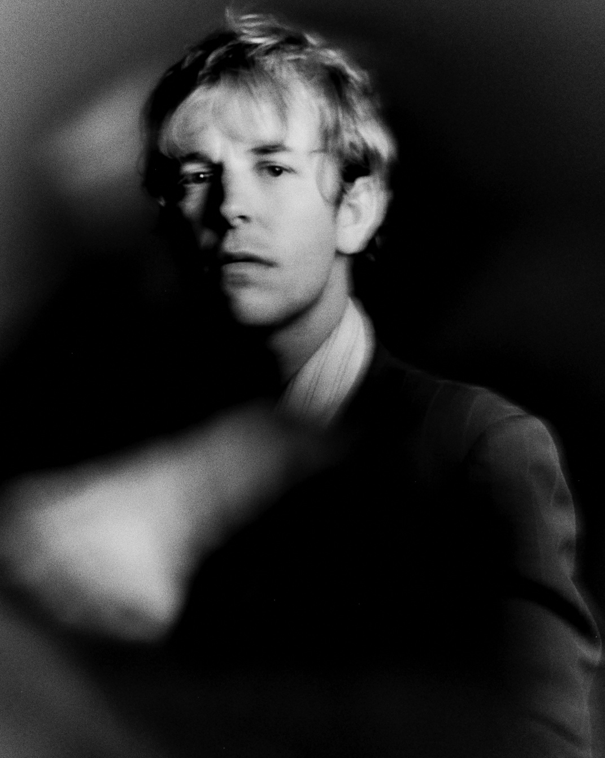
Credit: Darren Gwynn

Tom Odell is pleased to announce details of his new album, A Wonderful Life.

The new record is released on the 5th September 2025 via UROK/Virgin. It was recorded in London and features 10 tracks including the recent introductory track and album opener, ‘Don’t Let Me Go’.

Pre-order/pre-save the album here

On this his seventh studio album, Tom Odell has created a record that embodies a universal spirit of empathetic, total honesty; one that looks out at the broken landscape of modern, fractured society and finds dystopia and doom, but also - integrally - glimmers of beauty and hope.

To coincide with the album’s announcement, Tom shares a new single, ‘Don’t Cry, Put Your Head On My Shoulder’. A cinematic lullaby, the guitar-led track soon arrows skyward evoking all the anthemic qualities to suggest that Tom and his audience will be bathed in the glare of phone torches and lighter flames when it becomes a certain staple of his live set.

The song itself tells the story of a friend mired in strife and the difficulties of learning how best to help them. It’s another telling example of Tom Odell’s songwriting prowess, and a very welcome return for this ever-popular British singer-songwriter. Listen HERE

The songs on A Wonderful Life, seek understanding within a human existence that is, at its core, messy and convoluted and never just one thing. “I wish I could wrap it up into a nice little bow of what the mood and the message is, but these songs are the antithesis of that,” he says. “To live, and to write honestly about it, is such a profoundly important part of my life now. And I feel like if I have any duty whatsoever, it’s just to continue to do that.”

Tom has recently been out across Europe’s arenas in support of Billie Eilish, and will returns to many of the same venues to headline them later this year as part of a huge 27-date arena run across the UK and Europe. The run includes a night at the O2 Arena in London on 29th October.

Fans can pre-order the forthcoming album from Tom’s webstore before 5pm BST Tuesday 27th May for first access to UK/European arena tickets. The ticket pre-sale window then opens at 10am BST on Wednesday 28th May, before tickets go on general sale from 10am BST on Friday 30th May.

This weekend, Tom plays Radio 1’s Big Weekend 2025 in Sefton Park, Liverpool. The Billie Eilish tour continues across Europe throughout the rest of the month. Tom’s intimate headline tour arrives in Europe and the UK this Summer including a tiny show at Battersea Arts Centre in July that sold out in seconds. Those intimate headline dates continue out to North America in September.

Tom plays the Woodsies stage at Glastonbury this year. Further touring news is to be shared imminently.

Meanwhile over on TikTok, Tom’s 2012 breakthrough hit ‘Another Love’ has spent the last two years going quietly stratospheric, entering the top 50 on the Billboard TikTok chart, and soundtracking millions of TikTok videos, most commonly in support of Ukraine as a sign of hope, and by Iranian women to soundtrack protest videos in response to the death of Mahsa Amini whilst in the custody of the ‘morality police’. The song, originally written by a young Tom making his very first moves in this enduring musical career, has since accumulated over 3 billion streams on Spotify, becoming one of the top 25 most streamed songs of all time on the platform.

But these big streaming numbers and the accumulation of industry awards (BRITs and Ivor Novellos) only paint part of the story of this talented musician who manages to shoot his music directly to hearts right across the globe that instantly relate to millions. It’s one reason why artists both young (The Last Dinner Party, Billie Eilish, AURORA) and old (Cat Stevens, Elton John) have expressed their love and support for what he does.

A Wonderful Life feels like an important body of work by a musician right at the top of his game, and quietly becoming more popular by the day.

Album Tracklisting:

Don’t Let Me Go
Don’t Cry, Put Your Head On My Shoulder
Prayer
Can We Just Go Home Now
Why Do I Always Want The Things That I Can’t Have
Wonderful Life
Ugly
Strange House
Can Old Lovers Ever Just Be Friends?
The End Of Suffering

Intimate Headline Tour (+ Billie Eilish Arena Supports):
24th May – Radio One’s Big Weekend 2025, Sefton Park, Liverpool
29th May – Lanxess Arena, Cologne (w/ Billie Eilish)
30th May – Lanxess Arena, Cologne (w/ Billie Eilish)
1st June – O2 Arena, Prague (w/ Billie Eilish)
3rd June – Tauron Arena, Krakow (w/ Billie Eilish)
4th June – Tauron Arena, Krakow (w/ Billie Eilish)
6th June – Wiener Stadthalle – Halle D, Vienna (w/ Billie Eilish)
8th June – Unipol Arena, Bologna (w/ Billie Eilish)
11th June – Sala Apolo, Barcelona – SOLD OUT
14th June – Palau Sant Jordi, Barcelona (w/ Billie Eilish)
15th June - Palau Sant Jordi, Barcelona (w/ Billie Eilish)
18th June – Heimathafen Neukölln, Berlin – SOLD OUT
27th – 29th June – Glastonbury Festival (Woodsies)
3rd July – Bouffes du Nord, Paris – SOLD OUT
8th July – Battersea Arts Centre, London – SOLD OUT
15th July – De Wester, Amsterdam – SOLD OUT
18th September – The Vic Theatre, Chicago, IL
20th September – Lincoln Theatre, Washington, DC
21st September – Theatre of Living Arts, Philadelphia, PA
22nd September – Webster Hall, New York, NY
25th September – Paradise Rock Club, Boston, MA
27th September – St. Andrew’s Hall, Detroit, MI
29th September, MTELUS, Montreal, QC
30th September – Massey Hall, Toronto, ON

UK + European Arena Headline Tour:
21st October – Cardiff Utilita Arena, Cardiff
23rd October – 3Arena, Dublin
24th October – The SSE Arena, Belfast
26th October – OVO Hydro, Glasgow
28th October – Co-Op Live, Manchester
29th October – O2 Arena, London
31st October – Accor Arena, Paris
1st November – Lanxess Arena, Cologne
3rd November – Ziggo Dome, Amsterdam
7th November – Unity Arena, Oslo
8th November – Avicii Arena, Stockholm
10th November – Royal Arena, Copenhagen
11th November – Barclays Arena, Hamburg
13th November – QUARTERBACK Immobilien ARENA, Leipzig
14th November – Olympiahalle, Munich
16th November – Budapest Arena, Budapest
17th November – TAURON Arena, Krakow
19th November – Sportovni Hala Fortuna, Prague-Bubeneč
20th November – Uber Arena, Berlin
22nd November – SAP Arena, Mannheim
23rd November – Stadthalle, Vienna
26th November – Hallenstadion, Zurich
27th November – Unipol Forum, Milan
30th November – Sant Jordi Club, Barcelona
1st December – Movistar Arena, Madrid
3rd December – Rockhal, Esch-sur-Alzette
4th December – Sportpaleis, Antwerp

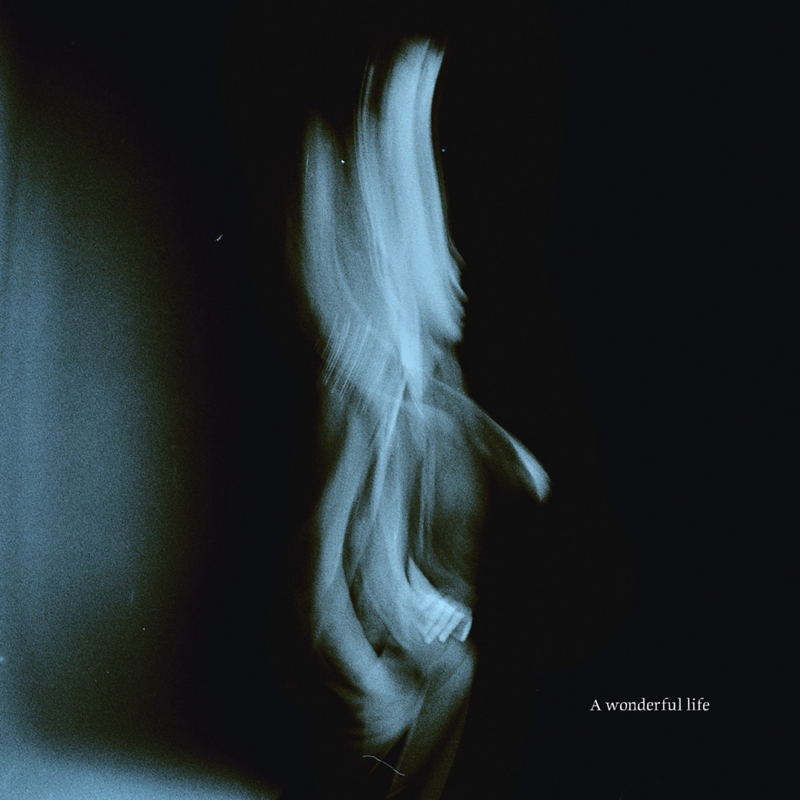
A Wonderful Life album artwork

About A Wonderful Life:

Tom Odell has been stripping back the layers, creating a prolific and increasingly vulnerable canon of work that speaks to the frailties of the human condition and the fragility of the world around us. Particularly since the pandemic and 2021’s Monsters, Odell’s songwriting has put rawness and honesty to the fore, with a whole new generation of fans finding vital solace in his music in response. Seventh album ‘Black Friday’’s haunting title track has earned nearly 700 million combined streams since its late-2023 release, while a resurgence of excitement around his first ever single - 2012’s ‘Another Love’ - has seen it soar to over three billion plays on Spotify alone.

As Odell has become braver as a writer, pushing himself to uncover the most fragile and often painful parts of his psyche, so has he established himself as a true artist of note: a fact underlined by a pair of Ivor Novello nominations for Best Song Musically and Lyrically, in both 2023 and 2024. For the now-34-year-old, it’s been an illuminating journey. “The things that you feel slightly uncomfortable playing to your friends or your parents, they’re what you should put out because then it’s worth sharing,” he says. “We keep so much stuff inside, and that’s what tends to torture us the most - not the things we’re prepared to talk about - so I try to write about that as much as possible.”

Though Odell first came to prominence as a Brit Award-winning new UK pop hope, it’s never been this type of shiny, mainstream success that fuels him. “I never applied to the role of pop star and I always felt like I was being perceived in the wrong way,” he reflects. And as he’s committed further to his own vision, crafting intensely personal songs dealing with mental health struggles, body image issues and beyond, he’s seen the connections spread across the globe, through his 2.4 million TikTok followers and out into the real world environs of the live stage, where he’s been supporting Billie Eilish on her European arena tour before embarking on his own run of intimate underplays. “It alleviates some of the loneliness of existing,” he suggests of why his music has resonated so strongly, “which is what we’re all going through, together.”

Now, with his seventh studio album, Odell has created a record that embodies this spirit of empathetic, total honesty; one that looks out at the broken landscape of modern, fractured society and finds dystopia and doom, but also - integrally - glimmers of beauty and hope.

A Wonderful Life was written over nine months in 2024, on tour buses and trains, far away from the stable home life he’d created. More than any album previously, perfecting the lyrics was a true labour of love. “I laboured over every line,” he nods. “I went in on those words every day, on every plane journey, just refining and refining and refining. I can be a bit obsessive, and the obsessive part of me is probably the worst part of me and the bit that I would pay so much money for a therapist to tell me how to lose. But it’s also the bit that does not give up on songs.”

As such, the tracks on Odell’s seventh represent some of the most direct and affective moments of his career so far. Written, partly, as a real-time reaction to the harrowing news cycle and “the sense, almost every week, that the world is ending in some capacity - which it is, for some people”, it finds the musician sharpening his pen to distil this maelstrom of despair, frustration and helplessness into tracks like gently rousing lead single ‘Don’t Let Me Go’. That song opens a conversation around the “scariness” of social media that the record often returns to: “Maybe we’re sick / Sick in our bones / You smile and look down at your phone / The city is filling with smoke,” goes one notable line - inspired by a video Odell found of train commuters merrily doom scrolling as the apocalypse rages on outside. Over the tender pianos of ‘Why Do I Always Want The Things I Can’t Have’, meanwhile, he laments: “I’ve been staring at screens, my eyes are aching / Losing my faith in this world we’re making”.

“For me, that sums it up because it takes accountability for the fact that I’m [responsible] just as much as you are or the people with loads of power are,” he says of the latter line. “I hate it when it’s just blame, because when people look back on this time in 30 years we will all be responsible for the world we’re living in. But I’m still quite optimistic, and I feel like maybe if one’s gotta have anything, it’s faith in ourselves because we made it this far.”

The album’s title-track, ‘Wonderful Life’ - which builds from meditative walking pace to rousing crescendo - internalises this faith in a track that finds comfort in stillness and the smallness of everyday things, while ‘Prayer’ addresses a childhood figure that might well be himself, offering comfort and reflection. “The hug of the younger self is nice to do if you can find them,” he smiles. On that track, and largely across the whole record, the intimacy and warmth of the production heightens the feeling of Odell’s voice speaking directly to you; of a hand reaching out. Recorded in three different studios in London, Odell and his band recorded everything live with the instruments “bleeding in on one another” to retain that tangible, human touch.

The heartfelt warmth of the acoustic-led ‘Don’t Cry, Put Your Head On My Shoulder’ is a perfect example of this, as it tells the story of a friend mired in strife and the difficulties of learning how best to help them. Meanwhile, on ‘Ugly’, Odell delivers its pained sentiments with a total lack of artifice: “You don’t wanna touch me / Don’t wanna fuck me / ‘Cause I’m ugly”. “Something I’ve never really talked about is some of my own weird shame around my body, and it feels so uncomfortable to actually say that in a song. But when you say it, it’s really fucking powerful,” he says. “‘Ugly’ is an exploration of what it feels like to be a human being - of looking out at the world and feeling like everybody seems to glide through life so easily, but the experience of actually living it yourself is so fraught and it’s not pretty.”

It’s a potentially shocking song to come from an outwardly successful musician on the form of their life, releasing music to a fanbase that’s now bigger than ever. But Odell is more interested in addressing life’s complexities head-on than creating a mysterious pop star persona. On A Wonderful Life, he’s created a record that seeks understanding within a human existence that is, at its core, messy and convoluted and never just one thing. “I wish I could wrap it up into a nice little bow of what the mood and the message is, but these songs are the antithesis of that,” he says. “To live, and to write honestly about it, is such a profoundly important part of my life now. And I feel like if I have any duty whatsoever, it’s just to continue to do that.”

