Releases new single ‘Karaoke’ from Highly Anticipated Album PISCES
Listen HERE

FEBRUARY 2026 UK ARENA TOUR ANNOUNCED
Album PISCES to be Released April 25 2025

Headlines London’s Royal Albert Hall for Teenage Cancer Trust on 26th March
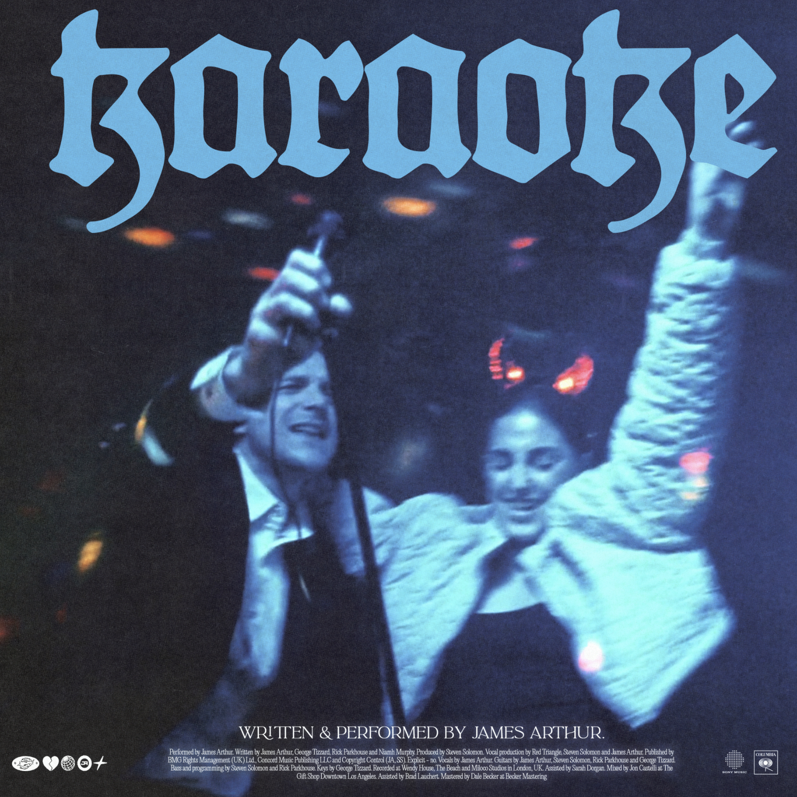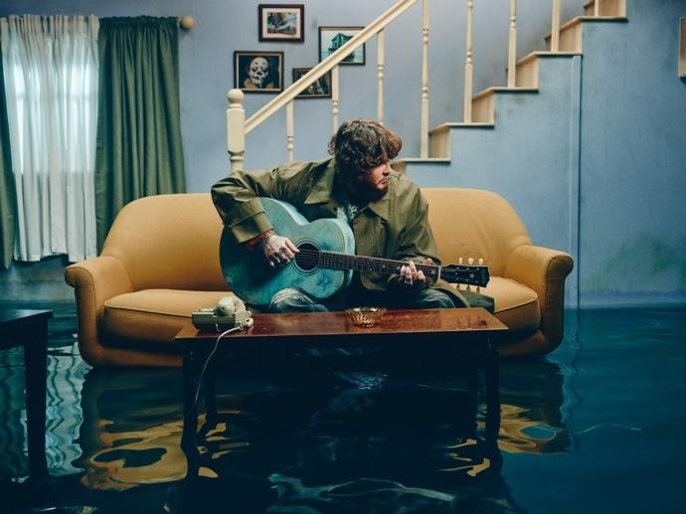
**** The Sun (Something For The Weekend)
Following the emotional depth of his recent single "Celebrate," James Arthur returns with "Karaoke," out now. The track, the latest from his highly anticipated album PISCES, offers a bold departure from the introspective vulnerability of "Celebrate." With a grunge-inspired guitar riff at its core, "Karaoke" pulses with energy as James channels raw emotion into a plea for a partner to embrace their wild side, despite the scars of a past relationship. Listen HERE.

Today also brings the news that James will embark on a UK Arena tour in February 2026. Kicking off in Nottingham on the 3rd February, it concludes in Manchester on the 21st February. Tickets go on sale Friday 21st March 2025 at 09:00 GMT from HERE.

James says, “I had the best time I’ve ever had on the Bitter Sweet Love world tour last year so I couldn’t be more thrilled to be hitting the road once again for the Pisces world tour. I hope to see some familiar faces back again and hopefully some new ones. Can’t wait to get in my feels with you all and have a big old sing song in some gargantuan rooms. See you on the road!”

"Karaoke" defies expectations, with its title almost serving as a red herring. The track’s relentless guitar line is a far cry from the carefree karaoke image, instead delving into the emotional turbulence of a relationship. James sings the chorus like a mantra: “I want you dancing on the table, want you making a scene / I want you acting like a nightmare while you look like a dream,” expressing the push-pull of love and desire amidst unresolved trauma.

This single marks another bold step in James’ artistic journey, as he continues to explore themes of vulnerability, trauma, and the complexity of human relationships. "Karaoke" is a testament to his growth as an artist, blending electrifying rock influences with his signature raw emotion and storytelling.

The release of "Karaoke" sets the stage for James Arthur’s sixth studio album PISCES on April 25, 2025. With PISCES, James Arthur dives deeper into his personal struggles, blending atmospheric production with his powerful, raspy vocals to create a collection that is as introspective as it is sonically adventurous.

For more information and to pre-order PISCES, visit:
www.betweendreamsandreality.com

The full list of live dates are:

November
17th Lisbon, Sagres Campo Pequeno
18th Madrid, Movistar Arena
20th Luxembourg, Rockhal
21st Zürich, Hallenstadion
23rd Paris, Zenith
24th Amsterdam, Ziggo Dome
26th Brussels, Forest National
29th Dusseldorf, Mitsubishi Electric Halle

December
1st Mannheim, SAP Arena
2nd Hamburg, Sporthalle
4th Stockholm, Annexet
6th Copenhagen, Royal Arena
7th Oslo, Unity Arena
9th Warsaw, COS Tower
11th Munich, Zenith
12th Vienna, Stadthalle
14th Prague, O2 Arena

January 2026
31st Belfast, SSE Arena

February 2026
1st Dublin, 3Arena
3rd Nottingham, Motorpoint Arena
4th Glasgow, OVO Hydro
6th Newcastle, Utilita Arena
7th Aberdeen P&J Live
10th Birmingham, bp pulse LIVE
11th Bournemouth, International Centre
13th Sheffield, Utilita Arena
14th Liverpool, M&S Bank Arena
16th Cardiff, Utilita Arena
18th London, The O2
21st Manchester, Co-op Live

About James Arthur:

James Arthur has cemented himself as one of the biggest names in contemporary pop and soul. He has amassed over 38 million monthly listeners on Spotify and has had 11 Platinum singles in the UK for hits like “Impossible,” “Can I Be Him,” “Naked,” “Rewrite the Stars,” and “Lasting Lover.” His recent collaboration with Kelly Clarkson on “From the Jump” further expands his reach to new audiences around the world.

James’ latest album Bitter Sweet Love recently soared to the top of the charts, earning him his second #1 album after eight years in the UK. The album’s success was celebrated with a sold-out UK and Europe arena tour, culminating in a historic performance in his hometown of Middlesbrough to an audience of 25,000 fans. His hit single ‚Say You Won’t Let Go‘ became the UK’s most streamed song of 2016 and went on to achieve over 4 billion streams worldwide and 3 billion streams on Spotify alone, which makes it the #15 most streamed track on the platform of all time.

Follow James
Facebook / Spotify / X / Instagram

For further information please contact kat@dedikatedpr.com

