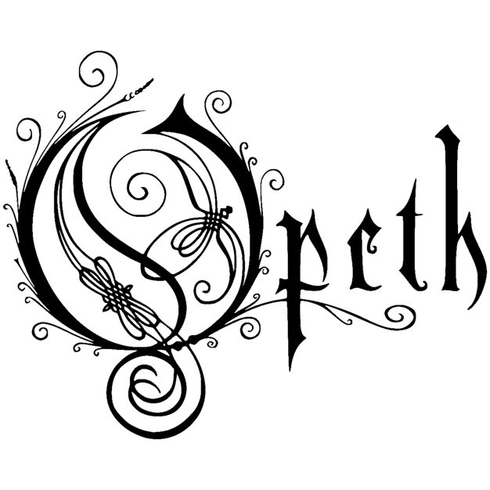

For Immediate Release,
August 2, 2024

OPETH
Announces New Album, 'The Last Will & Testament'
Shares First Single "§1"

'The Last Will & Testament' is due on October 11, 2024
via Reigning Phoenix Music

Announce EU Tour February 9 - 23, 2025
+ on tour in North America from October 11 - 31

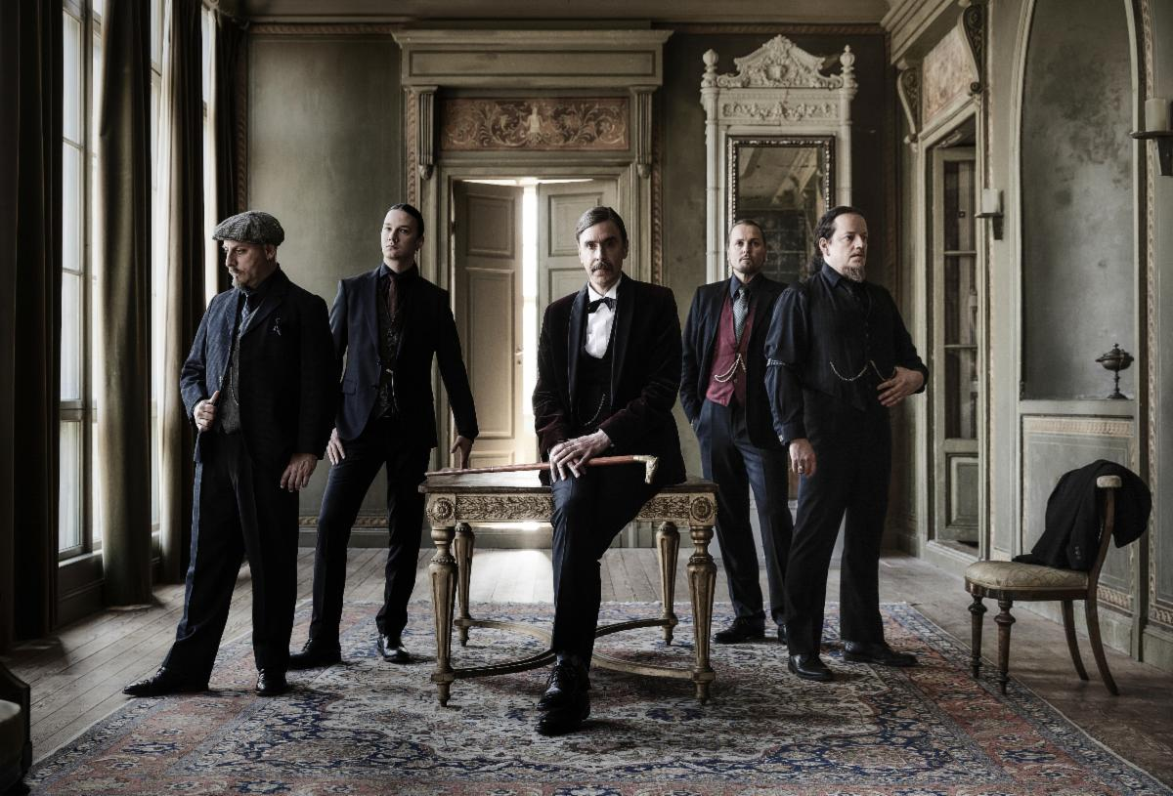

Photo by Terhi Ylimäinen

Listen "§1" HERE
Pre-Order ‘The Last Will & Testament’: HERE

Swedish prog legends OPETH are now pleased to reveal that their 14th studio album, 'The Last Will & Testament’, is set for release on October 11, 2024 via Reigning Phoenix Music! In celebration, the band is now sharing the first single from the offering, "§1" available on all DSPs Here. Prior to today's worldwide announcement, the album was teased yesterday, exclusively for attendees at Wacken Open Air 2024 in conjunction with the band's performance at the illustrious festival.

In addition to OPETH's previously announced North American headlining tour, which will take place in October 2024, the band is also now revealing an extensive European run for February 2025! OPETH is offering a special bundle for fans who pre-order 'The Last Will & Testament'. Starting today, August 2 at 10:00 A.M. CEST, fans who pre-order the album will receive a special ticket pre-sale code for advanced tickets to the European tour! The offer will end on Tuesday, August 6 at 15:00 CEST, so don't sleep on this limited opportunity!
General sales will start on Friday, August 9 at 10:00 A.M. local time.

Pre-order the album HERE to get access to the pre-sale for the EU tour
Tickets for North America are now available HERE

Opeth vocalist/guitarist Mikael Åkerfeldt admits: "I love this record. I have to say it (write it). Maybe I’m proud even? There are some familiar ingredients in there I suppose. Most of our music has sprung from the same source, so I guess it’s not much of a shocker if it’s going to sound like 'us’. I’m a bit in awe of what we did with “The Last Will and Testament”. It feels like a dream. There is some 'coherence' and 'songwriting skills' I hope, but what do I know? I tend to favour the 'strange' over the 'obvious,' but I feel like I’m in the minority, and that’s fine. So…fair warning! Don’t expect an instant rush (as per usual), but if you do “get it” (have you got it yet?) right away, that’s ok too!"

'The Last Will & Testament' is a concept album set in the post-World War I era, unfolding the story of a wealthy, conservative patriarch whose last will and testament reveals shocking family secrets. The narrative weaves through the patriarch's confessions, the reactions of his twin children, and the mysterious presence of a polio-ridden girl who the family have taken care of. The album begins with the reading of the father's will in his mansion. Among those in attendance is a young girl, who, despite being an orphan and polio-ridden, has been raised by the family. Her presence at the will reading raises suspicions and questions among the twins.

Regarding the record's creation, Åkerfeldt adds: "This is the first record with Walt on drums. Seeing and hearing him record his bits was otherworldly and what went through my head was something like: How can a human being play this stuff? The older cats (myself, Mendez, Fred and Jocke) did our bits in due time. We did them well (I like to think) and the alcohol concentration in our blood was mostly quite low as the red light was on. We’re professionals, you see! Rockfield Studios treated us well and we love that place! Stefan Boman recorded and mixed it all (CAPTURED it on TAPE… kind of…). Miles Showell did the master at Abbey Road Studios and then we (myself and Stefan) took him for a curry in Covent Garden. Travis Smith has done this odd-masterpiece-artwork that put 'clothes' on the music. All in all, we hope we’ve put together a nice little morsel of information for you to nibble on when it’s raining out. Thank you for your time. Thank you for reading. Thank you for listening. Thank you for giving us a respectable past. I’ll thank you for our future in the actual future, OK?"

Pre-Order ‘The Last Will & Testament’: HERE

Opeth's fourteenth album was written by Åkerfeldt, with lyrics conferred with Klara Rönnqvist Fors (The Heard, ex-Crucified Barbara). ‘The Last Will & Testament’ was co-produced by Åkerfeldt and Stefan Boman (Ghost, The Hellacopters), engineered by Boman, Joe Jones (Killing Joke, Robert Plant), and Opeth, with Boman, Åkerfeldt, and the rest of Opeth mixing at Atlantis and Hammerthorpe Studios in Stockholm. The strings on ‘The Last Will & Testament’ were arranged by Åkerfeldt and returning prog friend Dave Stewart (Egg, Khan) and conducted by Stewart at Angel Studios in London. Not one to miss a beat, visual artist Travis Smith returns to the fold, crafting his 11th cover, a haunting "photograph" reminiscent of Stanley Kubrick's infamous "Overlook Hotel" photograph. Miles Showell (ABBA, Queen) also revisits mastering and vinyl lacquer cutting at Abbey Road Studios in London.

Åkerfeldt rolls out the red carpet for storied flautist and Jethro Tull main man Ian Anderson. Not only do Anderson's signature notes fly on "§4" and "§7", he narrates on "§1", "§2", "§4", and "§7". Joining Anderson, Europe's Joey Tempest lends a backing vocal hand on "§2”, while Åkerfeldt's youngest daughter, Mirjam Åkerfeldt, is the disembodied voice in "§1".

‘The Last Will & Testament ‘is gripping from start to finish, jaw-dropping inside and out, representing some of Opeth's finest material to date. Just as Opeth welcomed many into its distressed arms over the years, the Swedes again deliver on the promise that great music always tells a compelling story—this time with growls.

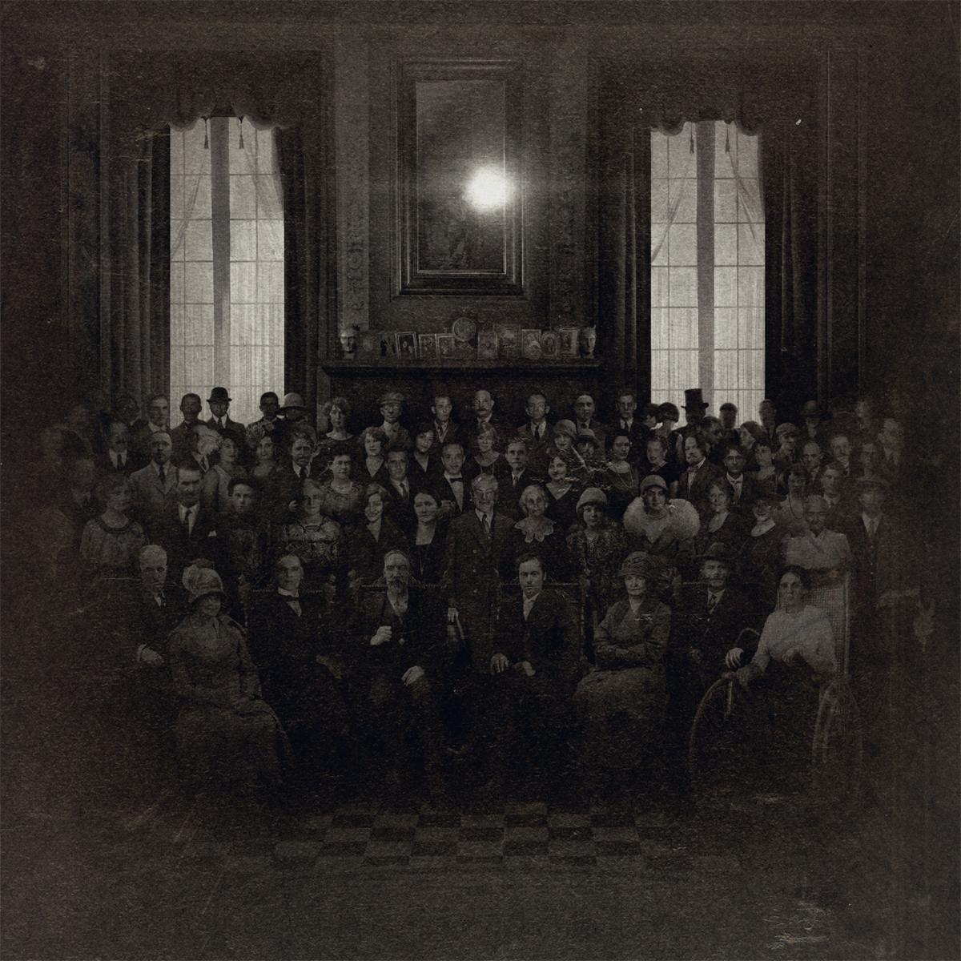

'The Last Will & Testament' Tracklist:
01 - §1 [LISTEN]
02 - §2
03 - §3
04 - §4
05 - §5
06 - §6
07 - §7
08 - A Story Never Told

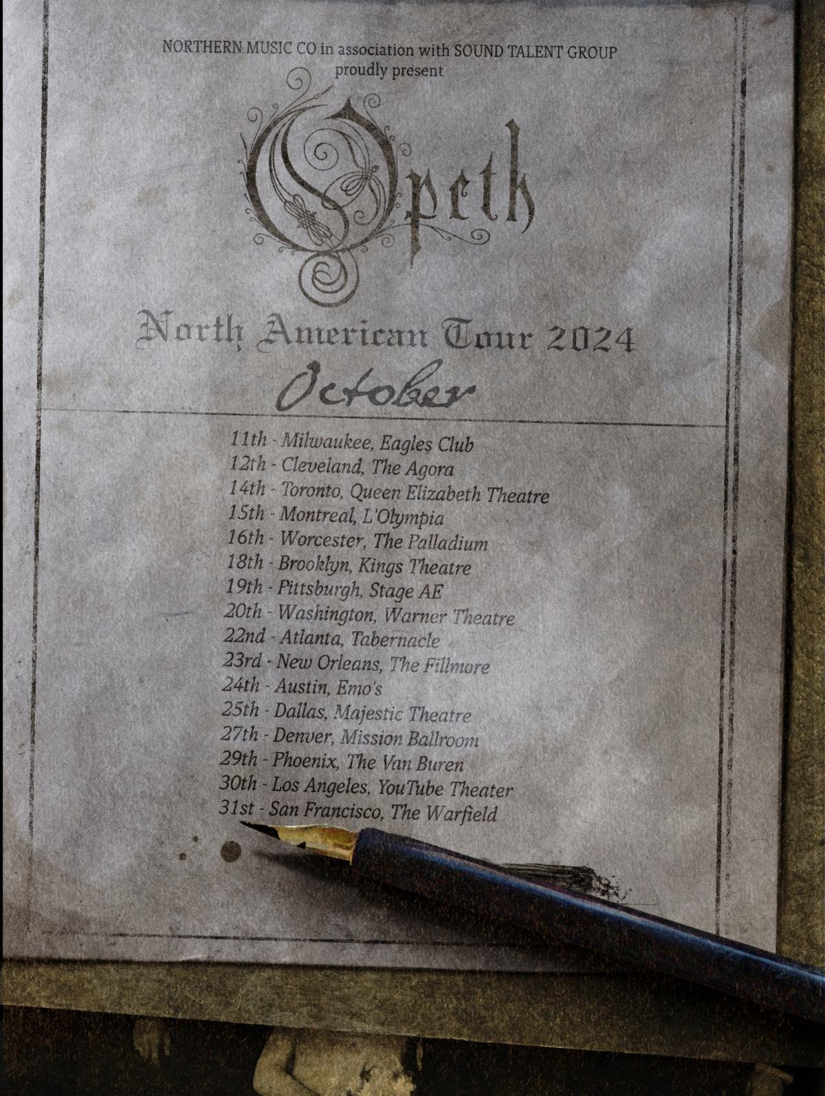

GET TICKETS HERE

OPETH North American Tour Dates (w/ TRIBULATION):
11 Oct: Milwaukee, WI @ The Rave / Eagles Club
12 Oct: Cleveland, OH @ Agora Theater & Ballroom
14 Oct: Toronto, ON @ Queen Elizabeth Theatre
15 Oct: Montréal, QC @ L’Olympia
16 Oct: Worcester, MA @ Palladium
18 Oct: Brooklyn, NY @ Kings Theatre
19 Oct: Pittsburgh, PA @ Stage AE
20 Oct: Washington, DC @ Warner Theatre
22 Oct: Atlanta, GA @ Tabernacle
23 Oct: New Orleans, LA @ Fillmore New Orleans
24 Oct: Austin, TX @ Emo’s Austin
25 Oct: Dallas, TX @ Majestic Theatre
27 Oct: Denver, CO @ Mission Ballroom
29 Oct: Phoenix, AZ @ The Van Buren
30 Oct: Los Angeles, CA @ YouTube Theater
31 Oct: San Francisco, CA @ The Warfield

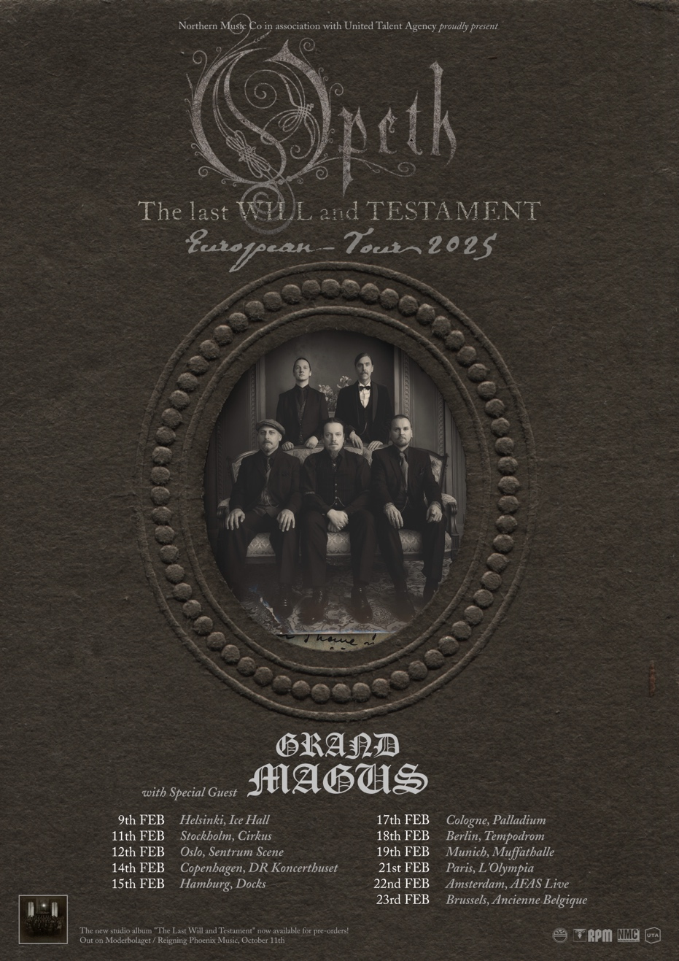

PRE-ORDER THE ALBUM HERE TO GET ACCESS TO THE TICKETS PRE-SALE

OPETH European Tour Dates 2025:
9 Feb: Helsinki (FI) @ Ice Hall
11 Feb: Stockholm (SE) @ Cirkus
12 Feb: Oslo (NO) @ Sentrum Scene
14 Feb: Copenhagen (DK) @ DR Koncerthuset
15 Feb: Hamburg (DE) @ Docks
17 Feb: Cologne (DE) @ Palladium
18 Feb: Berlin (DE) @ Tempodrom
19 Feb: Munich (DE) @ Muffathalle
21 Feb: Paris (DR) @ L'Olympia
22 Feb: Amsterdam (NL) @ AFAS Live
23 Feb: Brussels (BE) @ Ancienne Belgique

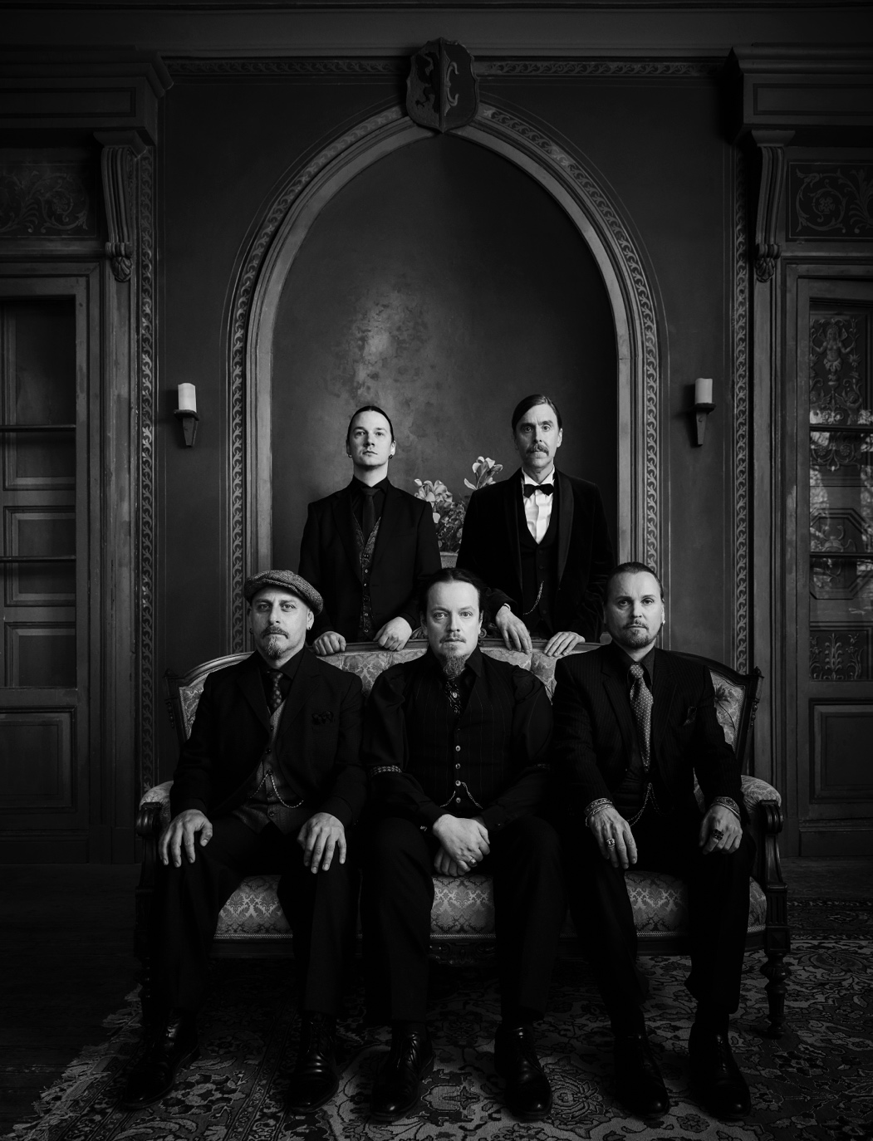
Photo by Terhi Ylimäinen

Lineup:
Mikael Åkerfeldt – Vocals, guitars
Fredrik Åkesson – Guitars, backing vocals
Martin Mendez – Bass guitar
Waltteri Väyrynen – Drums and percussion
Joakim Svalberg – Keyboards, backing vocals

Special Guests:
Ian Anderson (Jethro Tull) - spoken word (tracks 1, 2, 4, 7) // flute (tracks 4, 7)
Joey Tempest (Europe) - backing vocals (track 2)
Mirjam Åkerfeldt - spoken word (track 1)

All Music and Lyrics written by Mikael Åkerfeldt
Lyrical concept by Mikael Åkerfeldt, dramatic consultation by Klara Rönnqvist Fors

Produced by Mikael Åkerfeldt
Co-produced by Opeth and Stefan Boman
Engineered by Stefan Boman, Joe Jones and Opeth
Mixing by Stefan Boman and Mikael Åkerfeldt and Opeth at Atlantis and Hammerthorpe, Stockholm, Sweden
Mastering and vinyl lacquer cut by Miles Showell at Abbey Road studios, London, UK

Strings conducted by Dave Stewart at Angel Studios, London, UK
Strings arrangement by Mikael Åkerfeldt and Dave Stewart

Artwork by Travis Smith with directions from Mikael Åkerfeldt

About Reigning Phoenix Music
Founded in 2023, Reigning Phoenix Music is truly the 100% independently owned vision of music industry professional Gerardo Martinez and avionics and tech entrepreneur, Sven Bogner. The blueprint is to continue to help heavy metal, extreme, hard, and heavy music thrive by partnering with an array of well-established acts, new talent, and iconic artists, by offering best services and practices in the industry. But most important is to help the artists amplify their art and talent to a winning formula for success!

More on RPM:
reigningphoenixmusic.com | Facebook | Instagram | X | TikTok | YouTube

