NOTHING BUT THIEVES ANNOUNCE EXTENDED
‘DEAD CLUB CITY DELUXE’ WITH THREE NEW LIVE SONGS &
A LIVE VIDEO OF ‘OH NO :: HE SAID WHAT?’

ANNNOUNCE SECOND AND FINAL PART OF EUROPEAN TOUR WITH NEW 2025 DATES

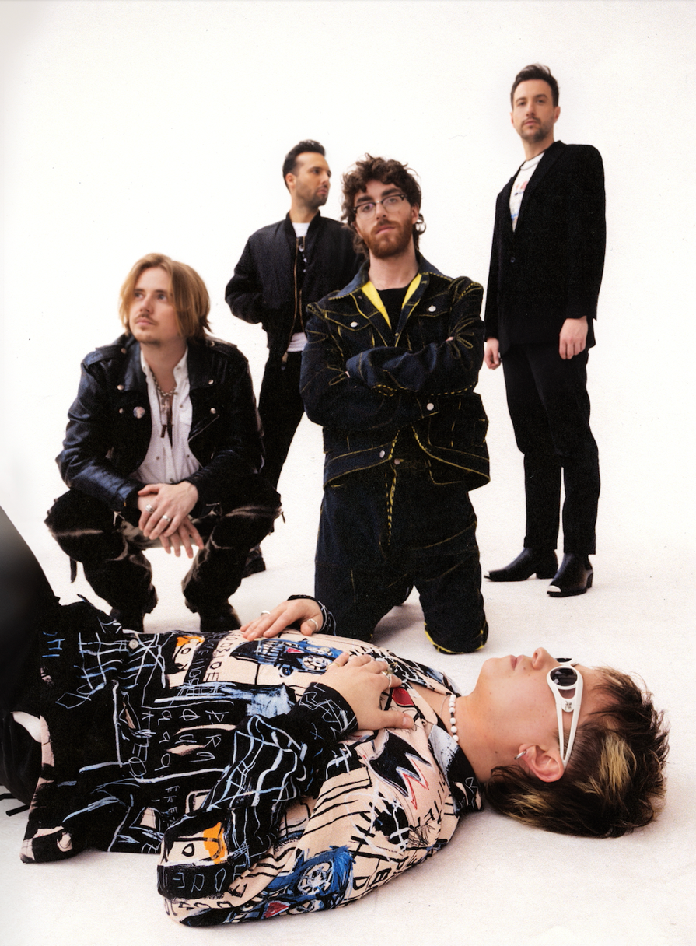

Nothing But Thieves have announced an extended version of their recent ‘Dead Club City Deluxe’ album featuring three new live tracks, which will be released on Friday 12th July via RCA/Sony.

The extended version of ‘Dead Club City Deluxe’ features three new live tracks, including ‘Oh No :: He Said What?’ recorded live at Amsterdam’s Ziggo Dome, alongside ‘Welcome to the DCC’ and ‘Tomorrow is Closed’ both live from Wembley Arena. There will also be a live video to accompany ‘Oh No :: He Said What?’.
Following sold-out headline tours across the UK, Europe and the US, alongside support dates with Green Day and packed-out festival performances, including The Other Stage at Glastonbury, they have also announced a headline European tour for early 2025. This will be the second and final leg of European dates on their epic Welcome to the DCC World tour and tickets go on pre-sale at 10am on Tuesday 9th July and general sale at 10am on Friday 12th July.

With a well-earned reputation for their energetic and impassioned performances, Nothing But Thieves ended 2023 with a sold-out headline UK and Ireland tour, including two nights at Wembley Arena and three nights at Manchester Apollo. Last year also saw them perform sold-out dates in Australia and North America. They finished touring their sold-out ‘Welcome to the DCC World Tour’ in Europe earlier this year, including two sold-out nights at Amsterdam’s Ziggo Dome selling a combined 34,000 tickets, alongside a South American tour.

This summer has already seen them performing headline outdoor shows at Leeds Millennium Square and Cardiff Castle, supporting Green Day on their stadium tour and playing to a packed-out crowd at Glastonbury festival. To close the year, they will head back to North America and Canada for a second run of tour dates in October and November, before heading back to Europe for another headline tour in early 2025. Full dates are listed below.

Nothing But Thieves enjoyed an incredible 2023; their fourth album ‘Dead Club City’ charted at #1, they performed a sell-out UK tour, including two nights at London’s Wembley Arena, Radio 1 named their single ‘Welcome to the DCC’ their Hottest Record of the Year and Radio X gave them the Best Record of the Year award for their single ‘Overcome’.

The band introduced a new era of Nothing But Thieves with ‘Dead Club City’, which was recorded and produced by Nothing But Thieves guitarist Dom Craik alongside John Gilmore (production, engineering) and Mike Crossey (mixing). The concept-style album showcased their city-sized members only club, with the tracklist and overall narrative formed by different characters and story arcs from in and around the city, with ‘Dead Club City Deluxe’ expanding and evolving the storyline. Using the club as a focal point, it is easy to imagine the real-world meaning behind ‘Dead Club City’. Themes such as advertisement, unity, internet culture, the music industry, ageing and politics, as well as escapism and change are highlighted by the alienation or privilege of a members only club.

Full tour dates are as follows:

July:
Weds 10th-Sat 13th – Madrid – Mad Cool
Thurs 11th-Sat 13th – Lisbon – NOS Alive

August:
Fri 9th – Buftea – Summer Well festival
Fri 9th-Sat 10th – Trencin – Grape festival
Sat 17th-Sun 18th – Japan – Summersonic
Fri 23rd-Sun 25th – Jakarta – LaLaLa festival

September:
Sat 7th – Munich – Superbloom festival

October:
Fri 4th – Orlando – House of Blues
Sat 5th – Atlanta – Coca-Cola Roxy
Sun 6th – Nashville – Marathon Music Works
Tues 8th – Washington – The Anthem
Thurs 10th – Boston – House of Blues
Fri 11th – Philadelphia – The Met
Sat 12th – New York – The Rooftop at Pier 17
Mon 14th – Montreal – MTELUS
Tues 15th – Toronto – HISTORY
Thurs 17th – Indianapolis – Egyptian Room at Old National Centre
Fri 18th – Chicago – Byline Bank Aragon Ballroom
Sat 19th – St. Louis – The Pageant
Mon 21st – Denver – Fillmore Auditorium
Tues 22nd – Salt Lake City – The Union Event Center
Thurs 24th – Vancouver – The Commodore Ballroom
Sat 26th – Seattle – The Paramount Theatre
Sun 27th – Portland – Roseland Theater
Tues 29th – San Francisco – The Masonic
Weds 30th – Los Angeles – Hollywood Palladium

November:
Sat 2nd – Austin – ACL Live at The Moody Theater
Sun 3rd – Dallas – The Factory in Deep Ellum

2025 European tour:

January:
Tues 28th – Dusseldorf – Mitsubishi Electric Halle
Wed 29th – Bremen – Pier 2
Fri 31st – Stockholm – Annexet

February:
Sat 1st – Oslo – Sentrum Scene
Mon 3rd – Copenhagen – KB Hallen
Wed 5th – Helsinki – Ice Hall
Thurs 6th – Tallinn – Unibet Arena Blackbox
Sat 8th – Vilnius – Compensa Concert Hall
Mon 10th – Warsaw – COS Torwar
Wed 12th – Frankfurt – Jahrhunderthalle
Thurs 13th – Esch-sur-Alzette – Rockhal
Sat 15th – Rome – Palazzo dello Sport
Sun 16th – Padova – Gran Teatro Geox

Nothing But Thieves are Conor Mason (vocals, guitars), Joe Langridge-Brown (guitars), Dominic Craik (guitars, keyboard), Philip Blake (bass guitar) and James Price (drums).

About Nothing But Thieves:
The past few years have been quite a ride for Southend five-piece Nothing But Thieves. Amassing over 1.2 million worldwide album sales, 2 billion worldwide streams and 250 million video views, they have built up a loyal and wide following for their impactful alt rock sound and achieved global success with multiple gold and platinum records around the world, including Australia, Russia, Netherlands, South Korea and Poland. Their first two albums ‘Nothing But Thieves’ and ‘Broken Machine’ are both now gold in the UK.

In 2020, they released their third album ‘Moral Panic’, which charted at #3 achieving over 320 million streams and saw support from the likes of BBC Radio 1, Virgin Radio and Radio X alongside winning Best Indie Act at Global Radio’s 2021 Awards. The album is now certified Silver and they followed this later that year with ‘Moral Panic II’, with both projects forming ‘Moral Panic (The Complete Edition)’ in 2021. ‘Moral Panic’ followed their 2018 EP ‘What Did You Think When You Made Me This Way’, their 2017 acclaimed album ‘Broken Machine’, which charted at #2 in the UK album chart, and their debut self-titled album ‘Nothing But Thieves’.

Website | Instagram | Youtube

For further information please contact beth@bandwagonpress.com.

