MADONNA
The Celebration Tour 2023 & 2024

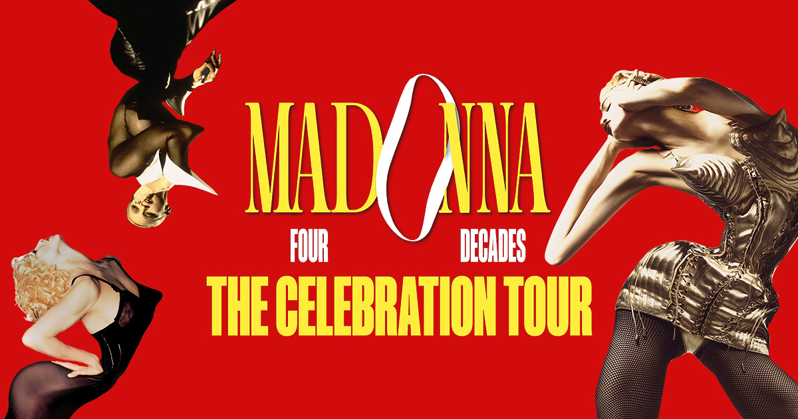

Tuesday, August 15th, 2023.

Excitement has been mounting with Madonna’s post that the North America rescheduled dates would be announced shortly. Today, Live Nation is pleased to confirm that most of the North America dates of Madonna’s Celebration Tour have been rescheduled and will take place immediately following the originally announced UK and Europe dates. Updated itinerary below. Tickets for the previously scheduled shows will be honored on the new dates. This includes all dates except Los Angeles and one date in New York due to a venue change, detailed below. Getting all shows rescheduled was the number one priority. Unfortunately, due to scheduling conflicts a few shows noted below will be canceled. Madonna regrets the inconvenience to fans and hopes to make it up to those markets in the future.

The Celebration Tour will officially kick off with four sold out shows in London this October, followed by shows across Belgium, Denmark, Sweden, Spain, Portugal, France, Germany, Italy, and the Netherlands throughout the remainder of 2023. The North American leg will begin on December 13th in Brooklyn at Barclays Center.

In New York, fans holding tickets to the previously scheduled Madison Square Garden concert on August 27th, 2023, will have an exclusive opportunity to purchase tickets to the newly added Barclays Center performance on Saturday, December 16th, 2023. Tickets for the original show at MSG will be automatically refunded to the original purchaser by Monday, August 28th. Ticketmaster will then provide all affected fans with a dedicated link and a unique code based on the quality of their previous seat locations to purchase tickets to the new date at Barclays Centre. Advance sales start Tuesday, August 29th and run through Thursday, August 31st. If tickets remain, they will go on sale to the public starting Friday, September 1st at 10am ET.

In Los Angeles, fans holding tickets to the shows previously scheduled at Crypto.com Arena (9/27/23, 9/28/23, 9/30/23 & 10/01/23) and Kia Forum (1/7/24 & 1/8/24) will also have an opportunity to purchase tickets to the new Kia Forum dates prior to the public. Tickets for the original shows in Los Angeles will be automatically refunded to the original purchaser by August 28th. Ticketmaster will provide all affected fans with a dedicated link and a unique code based on the quality of their previous seat locations to purchase tickets for their specific rescheduled event. Advance tickets for all previous Los Angeles ticket holders will begin Tuesday, August 29th and run through Thursday, August 31st. Fans unable to purchase tickets to the corresponding shows will have a second presale opportunity starting Friday, September 1st through Monday, September 4th to purchase tickets to any of the five Kia Forum performances. Remaining tickets will open for public sale Tuesday, September 5th (10am PT) at Ticketmaster.com

As mentioned, due scheduling conflicts, the following shows are unfortunately canceled: July 27 in Tulsa, December 22 in Nashville, January 15 in San Francisco, January 18 in Las Vegas, and January 20 in Phoenix. Refunds for these dates will be issued at the original point of purchase.

Madonna - The Celebration Tour - UK-EUROPE
Show Date: | City/Country | Venue Name
10/14/2023 | London, UK | The O2
10/15/2023 | London, UK | The O2
10/17/2023 | London, UK | The O2
10/18/2023 | London, UK | The O2
10/21/2023 | Antwerp, BE | Sportpaleis
10/22/2023 | Antwerp, BE | Sportpaleis
10/25/2023 | Copenhagen, DK | Royal Arena
10/26/2023 | Copenhagen, DK | Royal Arena
10/28/2023 | Stockholm, SE | Tele2 Arena
11/1/2023 | Barcelona, ES | Palau Sant Jordi
11/2/2023 | Barcelona, ES | Palau Sant Jordi
11/6/2023 | Lisbon, PT | Altice Arena
11/7/2023 | Lisbon, PT | Altice Arena
11/12/2023 | Paris, FR | Accor Arena
11/13/2023 | Paris, FR | Accor Arena
11/15/2023 | Cologne, DE | Lanxess Arena
11/16/2023 | Cologne, DE | Lanxess Arena
11/19/2023 | Paris, FR | Accor Arena
11/20/2023 | Paris, FR | Accor Arena
11/23/2023 | Milan, IT | Mediolanum Forum
11/25/2023 | Milan, IT | Mediolanum Forum
11/28/2023 | Berlin, DE | Mercedes-Benz Arena
11/29/2023 | Berlin, DE | Mercedes-Benz Arena
12/1/2023 | Amsterdam, NL | Ziggo Dome
12/2/2023 | Amsterdam, NL | Ziggo Dome
12/5/2023 | London, UK | The O2
12/6/2023 | London, UK | The O2
Madonna - The Celebration Tour - 2023/2024
New Date | Venue City | Venue Name | Rescheduled From
12/13/2023 | Brooklyn | Barclays Center | Original Date (no change)
12/14/2023 | Brooklyn | Barclays Center | Original Date (no change)
12/16/2023 | Brooklyn | Barclays Center | MSG - 8/27/2023*
12/18/2023 | Washington | Capital One Arena | Original Date (no change)
12/19/2023 | Washington | Capital One Arena | 9/2/2023
1/8/2024 | Boston | TD Garden | 8/30/2023
1/9/2024 | Boston | TD Garden | 8/31/2023
1/11/2024 | Toronto | Scotiabank Arena | 8/13/2023
1/12/2024 | Toronto | Scotiabank Arena | 8/14/2023
1/15/2024 | Detroit | Little Caesars Arena | 8/5/2023
1/18/2024 | Montreal | Bell Centre | 8/19/2023
1/20/2024 | Montreal | Bell Centre | 8/20/2023
1/22/2024 | New York | Madison Square Garden Arena | 8/23/2023
1/23/2024 | New York | Madison Square Garden Arena | 8/24/2023
1/25/2024 | Philadelphia | Wells Fargo Center | 12/20/2023
1/29/2024 | New York | Madison Square Garden Arena | 8/26/2023
2/1/2024 | Chicago | United Center | 8/9/2023
2/2/2024 | Chicago | United Center | 8/10/2023
2/5/2024 | Pittsburgh | PPG Paints Arena | 8/7/2023
2/8/2024 | Cleveland | Rocket Mortgage FieldHouse | 8/2/2023
2/13/2024 | Saint Paul | Xcel Energy Center | 7/30/2023
2/17/2024 | Seattle | Climate Pledge Arena | 7/18/2023
2/18/2024 | Seattle | Climate Pledge Arena | 7/19/2023
2/21/2024 | Vancouver | Rogers Arena | 7/15/2023
2/24/2024 | Sacramento | Golden 1 Center | 1/13/2024
2/27/2024 | San Francisco | Chase Center | 10/4/2023
2/28/2024 | San Francisco | Chase Center | 10/5/2023
3/1/2024 | Las Vegas | T-Mobile Arena | 10/7/2023
3/2/2024 | Las Vegas | T-Mobile Arena | 10/8/2024
3/4/2024 | Los Angeles | Kia Forum | Crypto.com - 9/27/23*
3/5/2024 | Los Angeles | Kia Forum | Crypto.com - 9/28/23*
3/7/2024 | Los Angeles | Kia Forum | Crypto.com - 9/30/23*
3/9/2024 | Los Angeles | Kia Forum | Crypto.com - 10/01/23*
3/11/2024 | Los Angeles | Kia Forum | Kia Forum - 1/7/24 & 1/8/24*
3/13/2024 | Palm Desert | Acrisure Arena | 1/11/2024
3/16/2024 | Phoenix | Footprint Center | 7/22/2023
3/19/2024 | Denver | Ball Arena | 7/25/2023
3/24/2024 | Dallas | American Airlines Center | 9/18/2023
3/25/2024 | Dallas | American Airlines Center | 9/19/2023
3/28/2024 | Houston | Toyota Center | 9/13/2023
3/29/2024 | Houston | Toyota Center | 9/14/2023
4/1/2024 | Atlanta | State Farm Arena | 9/5/2023
4/4/2024 | Tampa | Amalie Arena | 9/7/2023
4/6/2024 | Miami | Kaseya Center | 9/9/2023
4/7/2024 | Miami | Kaseya Center | 9/10/2023
4/14/2024 | Austin | Moody Center | 9/21/2023
4/15/2024 | Austin | Moody Center | 9/22/2023
4/20/2024 | Mexico City | Palacio De Los Deportes | 1/25/2024
4/21/2024 | Mexico City | Palacio De Los Deportes | 1/27/2024
4/23/2024 | Mexico City | Palacio De Los Deportes | 1/28/2024
4/24/2024 | Mexico City | Palacio De Los Deportes | 1/30/2024
Cancelled | Tulsa | BOK Center | 7/27/2023
Cancelled | Nashville | Bridgestone Arena | 12/22/2023
Cancelled | San Francisco | Chase Center | 1/15/2024
Cancelled | Las Vegas | MGM Grand Garden Arena | 1/18/2024
Cancelled | Phoenix | Footprint Center | 1/20/2024

*Tickets for the originally scheduled performances honored at the rescheduled events. Refunds if required available at point of purchase.
To connect with Madonna:
Website // Instagram // YouTube // TikTok // Facebook // Twitter

