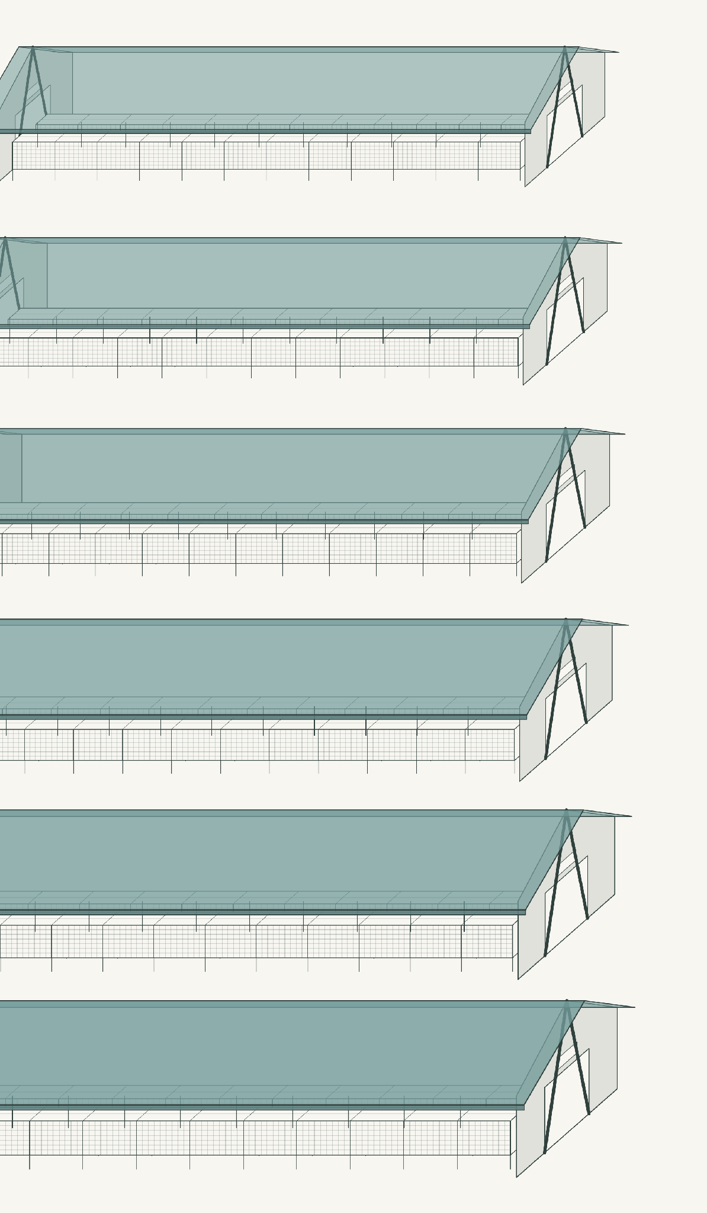



Pay to stay or pay to go?
Comparing the public cost of welfare standards versus a ban on EU fur farming
Authors:  Griffin Carpenter and  Artūrs Kaņepājs  Prepared for:  Eurogroup for Animals,  Respect for Animals,  World Animal Protection SE,  VIER PFOTEN International  Date:  2026.09.24 | Summary  The European Commission is deciding whether to end fur farming in the EU. Following the Fur Free Europe European Citizens’ Initiative, it is considering two approaches – a production ban or stricter welfare standards – each with the option of extending the measure to imported farmed fur, giving four policy options. This report estimates the EU-budget cost of each, drawing on the compensation experience of the 20 Member States that have already introduced fur-farming bans and on the costs of complying with the welfare standards under discussion.  On a one-off public-cost basis, a production ban costs less than German-level standards at all transition lengths and becomes less costly than the lower Ecorys standards after about 4.4 years. An immediate buy-out is estimated at about €591 million, compared with €920 million for 40% co-financing of German-level standards and €201 million for the Ecorys package. Both standards estimates are lower bounds because some compliance costs have not been quantified, and they exclude future enforcement and any ongoing public support required to maintain production. Over a longer horizon, the difference is likely to widen because standards require continued support for a loss-making sector, whereas a ban involves a one-off compensation cost. An EU ban would cover only the five Member States still farming – Denmark, Spain, Finland, Greece, and Hungary – together producing about 2.4 million pelts a year across around 800 farms.  Option 1: Ban on EU fur production. The cost is estimated from the 12 national bans that closed a functioning fur-farming industry. Five of these involved no monetary compensation, indicating that a sufficiently long transition can itself substitute for compensation. The estimated range therefore runs from about €591 million for an immediate ban to near-zero after eight years, with a five-year transition costing about €144 million.
Option 2: Ban on production plus ban on placing farmed fur on the EU market. Extending the ban to the market adds little to the estimated compensation bill. EU precedents for seal products and cat-and-dog fur banned the trade on public-morals grounds without compensating traders, manufacturers, or retailers. The main additional impact would instead be adjustment in the Greek manufacturing cluster around Kastoria and Siatista, pointing to a need for regional and retraining support rather than property compensation.
Option 3: Stricter welfare standards for EU fur production. Stricter standards would impose substantial compliance costs on a sector that is already loss-making, creating a potential need for public support if production is to continue. One-time 40% co-financing of the investment costed here would amount to about €201 million under the lower-cost Ecorys standards and €920 million under the German-level standards, before any ongoing support. Both estimates are lower bounds because unit costs are unavailable for some required welfare features. EFSA concludes that the main welfare consequences in current cage systems “cannot be prevented or substantially mitigated”, and even the more costly German-level standards examined here remain below the level needed to achieve that outcome.
Option 4: Stricter welfare standards for EU production and imported farmed fur. The direct compliance and subsidy costs for EU producers would be as in Option 3. Extending the requirements to imports would not create additional compensation liability for the EU budget, but would add an estimated €6 million a year in importer verification and compliance costs. As under Option 3, the standards considered here would not substantially mitigate the main welfare problems identified by EFSA.
Four findings follow:
- The public cost of a production ban is modest in comparison with the standards options, and one-off. Conditional compensation ranges from about €591 million for an immediate buy-out to near zero under a long transition, with a five-year phase-out costing about €144 million, below the €201–920 million estimated for stricter standards at 40% public co-financing. Standards, by contrast, would require continuing public support. Retraining the roughly 2,000 fur-farm workers would add an estimated €10–30 million, while support for the larger downstream workforce would require separate assessment.
- Transition length is the key determinant, and a legal one. Time is itself a form of compensation: a longer phase-out gives producers more time to recover their investment before the ban takes effect, reducing the monetary compensation required, potentially to zero. Courts in the Netherlands and Latvia have upheld phased bans on this basis.
- Stricter standards face a trilemma among welfare ambition, continued production, and public cost. Under 40% public co-financing, the estimated one-time cost is about €201 million for the Ecorys standards and €920 million for the German-level standards, both lower bounds, and both assume Finnish output recovers from its recent cull; a sensitivity holding it at current output is reported. The standards examined remain below the level EFSA identifies as necessary to substantially mitigate the main welfare problems of current cage systems. In Germany and Sweden, stricter requirements were followed by the end of the relevant fur-farming activity.
- Market measures can address leakage at relatively limited additional cost. Extending a production ban to the EU market would add little estimated compensation liability, consistent with the seal and cat-and-dog-fur precedents; extending welfare requirements to imported fur would add an estimated €6 million a year in importer verification and compliance costs.
Contents
1. Introduction and background 5
1.1 The EU fur farming sector 5
1.2 Political context 6
1.3 Research questions 7
2. Past phase-out lessons and costs 8
2.1 Fur bans in EU Member States 8
2.2 Other relevant production and trade bans 9
2.3 Analysis and lessons 10
3. Cost estimates 14
3.1 Policy option 1: a ban on EU fur production 14
3.2 Policy option 2: a ban on the production and placing on the market of farmed fur 16
3.3 Policy option 3: the adoption of stricter standards without requirements for imports 16
3.4 Policy option 4: the adoption of stricter standards with requirements for imports 27
4. Comparison of the policy options 29
4.1 Comparing the costs of the policy options 29
4.2 The standards trilemma 30
5. Discussion 32
5.1 What the costed standards can achieve 32
5.2 Dynamic viability and fiscal risk 32
5.3 Market measures and the legal basis for sales or import bans 33
5.4 Wider societal costs 33
5.5 A just transition 34
6. Conclusions 35
Sources 36
Appendix 41
A.1 Costing method for new standards 41
A.2 Cost derivation, mink 42
A.3 Cost derivation, fox 45
A.4 Cost derivation, raccoon dog 47
A.5 Cost derivation, chinchilla 49
A.6 Enclosure space across standards 51
A.7 Sensitivity tests 54
A.8 Derivation of the regression model for the cost of an EU ban 57
A.9 The Tobit robustness check 58

1. Introduction and background

1.1 The EU fur farming sector
The EU fur-farming sector has contracted sharply and is now a fraction of its former size. In 2024, it produced about 6.3 million pelts across 1,148 farms, well below its mid-2010s peak (Carpenter, 2025). Three developments account for much of the decline: Denmark culled its entire mink herd in 2020 during the COVID-19 outbreak; the Netherlands brought forward its mink ban to 2021; and subsequent national bans closed production across much of the EU.
Mink dominates the remaining sector, and its economics are weak. Mink accounted for about 5.8 million of the 6.3 million pelts produced in 2024, or roughly 92%, ahead of fox (306,000), chinchilla (141,000), and raccoon dog (29,000) (Carpenter, 2025). At 2024 prices, production was loss-making for every species except chinchilla: relative to operating break-even, the loss was about €8 per mink pelt, €40 per fox pelt, and €49 per raccoon-dog pelt, while chinchilla generated a margin of about €27 (own calculations based on Carpenter, 2025). Across the sector, this corresponds to an operating loss of roughly €58 million a year.
Production is now concentrated in a small number of Member States. Twenty-four of the 27 Member States have banned fur farming, partially banned it, or effectively ended it through welfare standards or invasive-species rules (Carpenter, 2025). Five still have active production: Denmark, Spain, Finland, and Hungary under partial bans, and Greece with no ban in place. Finland and Greece are the largest producers among them. Poland, until recently the largest EU producer at about 2.7 million mink pelts, has now banned fur farming, with a transition running to 2033. Table 1 records the legal status and key dates.

Table 1: Fur farming bans in EU Member States, key dates
Member State | Species | Adopted | Enacted | Phase-out | Compensation
Austria | All four | 2004-09-28 | 2005-01-01 | 2005-01-01 | No
Belgium (Flanders) | All four | 2019-03-22 | 2019-05-05 | 2023-12-01 | Yes
Bulgaria | Mink (invasive-species route) | 2022-05-31 | 2022-06-01 | 2025-01-01 | No
Croatia | All four | 2006-12-01 | 2007-01-01 | 2017-01-01 | No
Cyprus | n.a. | No ban; not farmed
Czechia | All four | 2017-06-07 | 2017-10-01 | 2019-01-31 | Yes
Denmark | Mink (2020 COVID cull, reversed 2023); fox 2009 | 2020-04-11 | 2020-04-11 | 2020-11-01 | Cull (out of scope)
Estonia | All four | 2021-06-02 | 2021-07-01 | 2026-01-01 | No
Finland | n.a. | No ban; still producing
France | Mink, fox, raccoon dog | 2021-11-18 | 2021-11-30 | 2021-11-30 | No
Germany | All four (welfare-standards route) | 2017-06-30 | 2017-09-01 | 2022-07-05 | No
Greece | n.a. | No ban; still producing
Hungary | Mink, fox, raccoon dog, coypu (chinchilla exempt) | 2020-11-24 | 2020-11-27 | 2020-11-27 | No
Ireland | All four | 2022-03-29 | 2022-04-04 | 2022-12-31 | Yes
Italy | All four | 2021-12-30 | 2022-01-01 | 2022-06-30 | Yes
Latvia | All four | 2022-09-22 | 2022-10-17 | 2028-01-01 | No
Lithuania | All four | 2023-09-21 | 2023-09-21 | 2027-01-01 | Yes
Luxembourg | All four | 2018-06-27 | 2018-06-29 | 2018-06-29 | n.a.
Malta | All four | 2022-06-21 | 2022-06-21 | 2022-06-21 | n.a.
Netherlands | Mink, raccoon dog (fox/chinchilla earlier) | 2012-12-18  2020-12-14 | 2013-01-15  2021-01-08 | 2021-08-01 | Yes
Poland | Mink, fox, raccoon dog, chinchilla | 2025-11-07 | 2025-12-19 | 2033-12-31 | Yes
Portugal | n.a. | No ban; not farmed
Romania | Mink, chinchilla | 2024-10-22 | 2024-11-25 | 2027-01-01 | No
Slovakia | All four | 2019-10-17 | 2021-01-01 | 2025-12-31 | No
Slovenia | All four | 2013-03-07 | 2013-04-02 | 2015-01-01 | No
Spain | Mink (ban on new farms only) | 2011-11-14 | 2016-03-16 | still producing | No
Sweden | Mink (voluntary buyout); fox/chinchilla via standards | n.a. | n.a. | 2025 | Yes (voluntary)
Note: Adopted = decisive parliamentary vote; Enacted = the ban law entering into force; Phase-out = end of the transition. ‘Comp.’ = whether monetary compensation was provided. Source: Own compilation.

1.2 Political context
In March 2022, the European Commission registered the Fur Free Europe European Citizens’ Initiative, which collected more than 1.5 million validated signatures before being submitted in June 2023 (European Commission, 2023). The initiative called for a ban on keeping and killing animals for fur and on placing farmed fur and fur products on the EU market. In its 7 December 2023 reply, the Commission committed to assess a ban against stricter welfare standards and to consider the necessity, proportionality, and economic and social impacts of each, including whether any measure should apply to imports (European Commission, 2023). It subsequently requested a scientific opinion from EFSA and conducted a Member State survey and a call for evidence.
The Commission’s assessment therefore distinguishes two approaches – a production ban or stricter standards – each with a further question of whether the measure should extend to imports. This produces four policy options: a ban on EU fur production; a ban on production and placing farmed fur on the EU market; stricter standards for EU production; and stricter standards with matching import requirements.
In July 2025, the EFSA Panel on Animal Health and Welfare (AHAW, 2025) concluded that the welfare problems of farmed mink, foxes, raccoon dogs, and chinchillas cannot be prevented or substantially mitigated in the cage systems currently in use.
Press reporting in early 2026 indicated that a draft Communication was leaning towards stricter standards rather than a ban, with legislation expected at the end of 2027 (Brzeziński, 2026). The Commission has not published its impact assessment, so the public cost of the options is not yet known; this report provides estimates based on the assumptions described below.

1.3 Research questions
This report estimates the cost to the EU budget of the four policy options under assessment, focusing on compensation or public support for fur farmers. For a production ban, compensation is estimated by transferring per-unit compensation observed in national precedents, adjusted for transition length, to the Member States that still farm fur (Section 3.1). For stricter welfare standards, public support is estimated from the capital required for compliance, using the Finnish cost basis scaled to the producing Member States (Section 3.3).
The analysis therefore focuses on public-budget costs associated with supporting producers. It does not estimate downstream manufacturing costs or wider effects on animal welfare, the environment, or public health, many of which fall outside public budgets and were examined in an earlier full-cost account of the sector (Carpenter, 2025). Nor does it estimate the value of output, exports, or trade that may cease under a ban, or the wider net economic effects of the policy options.

2. Past phase-out lessons and costs

2.1 Fur bans in EU Member States
Fur farming has ended in EU Member States through four broad mechanisms. The most common is a statutory ban with a transition period but no monetary compensation, on the basis that sufficient time allows farmers to recover their investment. A second is a ban paired with compensation, using asset-based, itemised, per-animal, or income-based schemes. A third achieves an effective end to production without a dedicated ban, through welfare or permit standards that make farming unviable. The fourth is a voluntary buy-out. This section groups the Member States by mechanism; Table 1 provides the corresponding dates and headline compensation status.
The largest group banned fur farming with a transition period and no monetary compensation. Croatia legislated in 2006 with a phase-out to 2017, Slovenia in 2013 with a phase-out to 2015, Slovakia in 2019 with a phase-out to 2025, Estonia in 2021 with a phase-out to 2026, Latvia in 2022 with a phase-out to 2028, and Romania in 2024 with a phase-out to 2027; France closed its small sector immediately in 2021. Austria’s regional bans in the mid-2000s fall into the same broad category. In these cases, the state did not offer monetary compensation. The principle that a sufficiently long transition can substitute for monetary compensation has been tested in court: Latvia’s Constitutional Court held in 2024 that its multi-year transition was constitutionally adequate (Satversmes tiesa, 2024), while the Netherlands Supreme Court reached the same view in 2016 (Hoge Raad, 2016). Compensation in the Netherlands arose only after the transition was cut short by the 2020 COVID-19 closure. The common pattern is a transition long enough – typically four to ten years – to allow farmers to run down stock and recover investment.
A second group paired bans with asset-value schemes, compensating farmers for buildings, cages, and land left stranded, usually with a demolition or clean-up grant. Belgium (Flanders) is the clearest case: its 2019 ban, with closure by the end of 2023, compensated seventeen mink farms through the regional Landcommissie on an asset-valuation basis, paying about €4.7 million, or roughly €277,000 per farm (€47 per pelt of prior output), with about €0.26 million of administration on top (Vlaams Gewest, 2019, 2020). Italy’s 2022 ban compensated five farms on a similar asset-valuation basis. The two schemes ranged from about €250,000 to €1 million per farm and from about €47 to €109 per pelt (Repubblica Italiana, 2021). Czechia’s 2017 scheme differed: rather than directly valuing assets, it capped compensation at one year’s average net profit and reimbursed undepreciated capital under a de minimis ceiling, paying nine farms about €2.8 million, or roughly €312,000 per farm (€137 per pelt) (Česká republika, 2017).
A third group itemised different components of loss. Ireland’s 2022 ban compensated its three farms for foregone income, non-income assets, demolition, and worker retraining, paying between about €3.7 million and €4.4 million in total (Ireland, 2022a, 2022b). The Netherlands ran the largest itemised scheme: after its 2013 mink ban was accelerated by the 2020 COVID-19 outbreak, the state provided an income-based settlement for about 130 farms, capped at around €130 million in programme terms, with roughly €20 million of administration, followed by a further top-up after a 2025 court ruling. Poland’s 2025 ban, the newest and by far the largest still to pay out, also uses an income basis: compensation is set as a share of historical revenue that declines over the eight-year transition to 2033 (Rzeczpospolita Polska, 2025). Lithuania’s 2023 ban pays on a per-animal basis that likewise declines through 2027 (Lietuvos Respublika, 2023).
Two Member States reached an effective end to fur farming without a dedicated ban. Germany tightened welfare and permit standards from 2017, making mink farming commercially unviable, with no compensation scheme attached (Bundesrepublik Deutschland, 2017a). Bulgaria reached the same outcome through invasive-species rules: after a 2025 Supreme Administrative Court ruling, its last mink farm closed, again without compensation. Sweden ended production through a voluntary decommissioning scheme that bought out its remaining mink farms at a fixed rate per breeding female, with the last farm closing in 2025 (Regeringskansliet, 2023).
Denmark is a distinct case. Its 2020 mass cull was an emergency animal-health measure against COVID-19, not a policy ban, and its compensation bill of about €2.0–3.9 billion reflects compensation for lost future revenue in the world’s largest mink sector rather than the cost of a phased ban. Mink farming has since resumed in Denmark, although at a much smaller scale.

2.2 Other relevant production and trade bans
An EU fur ban would not be the first EU intervention to end or restructure an entire production sector. The precedents considered here – the 2006 sugar reform, the 2015 abolition of milk quotas, the ethical trade bans of the 2000s, and the coal phase-outs now under way – span a range of approaches, from paid restructuring of production capacity to market restrictions without compensation. They also illustrate different routes for financing a transition, nationally and at EU level.
The 2006 sugar reform is the closest precedent for paying producers to leave a market. Following a WTO ruling and chronic oversupply, the EU cut the guaranteed sugar price by about a third and established a restructuring fund that paid factories to renounce quota and dismantle capacity, while growers received income compensation of roughly 60% of estimated revenue loss, folded into the single farm payment (Council Regulation (EC) No 320/2006; European Union, 2006). Between 2007 and 2015, the package cost on the order of €7.5 billion, and about half of the EU’s sugar factories closed. The precedent shows that an income-based buy-out of production capacity can be expensive, but can be implemented alongside a multi-year transition.
The abolition of milk quotas took a different approach. Rather than closing a sector or buying out capacity, the EU removed a production constraint and left output to market forces. The 2014–2016 downturn was met with temporary exceptional aid, intervention buying, and private-storage support, alongside the CAP’s continuing income-support and market-safety-net instruments (European Parliament, 2015). These measures did not fully compensate producers for price losses, but were intended to ease cash-flow pressure and cushion market adjustment (European Court of Auditors, 2021). Dairy is therefore a contrast rather than a close precedent for fur: it illustrates support for adjustment in a continuing sector, whereas a fur ban would deliberately end a production activity and potentially strand assets.
At the other end of the range are the EU’s ethical trade bans, which barred products on public-morals grounds without monetary compensation. The 2009 seal products regulation (Regulation (EC) No 1007/2009; European Union, 2009) banned the placing of seal products on the EU market. In EC-Seal Products (World Trade Organization, 2014), the WTO Appellate Body accepted the public-morals rationale for the ban but found that its application did not satisfy the non-discrimination requirements of Article XX. The 2007 cat-and-dog-fur regulation (Regulation (EC) No 1523/2007; European Union, 2007) likewise banned placing these products on the market without compensation to the trade. These are the closest EU precedents for the market-ban element of Option 2, although they do not establish the outcome of any future fur measure.
The coal phase-outs now under way provide a recent example of Union-level co-financing. Germany is retiring coal capacity through reverse auctions for hard-coal plants and negotiated settlements with lignite operators (Bundesrepublik Deutschland, 2020); Spain and Czechia have relied more on negotiated settlements paired with regional support (Instituto para la Transición Justa, 2018; Ministerstvo životního prostředí České republiky, 2021). These transitions draw on the Just Transition Fund (Regulation (EU) 2021/1056; European Union, 2021), alongside cleared state aid. For fur, the coal precedent is relevant mainly to funding architecture: it demonstrates that an EU-level phase-out can, where eligibility conditions are met, be co-financed through existing EU instruments and national support.
Taken together, these precedents illustrate the range of possible compensation and financing approaches. Ethical trade bans have not compensated downstream traders; production phase-outs have used both compensation and transition periods; and the coal experience shows that EU-level co-financing can complement national funding. Which elements would apply to an EU fur measure would depend on its legal design, compensation rules, and funding arrangements.

2.3 Analysis and lessons
The compensation models differ not only in how much they pay, but also in which losses they cover. Five components recur: foregone future income, which a sufficiently long transition can partly offset; stranded physical assets such as buildings and cages; winding-down costs such as demolition and clean-up; worker severance; and retraining.
The national schemes span a wide range. Per farm, monetary compensation ranges from zero under transition-only bans to about €1.3 million; per pelt of prior output, it ranges from zero to about €137. The available evidence indicates that transition length is an important determinant of compensation: as the phase-out lengthens, farmers have more time to operate and recover investment, reducing the amount of loss remaining when the ban takes effect. At a sufficiently long transition, monetary compensation can converge towards zero. Three independent pieces of evidence provide a cross-check on this relationship.
Twelve of the Member State bans listed in Table 1 applied to a functioning fur-farming industry and form the evidence base for the analysis. The cost of an EU ban is estimated using a pooled empirical regression. Cost per farm is modelled as a function of transition length and farm size, measured as pelts per farm. The model has two parts: the first estimates the probability that a ban includes monetary compensation as a function of transition length; the second estimates compensation per farm when compensation is paid, using transition length and farm size. The expected cost is the product of these two components. The derivation is set out in Appendix A.8.
Table 2: National fur-ban compensation – estimated total, per farm, per pelt, and transition length.
Member State | Compensation (€ million) | Per farm (€) | Per pelt (€) | Transition (years)
Netherlands | 161.2 | 1,240,000 | 40.3 | 0.6
Ireland | 4.0 | 1,344,000 | 67.2 | 0.8
Italy | 4.9 | 981,000 | 109 | 0.5
Czechia | 2.8 | 312,000 | 137 | 1.7
Belgium | 4.7 | 277,000 | 47.1 | 4.7
Lithuania | 6.9 | 84,000 | 11.8 | 3.3
Poland | 25.2 | 119,000 | 11.9 | 8.2
Croatia | 0 | 0 | 0 | 10.1
Slovakia | 0 | 0 | 0 | 6.2
Latvia | 0 | 0 | 0 | 5.3
Estonia | 0 | 0 | 0 | 4.6
Romania | 0 | 0 | 0 | 2.2
Note: Cost in Lithuania and Poland estimated against the adopted laws.
Table 3: What each paying scheme covers
Member State | Clearance | Assets | Income | Severance | Per-head | Retrain | Capped?
Netherlands | Yes* | Yes* | Yes | Yes | – | Yes | Yes, total budget
Belgium | Yes | Yes | Yes | – | – | Yes* | Yes, total budget
Ireland | Yes | Yes | Yes | Yes* | – | Yes* | No
Italy | Yes | Yes | – | – | – | Yes | Yes
Czechia | Yes | Yes | – | – | – | – | Yes, 1 year net profit
Lithuania | Yes | – | – | Yes | Yes | – | No
Poland | – | – | Yes | Yes | – | – | No
Note: Yes = covered and material; Yes* = covered by the scheme but immaterial or a separate line in the figure; – = not covered.
Figure 1: Two-part regression fit to Member State fur bans
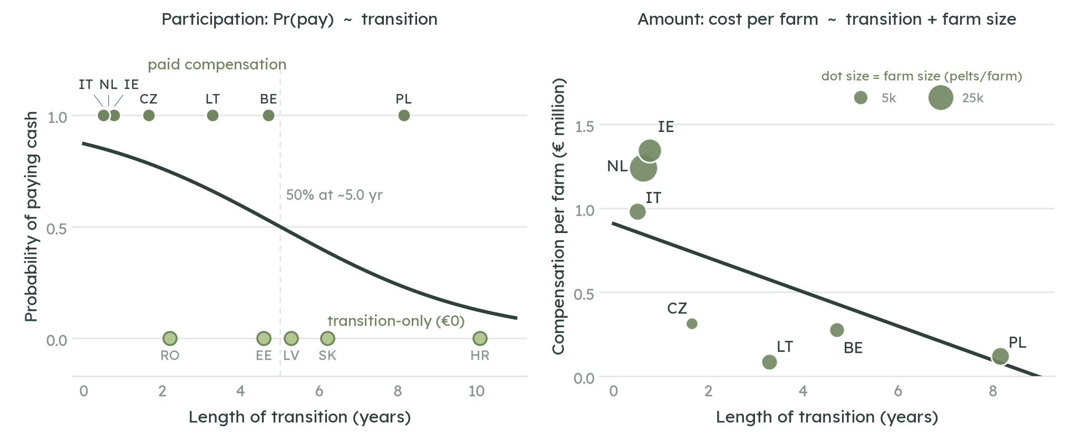
Note: Left: the participation logit, Pr(pay) = 1 / (1 + exp(−(1.92 − 0.384 × transition))), with paying schemes at the top and transition-only bans at the bottom. Right: the amount equation, cost per farm = 521,765 − 101,709 × transition + 31.8 × (pelts per farm), R² = 0.835; dot size shows average farm size. Source: Own calculations.
The regression fits the observed schemes reasonably well (R² = 0.835) and is statistically significant overall (p = 0.03). Three independent pieces of evidence provide a useful check on the estimated transition effect. The Netherlands natural experiment implies a decline of about 9% a year; Belgium’s scheme reduced the buy-out by 10% for each year a farm delayed closing; and Poland’s legislation reduces its income-based payment by 20% a year (Figure 2). These tapers bracket the regression estimate of about 11% a year. The agreement between the within-country Netherlands comparison and the cross-country regression provides some reassurance that the estimated transition effect is not driven solely by cross-country differences.
Figure 2: Three independent tapers bracket the regression’s transition slope
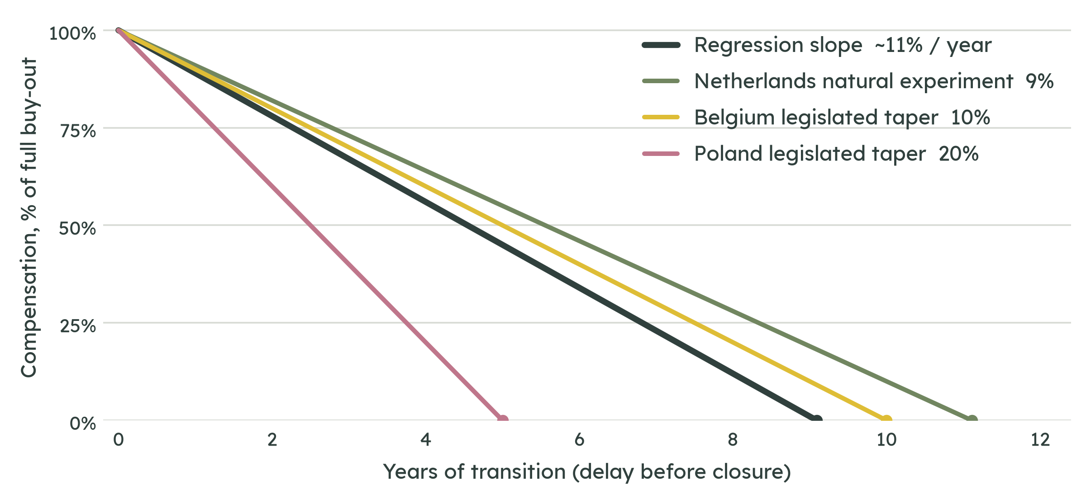
Source: Own calculations for Netherlands based on Table 2 and the two legislated schemes’ compensation rules (Belgium: Vlaams Gewest, 2020, taper from 1 April 2021; Poland: Rzeczpospolita Polska, 2025). Each line shows compensation as a percentage of the full buy-out against years of transition. The Netherlands slope is the two-point natural experiment (an accelerated one-year closure at about €40 per pelt against the original eleven-year plan at zero); Belgium and Poland are the legislated within-scheme tapers. Together, the three span the regression’s own transition slope of about 11% a year.
The legal principle behind transition-only bans has survived challenges in the Netherlands and Latvia. Courts in both cases treated the relevant phase-out as adequate compensation in itself, implying that a shorter transition may create a stronger case for monetary compensation. The main counter-risk is that a phase-out can be cut short by external events, as in the Netherlands, turning a no-compensation pathway into a substantial bill. Administration is a smaller cost on top of compensation: the two schemes that report it separately, Belgium and the Netherlands, spent about 6% and 15% of compensation, respectively. This study therefore assumes a central administration rate of 10% in Section 3.
Almost all of these schemes were funded from national budgets, typically through agriculture ministries or their paying agencies, rather than EU funds. Administration was generally absorbed into agency running costs rather than reported separately. No dedicated EU instrument has yet co-funded a fur-farming phase-out. An EU ban would therefore place the compensation question at Union level for the first time, making national precedents the closest available guide to potential cost.
Stricter welfare standards have also acted as de facto bans and driven fur production out in two cases, both without compensation. Sweden’s 1995 requirement that foxes be able to dig and move freely ended fox farming by 2001, while Germany’s welfare rules, tightened from 2017, resulted in the last mink farm closing in 2019, ahead of the 2022 permit deadline. Both changes had multi-year phase-ins, of roughly six years in Sweden and five years in Germany (Table 1).

3. Cost estimates
This section estimates the cost to the EU budget of each of the four policy options. For a ban, the estimate comprises compensation for eligible losses plus an allowance for administration. For stricter standards, it comprises the public share of the one-time investment required for compliance. Ongoing enforcement and inspection costs are not estimated. Costs borne privately by producers, and wider costs imposed by fur farming on society, are considered separately.

3.1 Policy option 1: a ban on EU fur production
The first policy option is a ban on fur production within the EU. Its scope is narrower than the whole EU industry because several Member States are already closing production under national measures. Poland, Lithuania, and the transition-only-ban states are already closing under their own laws; the Netherlands, Ireland, Italy, Belgium, and Czechia have already closed with compensation; and Germany, Sweden, and Bulgaria have effectively ended production through welfare standards, a voluntary buy-out, and invasive-species rules, respectively. An EU ban would therefore add no buy-out cost in these cases. The in-scope base is the five Member States still farming without a binding national ban covering all fur-farmed species: Denmark, Spain, Finland, Greece, and Hungary. Together, these Member States accounted for about 2.37 million pelts across 799 farms in 2024 (Carpenter, 2025).
The compensation cost is estimated by applying the regression from Section 2.3 to remaining EU production. For each in-scope country, the regression predicts cost per farm at the chosen transition length, given farm size; multiplying by the number of farms and summing gives the EU total. Because the model is estimated per farm, the result is driven mainly by farm count and is only moderately sensitive to pelt numbers. Reconciling Finland to its standard production assumption (Finland 2.1 million pelts; EU 3.8 million pelts) changes the cost estimate by about 14%. All monetary values are inflation-adjusted to 2025 using the harmonised index of consumer prices (Eurostat, n.d.), with non-euro amounts converted at InforEuro rates (European Commission, n.d.-a).
Two scenarios bound the modelled cost. At the lower end, the EU could follow the transition-only bans and provide a sufficiently long phase-out for monetary compensation to approach zero. At the higher end, it could offer a lost-income package, as Poland is doing, or an asset-value buy-out, as Belgium and Italy did, with compensation tapering as the transition lengthens. The resulting estimates, including a 10% administration allowance, are shown in Figure 3 and Table 4 for transitions from immediate closure to ten years. Under the model, compensation reaches zero at around ten years.
Figure 3: Estimated EU cost of a production ban by length of the transition period
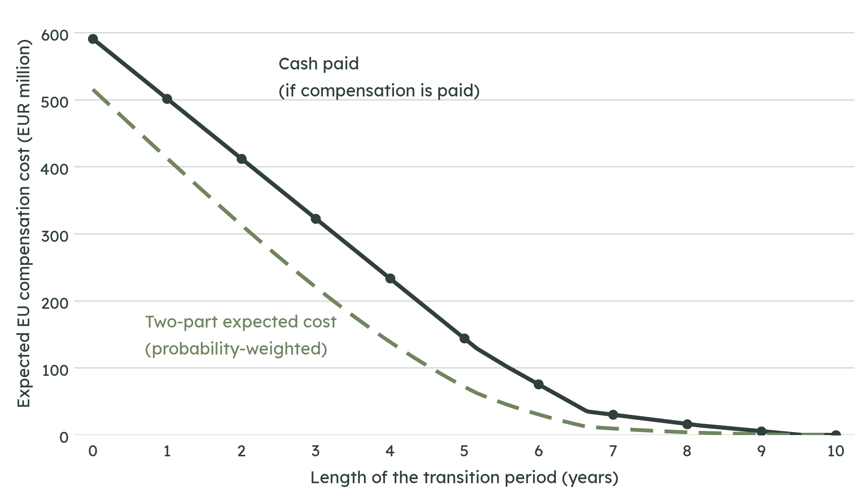
Source: Own calculations.
Table 4 decomposes the estimate into three steps. The ‘probability of paying’ column is the participation estimate from the two-part model: the estimated probability that a ban results in monetary compensation at a given transition length. Multiplying this probability by compensation conditional on payment gives the two-part expected cost. The conditional compensation figure and the probability-weighted figure answer different questions and should not be treated as interchangeable.
Table 4: Estimated EU cost of a production ban, by transition length and regression method
Transition (yrs) | Probability of paying | Compensation if paying (€ million) | Two-part expected cost (€ million)
0 | 0.87 | 591 | 515
1 | 0.82 | 502 | 413
2 | 0.76 | 412 | 313
3 | 0.68 | 323 | 221
4 | 0.59 | 233 | 139
5 | 0.50 | 144 | 72
6 | 0.41 | 76 | 31
7 | 0.32 | 30 | 10
8 | 0.24 | 16 | 4
9 | 0.18 | 6 | 1
10 | 0.13 | 0 | 0
Source: Own calculations. The compensation-if-paying column is the compensation owed; the two-part expected cost multiplies it by the probability that any is paid. A long enough phase-out reaches zero.
The estimates span from near zero to more than €500 million, reflecting the relationship between transition length and the assumed compensation design. An immediate buy-out is estimated at about €591 million on the conditional compensation basis (€515 million on the probability-weighted basis). With a five-year transition, the corresponding figures fall to about €144 million and €72 million, respectively. With a sufficiently long phase-out, the modelled compensation approaches zero.

3.2 Policy option 2: a ban on the production and placing on the market of farmed fur
The second policy option adds a market ban to the production ban, barring the placing of farmed fur on the EU market. This would extend beyond farms to downstream businesses – dressers, manufacturers, wholesalers, and retailers – that buy, process, and sell fur, whether of EU or imported origin. The compensation question is whether these businesses would have a claim on public funds comparable to that of farmers whose production assets are stranded by the ban.
The most exposed downstream cluster is in Greece, around Kastoria and Siatista in western Macedonia, where fur dressing and garment manufacture form a major local industry and support several thousand jobs, largely based on imported and re-exported skins rather than domestic pelts (Carpenter, 2025). A placing-on-the-market ban would therefore affect this cluster more directly than a production ban alone. The employment effect, concentrated in a small number of municipalities, is the principal additional social impact considered here.
Two EU-wide trade bans provide relevant precedents, although neither determines the legal treatment of a future fur measure. The 2009 seal products regulation (Regulation (EC) No 1007/2009; European Union, 2009) banned the placing of seal products on the EU market on public-morals grounds. In EC-Seal Products (World Trade Organization, 2014), the WTO Appellate Body accepted that rationale but found that its application did not satisfy the non-discrimination requirements of Article XX. The 2007 cat-and-dog-fur regulation (Regulation (EC) No 1523/2007; European Union, 2007) likewise banned placing these products on the market without compensation to the trade. These precedents indicate that a market ban need not entail a downstream buy-out, but the legal position would depend on the design of an EU fur measure.
On these precedents, extending a production ban to the placing-on-the-market ban would add little or no estimated compensation cost: farmers are already covered under Option 1, while there is no established EU precedent for compensating downstream businesses for the loss of future sales under an ethical trade ban. The main additional adjustment costs would fall on the Kastoria and Siatista cluster and on EU fur retailers. A just-transition package could address these through retraining and regional support rather than property compensation. The legal considerations are discussed further in Section 5.3.

3.3 Policy option 3: the adoption of stricter standards without requirements for imports
The third policy option would require new welfare standards for fur farming, particularly concerning housing conditions. Because the EU has not specified the standards it would adopt, this assessment uses the hypothetical EU standards developed by Ecorys in consultations supporting the Commission’s impact assessment as the main scenario. For comparison, it also considers the status quo, the standards proposed in Finland, and the standards already applied in Germany.
Two assumptions underpin the cost scenarios. First, cage-conversion costs are determined by the total horizontal space required to produce a pelt, following the cost assessment prepared for the Finnish government (Luke, 2025). The alternative standards also specify requirements such as additional enrichment and, under the German standard, access to open water. Where possible, the cost of these additional elements is estimated for mink in Table A2b. The estimates exclude inspection and administration costs, which already arise under existing standards and are assumed to change little under the new requirements. The resulting estimates should therefore be treated as lower bounds.
Second, the main scenario assumes that pelt production remains at 2024 levels in all in-scope countries except Finland, where production expands consistently with Luke (2025) calculations as production recovers from the country-specific cull associated with avian influenza. Sensitivity tests consider different assumptions about production levels and capacity expansion in Appendix A.7.1, and capacity utilisation for mink pelt production in Appendix A.7.2. Spare capacity is estimated from peak pelt production and the number of farms remaining, with the approach corroborated by other evidence (Appendix A.1).
The capital investment required to convert cages is annualised over 15 years at a 3% discount rate and added to annual production costs. The central calculation assumes full capacity utilisation, so that empty cage capacity does not increase the cost per pelt during the depreciation period. This is deliberately favourable to the standards scenarios, given the historical volatility of production. Sensitivity to capacity utilisation and capital-cost assumptions is examined in Appendix A.7.

3.3.1 Mink
Potential standards and costs
The standards considered range from 2,550 cm² per two mink, with no open water under the current EU requirement, to at least 1 m² per mink with a swimming basin under the German standard (Figure 4). The German requirement is the most demanding of the standards costed here, but it remains modest in absolute spatial terms: 1 m² per mink is a small fraction of the space used by a wide-ranging, semi-aquatic carnivore in the wild. The full space and water allowances by standard are set out in Appendix A.6.
The single-level and two-level Ecorys systems provide about 2.1 and 1.7 times as much horizontal space as the status quo, respectively, in both cases without open water. The lower and upper ranges for capital costs and break-even prices indicate costs without and with new sheds, respectively. The main calculations exclude solid or partly solid floors, enrichment, and open-water access; these elements are quantified separately in Appendix A.2.
Figure 4: Mink housing standards, space per animal, space per pelt, and cost of compliance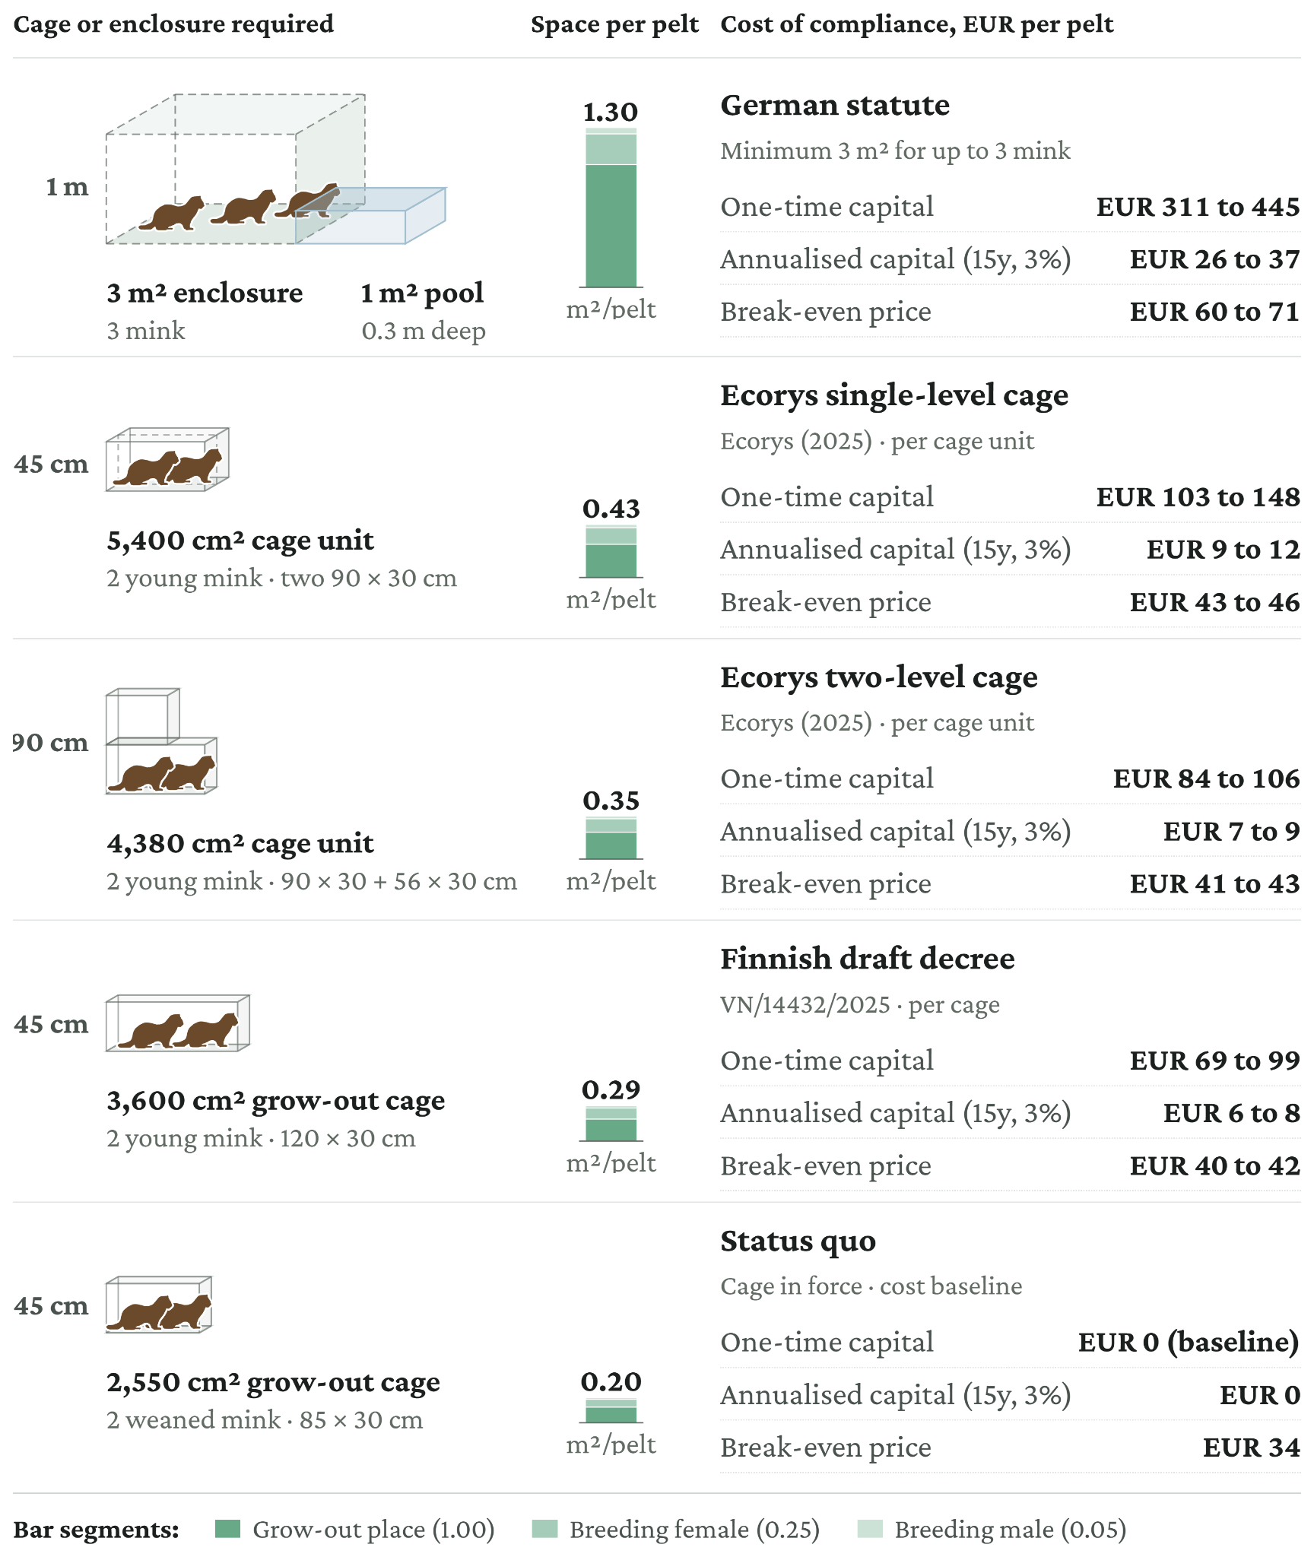
Source: Own calculations. Cage geometry from the Finnish draft decree (MMM, 2025a), the European Commission survey measures (Ecorys, 2025) and the German fur-keeping annex (Bundesrepublik Deutschland, 2017a). Costs calibrated on Luke (2025). For the two-level Ecorys cage, space per pelt is the total usable surface of both levels. The swimming basin for the German enclosure is for illustration only and is not costed here. Full derivation in Appendix A.2.
Industry viability
With a break-even price of €40.9 per pelt for cages that can be fitted within existing sheds, the Ecorys two-level setup would have resulted in a financial loss in 15 of the last 26 years, or 58% of the period. Where new sheds are required, the break-even price rises to €42.7 per pelt, with losses in 65% of years. This compares with losses in 38% of years under the status quo and at least 92% under the German standard (Figure 5).
Figure 5: Mink pelt price against the break-even price under each standard, 2001 to 2026
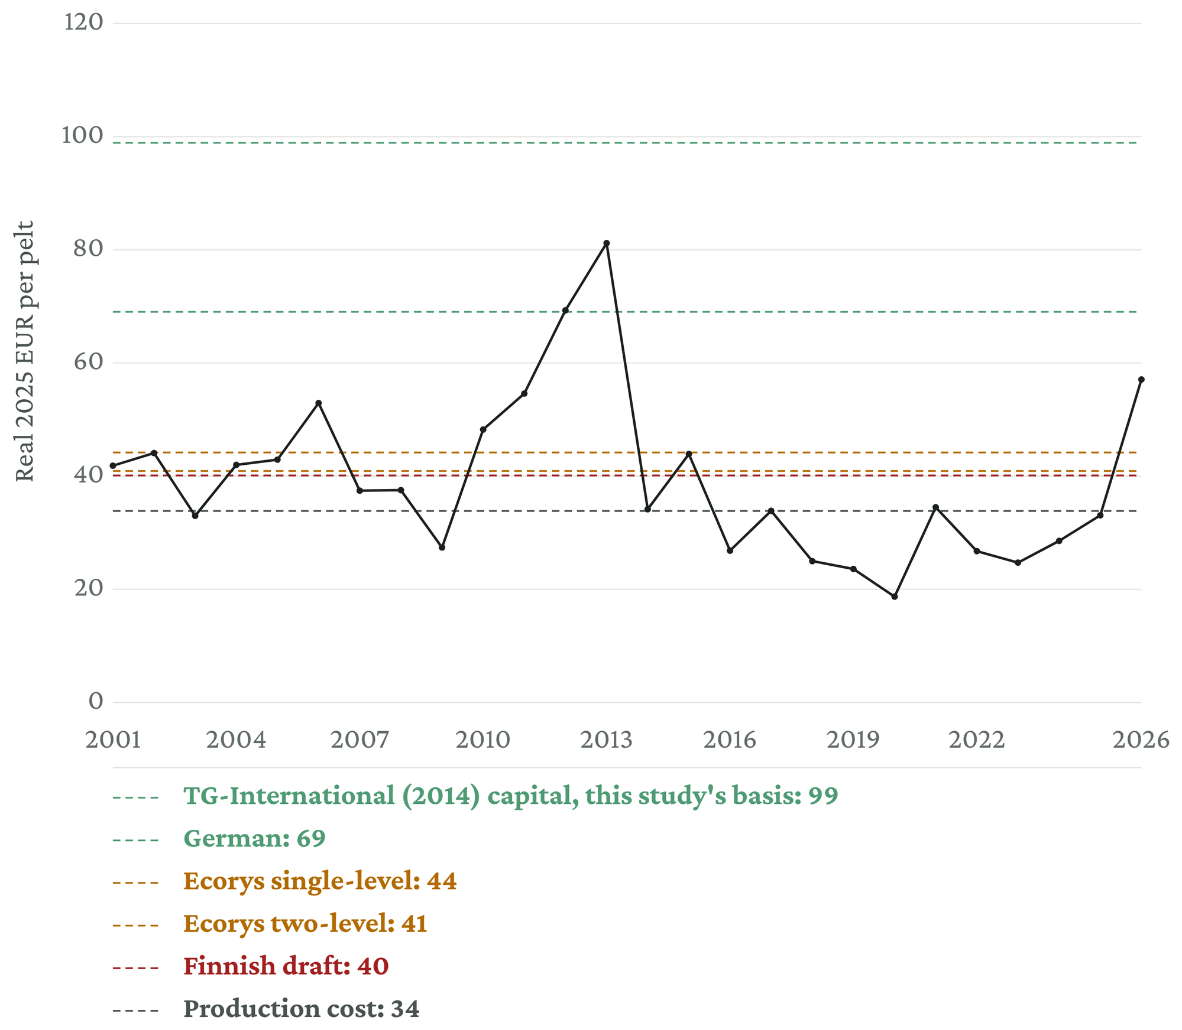
Source: Own calculations based on FIFUR (2025) for 2001–2024 and Saga Furs auction data for 2025–2026, inflation-adjusted to 2025. Break-even prices calculated for production levels in the Main scenario.

3.3.2 Fox
Potential standards and costs
Fox space requirements range from the 1.2 m² grow-out cage under the status quo, equivalent to 0.6 m² per weaned fox, to the German standard, which requires 3 m² per fox in an enclosure of at least 12 m² and therefore nearly five times as much space per pelt (Figure 6).
Figure 6: Fox housing standards, space per animal, space per pelt, and cost of compliance
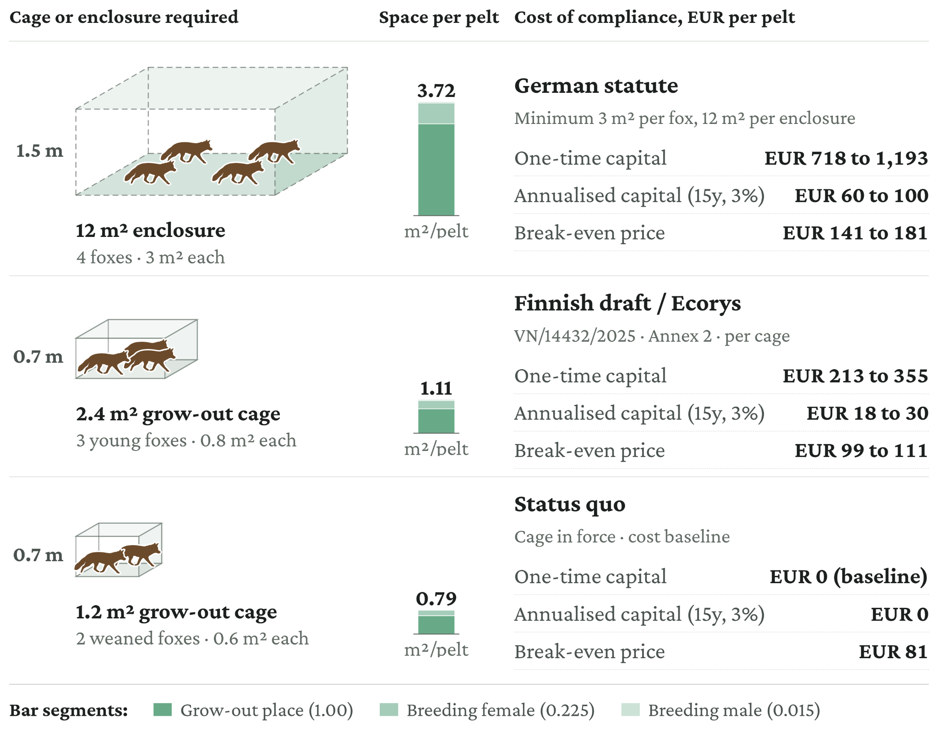
Source: Own calculations. Cage geometry from the Finnish draft decree (MMM, 2025a), the European Commission survey measures (Ecorys, 2025) and the German fur-keeping annex (Bundesrepublik Deutschland, 2017a). For the cage in force, the adult allowance is from the explanatory memorandum to the decree (MMM, 2025b) and the pair-housed juvenile allowance from EFSA (2025). Costs calibrated on Luke (2025). Derivation details in Appendix A.3.
Industry viability
With a break-even price of at least €99 per pelt, operations under the Finnish draft and Ecorys standards would have made a loss in at least 18 of the last 26 years, or 69% of the period. This compares with losses in 58% of years under the status quo and 92% under the German standard (Figure 7).
Figure 7: Fox pelt price against the break-even price under each standard, 2001 to 2026
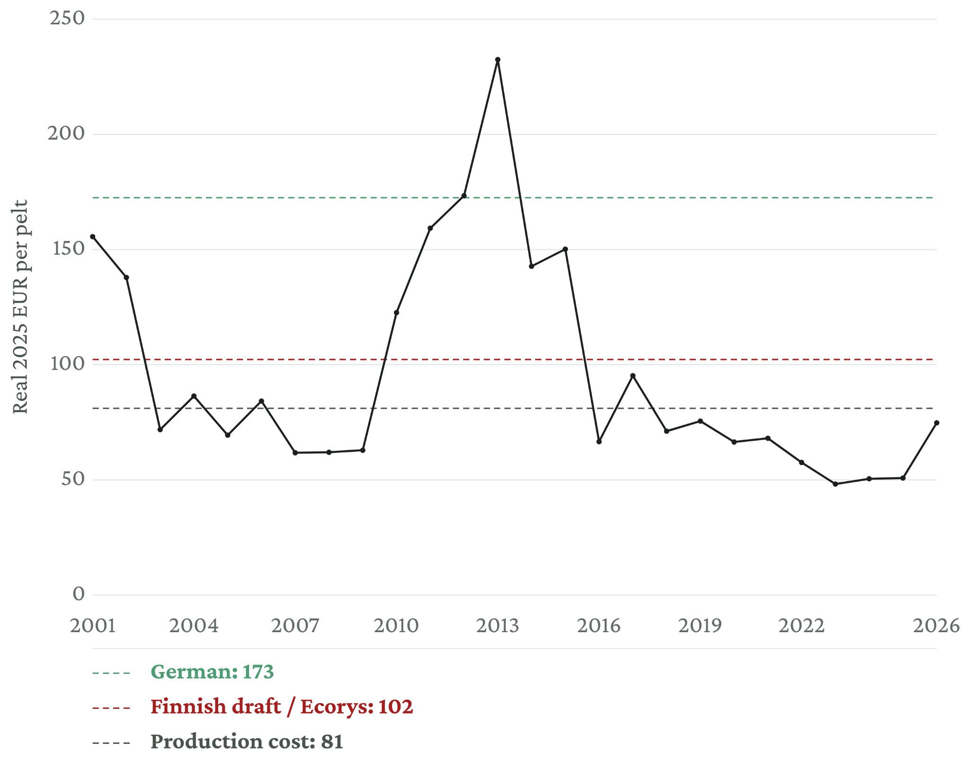
Source: Own calculations based on FIFUR (2025) for 2001–2024 and Saga Furs auction data for 2025–2026, inflation-adjusted to 2025.

3.3.3 Raccoon dog
Potential standards and costs
Under the status quo, there are no raccoon-dog-specific requirements, and fox requirements are generally observed on raccoon-dog farms in practice (MMM, 2025b). The Finnish draft decree and the survey measures both set 0.8 m² per juvenile, while the German statute applies the fox rule to raccoon dogs, requiring 3 m² per animal in an enclosure of at least 12 m² (Figure 8). Luke (2025) prices raccoon-dog enclosures at the same per-metre rates as fox enclosures.
Figure 8: Raccoon dog housing standards, space per animal, space per pelt, and cost of compliance.
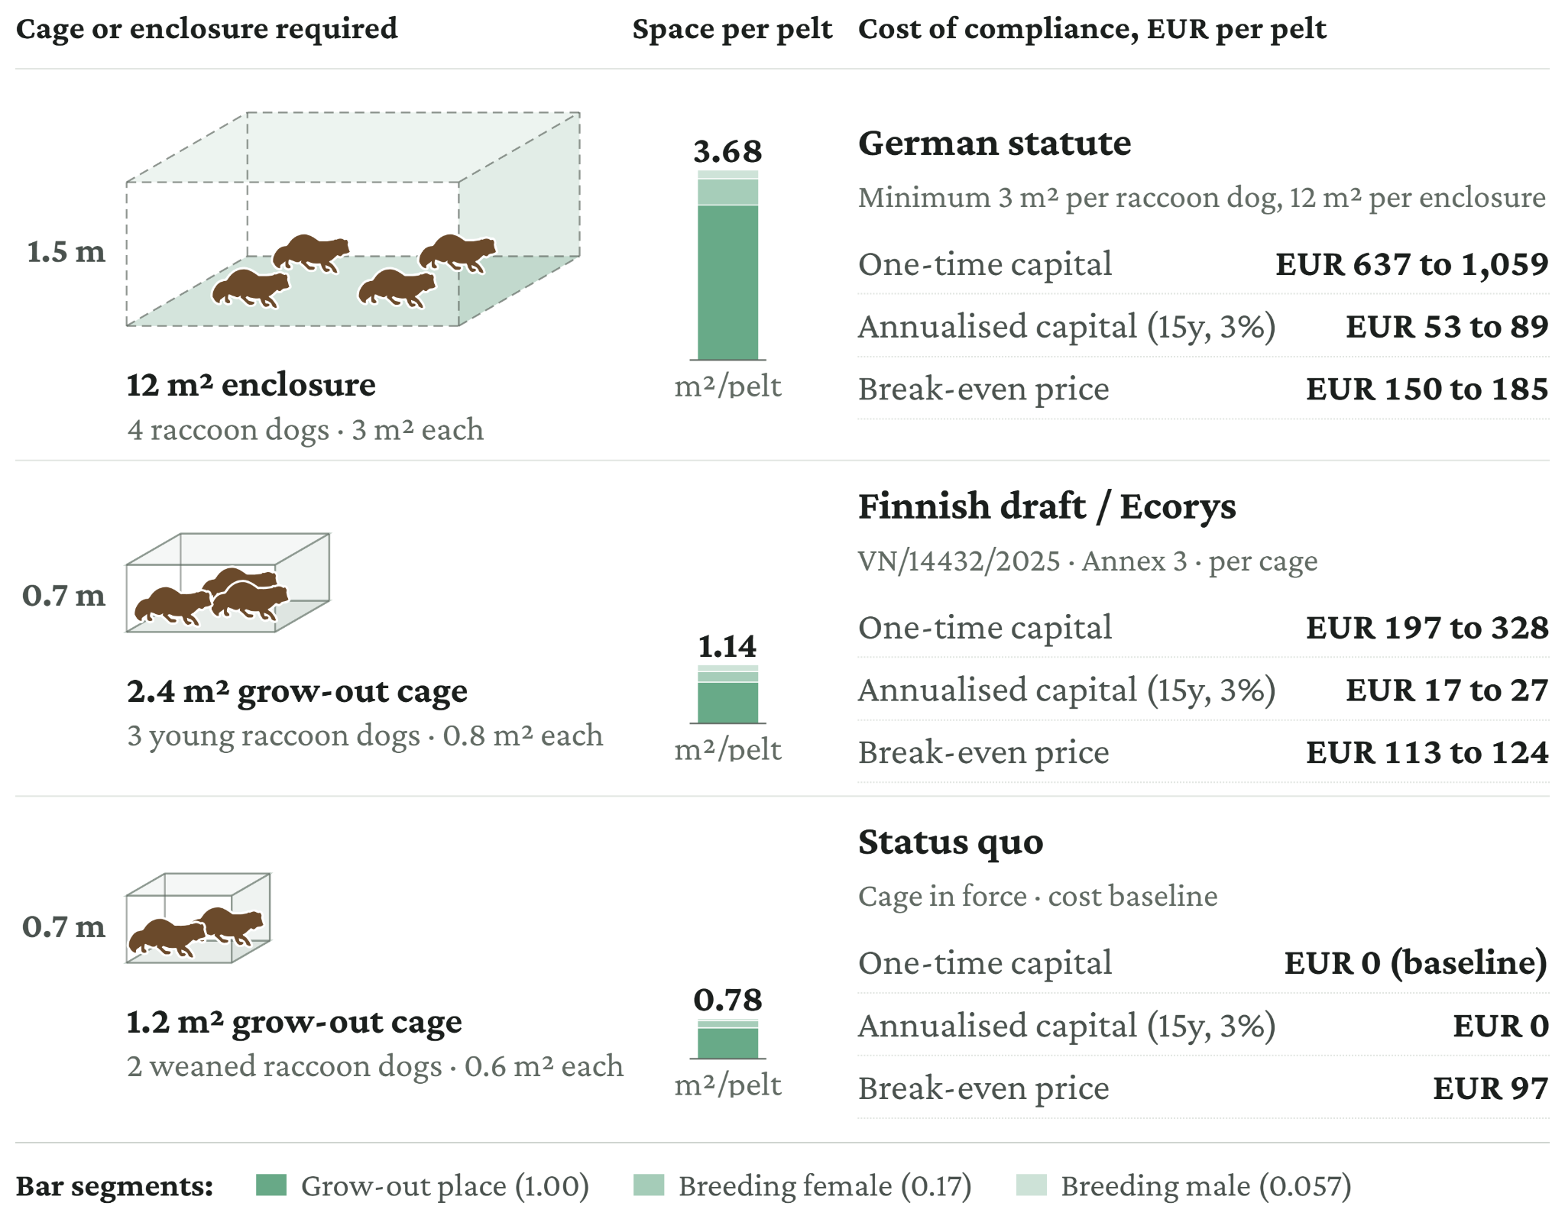
Source: Own calculations. Cage geometry from the Finnish draft decree (MMM, 2025a), the European Commission survey measures (Ecorys, 2025) and the German fur-keeping annex (Bundesrepublik Deutschland, 2017a), which sets one rule for foxes and raccoon dogs. In practice, raccoon-dog farms generally follow the fox requirements (MMM, 2025b). Costs calibrated on Luke (2025). Derivation details in Appendix A.4.
Industry viability
Raccoon dog farming is the least profitable of the species considered. With a break-even price of at least €113 per pelt under the Finnish draft decree and Ecorys standards, operations would have made a loss in at least 19 of the last 26 years, or 73% of the period. This compares with losses in 50% of years under the status quo and at least 85% under the German standard.
Figure 9: Raccoon dog pelt price against the break-even price under each standard, 2001 to 2026.
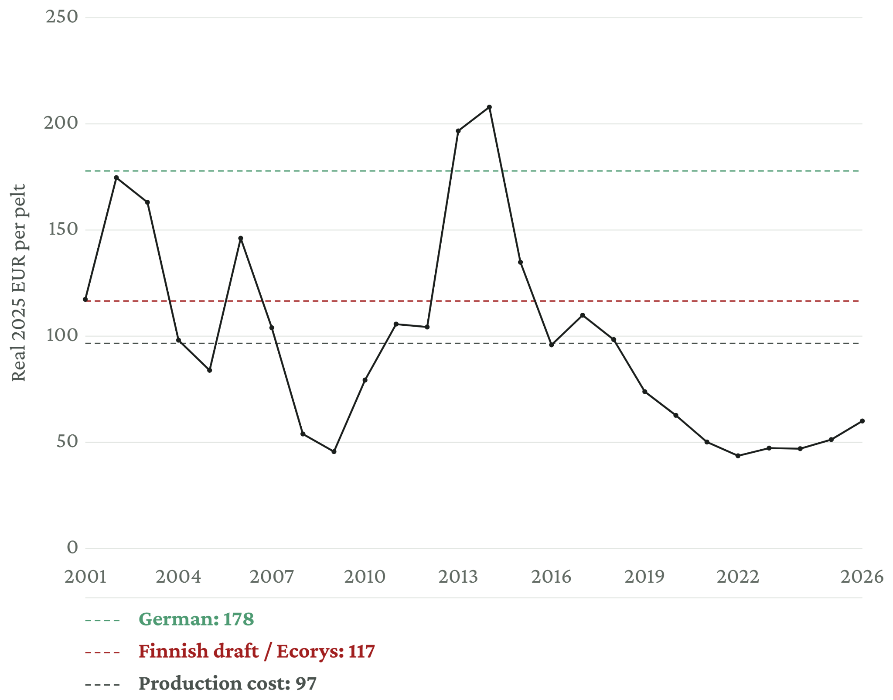
Source: Own calculations based on FIFUR (2025) for 2001–2024 and Saga Furs auction data for 2025–2026, inflation-adjusted to 2025.

3.3.4 Chinchilla
Potential standards and costs
Unlike the other species, neither Luke (2025) nor the Finnish draft decree (MMM, 2025b) considers chinchillas, because there is no chinchilla farming in Finland (Carpenter, 2025). For chinchillas, this assessment therefore considers only two alternatives to the status quo: the Ecorys and German standards (Figure 10). The German statute is the only alternative already in force as law. No chinchilla cage-conversion cost was identified, so the analysis uses the mink cage-hardware rate as an analogue. This approach was checked against commercial chinchilla-cage offerings; see Appendix A.5.
Figure 10: Chinchilla housing standards, space per animal, space per pelt, and cost of compliance
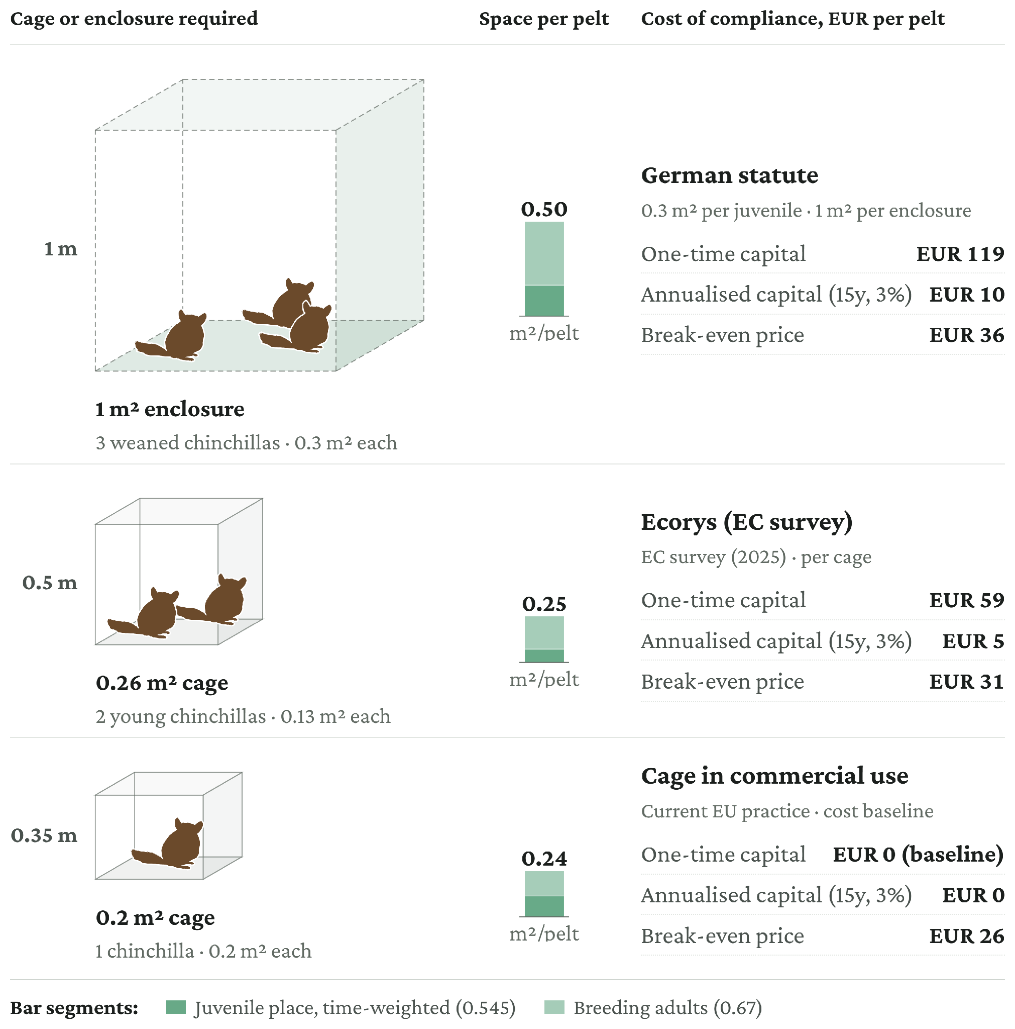
Source: Own calculations. Cage geometry from the European Commission survey measures (Ecorys, 2025) and the German fur-keeping annex (Bundesrepublik Deutschland, 2017a). The cage is in commercial use based on EFSA (2025). One-time capital is an analogue: cage area is priced at the mink cage-hardware rate. Derivation details in Appendix A.5.
Industry viability
The latest chinchilla price data available for this study are from 2022. Subject to this limitation, chinchilla is the only species for which observed prices exceed break-even in most years under both recorded price series.
Figure 11: Chinchilla pelt price on its two recorded bases against the break-even price under each standard.
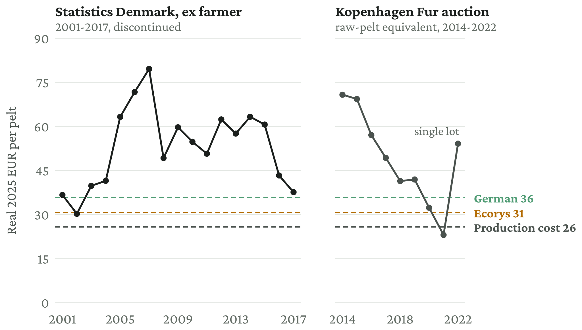
Source: Own calculations. Pelt price derived from Carpenter (2025), Table A25a.

3.3.5 EU total
The results under the main scenario are summarised in Table 5. Three public co-financing levels – 20%, 40%, and 80% – are shown in Table 6. These are illustrative rather than forecasts of the subsidy rate that would ultimately apply.
- A 0% public contribution is both a lower bound and a plausible default for a new mandatory welfare standard: EU rules restrict recurring support for compliance with mandatory standards, and the current Finnish draft does not propose support (European Commission, 2022; MMM, 2025b). Sweden attached no compensation to the 1995 requirement that foxes be able to dig and move freely, and fox farming had ended by 2001; Swedish chinchilla standards from 2012 followed the same pattern (Carpenter, 2025). Germany likewise provided no compensation for welfare and permit standards tightened from 2017 that ended mink farming by 2022 (Bundesrepublik Deutschland, 2017a; Carpenter, 2025).
- For fur-farming standards specifically, Finland provides a precedent: a 2008 scheme granted up to 15% of eligible costs for cage-replacement investments (Finnish Government, 2008). The rate rose to 22% at the end of 2009, when industry bodies estimated that about one-third of mink and foxes were still in cages that did not meet the law (Yle, 2009). A 20% contribution is therefore included as an illustrative low-compensation scenario. The Finnish experience also suggests that a low subsidy rate may not be sufficient to induce rapid compliance.
- Forty percent is the highest rate observed in the comparable obligation identified here: Germany paid 40% of eligible costs, capped at €500,000 per holding and project, for converting sow housing to standards made mandatory in 2021, with transition periods of eight and fifteen years (BMEL, 2020). Uptake was limited: of the €300 million announced for the programme, just under €30 million was paid to 119 farms (Deutscher Bundestag, 2023). Applications closed within fifteen months and funded work had to be completed within two years, while the requirements themselves bound only eight and fifteen years after the rules took effect. The observed uptake therefore provides limited evidence about the subsidy rate that would be needed for fur-farm compliance.
- The theoretical upper bound considered is the 80% limit for aid for investment linked to animal welfare: the aid intensity “may be increased to a maximum of 80 %” for such investments (Article 14(12)(a); European Commission, 2022).
Table 5: Investment cost of new standards in the EU, € million
 | Ecorys* | Germany
EU total | 502.7 | 2,300.8
Mink | 221.9 | 1,104.8
Fox | 253.5 | 1,092.0
Raccoon dog | 23.8 | 96.9
Chinchilla | 3.49 | 7.10
Note: Derivation details in Appendix A.1. * For mink, the Ecorys two-level cage is assumed, which costs less per pelt than the single-level cage.
Pairing the two standards that could plausibly be adopted with low (20%) and high (80%) public co-financing gives four illustrative scenarios. The 40% case is shown separately in Table 6 because it is used in the main cross-option comparison.
German standards, high co-financing (80%). An 80% subsidy reduces the annualised capital cost borne by mink farmers from about €35 to about €7 per pelt. The farmer-borne increase is then comparable to the unsubsidised Finnish or Ecorys standards (Figure 5), with the break-even price exceeded in a significant share of years. The subsidy would cost about €1.8 billion across all species.
German standards, low co-financing (20%). Leaving most of the capital cost with farmers reduces the annualised cost they bear from about €35 to about €28 per mink pelt, producing a break-even price of about €62 that was exceeded in just two of the last 26 years. The subsidy would cost about €460 million across all species. The historical German experience suggests that production could contract substantially under such a burden, although the effect cannot be predicted from the available evidence.
Ecorys two-level standards, high co-financing (80%). Because the Ecorys capital requirement is much smaller, an 80% subsidy makes the farmer-borne cost modest: one-time capital is about €84 per mink pelt, and the annualised cost to farmers falls from about €7 to about €1.4 per pelt. The break-even price of about €35 was exceeded in 14 of the last 26 years (Figure 5). The subsidy would cost about €402 million across all species.
Ecorys two-level standards, low co-financing (20%). Farmers would bear an annualised cost of about €5.6 per mink pelt, putting the break-even price at about €39, a level exceeded in 11 of the last 26 years (Figure 5). The subsidy would cost about €101 million across all species.
Table 6 illustrates the public and private cost for different compensation levels with Ecorys standards.
Table 6: Public compensation with Ecorys* and German standards, € million
 |  | 0% compensation | 20% compensation | 40% compensation | 80% compensation
Ecorys | EU public cost | 0 | 100.5 | 201.1 | 402.2
Ecorys | Farmer-financed remainder | 502.7 | 402.2 | 301.6 | 100.5
Ecorys | Total cost | 502.7 | 502.7 | 502.7 | 502.7
German | EU public cost | 0 | 460.2 | 920.3 | 1,840.7
German | Farmer-financed remainder | 2,300.8 | 1,840.7 | 1,380.5 | 460.2
German | Total cost | 2,300.8 | 2,300.8 | 2,300.8 | 2,300.8
Note: Derivation details in Appendix A.1. *For mink, the Ecorys two-level cage is assumed, which costs less per pelt than the single-level cage.

3.4 Policy option 4: the adoption of stricter standards with requirements for imports
Under Option 4, imported fur would have to meet welfare standards equivalent to those applying to EU production. Costs to EU farms would remain those estimated under Option 3. Costs incurred by third-country farms would affect the EU mainly through higher import prices or reduced availability of compliant fur.
The potential scope of the import requirement can be approximated using EU trade data. Extra-EU imports of raw and processed furskins and natural-fur articles (CN headings 4301 to 4303) were worth approximately €217.5 million in 2025. This estimate subtracts artificial-fur imports of €25.5 million from total Chapter 43 imports of €243 million (EU Trade Explorer, 2026). It is only a proxy for affected trade because it includes some wild fur and excludes some products containing fur that are classified under other CN chapters.
Switzerland provides evidence that a certification-based import restriction could be implemented in practice. From July 2029, commercial imports of fur produced using methods considered cruel will be barred, followed by a sales ban from July 2030. The certification programme is expected to consider enclosure conditions, killing methods, and opportunities for species-typical behaviour, although detailed requirements are still being developed. Switzerland’s domestic rules require an outdoor enclosure and bathing pool for mink, but it has not yet been confirmed whether the import standard will contain the same requirements (BLV, 2026; Schweizerischer Bundesrat, 2008).
Existing EU systems also provide possible implementation models. An EU verification system could rely on recognised third-country control bodies, farm certification, supply-chain documentation, and customs checks. Similar arrangements are already used for imported meat, for which compliance with equivalent welfare-at-killing requirements must be certified, and for organic products, which are checked by recognised control bodies and accompanied by electronic certificates (Council of the European Union, 2009, Article 12; European Commission, n.d.-b).
The review of the EU Timber Regulation estimated recurrent importer compliance costs at 0.29% to 4.3% of affected import value, with a central estimate of 2.9% (European Commission, 2021, pp. 31–32). Applied to the €217.5 million proxy for extra-EU fur imports, this gives indicative annual compliance costs of €0.6 million to €9.4 million, with a central estimate of about €6.3 million. The Timber Regulation is not a direct equivalent to animal-welfare certification, so this should be treated as a scale benchmark rather than a forecast. Fur certification would require different technical checks, including farm-level welfare inspections. The estimate covers certification, traceability, and related business administration; public expenditure on supervising control bodies, customs checks, and enforcement would be additional.
Compared with Option 3, Option 4 could reduce competition from lower-standard imports for EU fur farms, but could also increase input prices for EU manufacturers. If manufacturers continued to rely on imported pelts, higher import prices could reduce their margins unless costs were passed on to customers. Switching from imported to EU-produced pelts could increase GVA in the EU farming sector, while potentially reducing output or GVA among manufacturers facing higher input costs. The net effect on EU GVA would therefore depend on the extent of import substitution, changes in prices, and the response of producers and consumers.

4. Comparison of the policy options

4.1 Comparing the costs of the policy options

4.1.1 One-off costs and transition effects
The public cost of a production ban depends strongly on the length of the transition. Compensation is required primarily for productive assets and other losses that cannot be recovered before production ends. With a longer transition, existing assets depreciate, farms have more time to adjust, and the value of losses remaining at closure falls. A longer transition can therefore substantially reduce the monetary compensation required.
Figure 12 compares the estimated one-off public cost of a production ban at different transition lengths with the estimated one-time public co-financing of the Ecorys and German-level standards. The ban estimates include compensation for eligible losses plus 10% for administration. On the conditional basis, an immediate buy-out would cost approximately €591 million, falling to approximately €144 million with a five-year transition. With a sufficiently long transition, the modelled compensation can fall to zero.
Figure 12: Public cost of a ban compared with stricter welfare standards.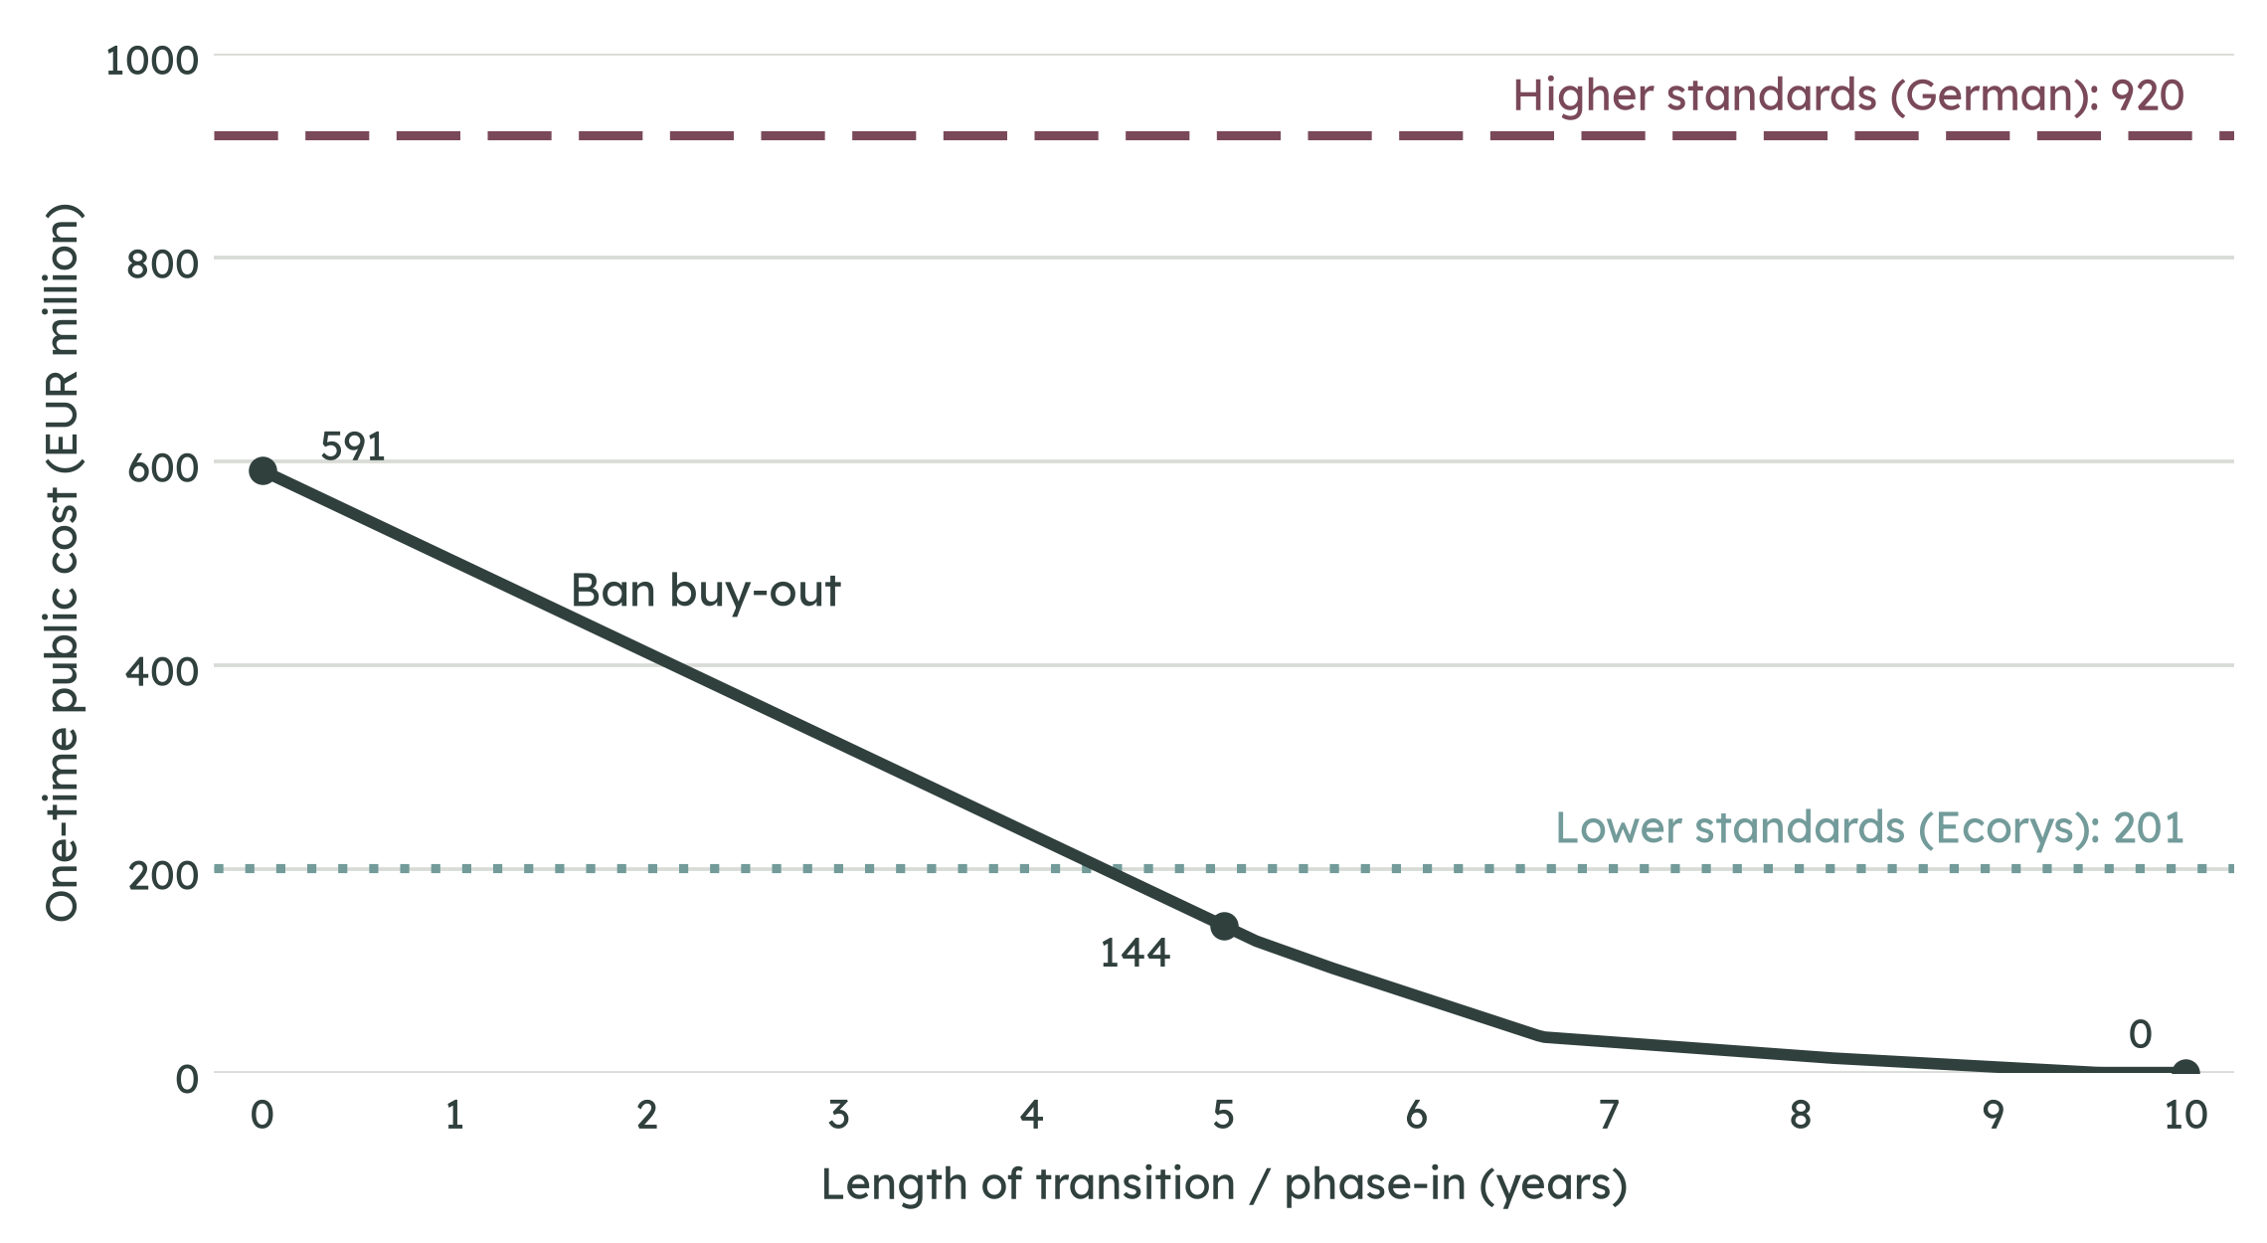
Note: Figures assume compensation is paid and are therefore not probability-adjusted. Ban costs comprise conditional compensation plus 10% administration; standards costs comprise one-time public co-financing of 40% of estimated compliance investment. Standards costs exclude future expenditure required to maintain or raise standards, ongoing enforcement, and any compensation associated with a later phase-out. Maintaining production under stricter standards could require further public support if farms remain unprofitable, which is not quantified here.
The standards scenarios have a different cost structure. Their principal cost is investment required to bring farms into compliance, rather than compensation for assets that can no longer be used. Extending the transition does not therefore reduce their cost mechanically. Under 40% public co-financing, the Ecorys standards would cost approximately €201 million, while the German-level standards would cost approximately €920 million.
The standards estimates should be treated as lower bounds. They include the modelled capital investment and public co-financing, but exclude some potentially relevant compliance costs, future enforcement costs, and any ongoing public support that might be required to keep farms operating at the specified standard.
The relative one-time public cost therefore depends strongly on the transition period and the standard assumed. Under the model, a production ban becomes less costly than the Ecorys standards after approximately 4.4 years and is less costly than the German-level standards at every transition length examined. These comparisons are conditional on the assumed compensation design and on standards being supported at 40% of the modelled investment cost. They do not include future operating support, enforcement, or any later compensation.
These two costs rest on different production levels, by design. A ban is costed on current production, because it ends the activity as it stands and compensates the farms and output that exist. Stricter standards are costed on the production that would continue under them, which for Finland means the recovered output assumed in the standards scenario, because standards must equip the production that keeps operating. The gap between the two bases is almost entirely Finland, whose 2024 output is temporarily depressed by an avian-influenza cull and is assumed to recover toward capacity. This mainly affects the comparison with the lighter Ecorys standard: at a five-year transition the ban, at about €144 million, is below the German standard on either basis (€440–920 million at 40% co-financing), but the Ecorys standard costs about €201 million if Finnish output recovers and about €96 million if it is held at current output (Appendix A.7.1). The ban’s advantage over the Ecorys standard at a five-year transition therefore depends on the recovery assumption, while its advantage over the German standard does not.

4.1.2 Compensation design and uncertainty
The estimated cost of a production ban is conditional on the design of the compensation scheme. The €591 million immediate buy-out estimate is therefore not a forecast of what an EU compensation scheme would necessarily pay; it is the modelled cost under the compensation assumptions set out in Section 3.1.
Compensation can cover different categories of loss, including stranded assets, stock, foregone income, severance, and retraining. The method used to value assets can also materially affect the result. Compensation based on the depreciated value of existing assets will generally be lower than compensation based on replacement cost or a new-for-old approach.
The transition period provides an additional mechanism for reducing compensation. Where producers have time to depreciate existing investments and adjust their operations, fewer assets are stranded when the ban takes effect. The compensation requirement can therefore decline without a correspondingly large public payment.
The figures should consequently be interpreted as conditional compensation estimates rather than forecasts of actual EU expenditure. The eventual fiscal cost would depend on the final eligibility rules, valuation methodology, transition period, and uptake of any compensation scheme.

4.2 The standards trilemma
Stricter standards face a trilemma among three objectives: achieving substantial welfare improvement, maintaining EU production, and limiting public expenditure. More demanding standards increase the cost of keeping farms in production. Limiting public expenditure therefore creates pressure towards less costly requirements, while requirements designed to address the welfare problems identified by EFSA could make production less viable. If production subsequently contracts or ceases, the policy may function in practice as a phase-out rather than as a stable model of production under higher standards.
The cost estimates illustrate this tension. Public co-financing of the Ecorys standards is estimated at about €201 million and of the German-level standards at about €920 million, compared with a conditional ban cost of about €591 million for immediate closure and €144 million for a five-year transition. The lower cost of the Ecorys scenario is conditional on the less extensive requirements being adopted and on production continuing. The precedents in Germany for mink and Sweden for fox show that stricter requirements can instead be followed by the end of production. In such cases, standards may operate as a de facto phase-out, without necessarily providing the same structured compensation as a statutory ban.
Setting and defending detailed standards is also demanding in practice. In July 2026, Finland’s Chancellor of Justice found the justification for proposed fur-farming requirements insufficient in several respects, including the transition period and cage requirements (Oikeuskansleri, 2026). The preparation process had begun in 2013. The finding does not determine the appropriate level of EU standards, but it illustrates the evidential and legal requirements involved in imposing substantial new obligations on producers.
A further consideration is leakage. If EU production becomes more costly while imported fur remains available, some demand may shift to production outside the EU. Options 2 and 4 therefore pair production-side measures with measures governing access to the EU market. Table 7 summarises the estimated public costs and the main features of the four options.
Table 7: Side-by-side comparison of the four policy options
Policy option | Estimated one-off public cost | Main additional cost / issue
1. Production ban | About €144m with a five-year transition; €0–591m depending on transition | Compensation and administration
2. Production + market ban | About €144m with a five-year transition; €0–591m depending on transition | Market enforcement
3. Stricter standards, no import requirements | About €201m for Ecorys standards; about €920m for German-level standards | Ongoing support may be required to maintain production
4. Stricter standards + import requirements | About €201m / about €920m | About €6m/year import compliance, with an estimated range of €1–9m
Note: Ban costs comprise one-off compensation and 10% administration. Standards costs comprise one-time public co-financing of 40% of the estimated investment required for compliance. Ongoing support, enforcement, and other recurrent costs are excluded unless otherwise stated. Source: Sections 3.1–3.4.

5. Discussion

5.1 What the costed standards can achieve
The fiscal comparison needs to be considered alongside the welfare outcomes that the standards are capable of delivering. The relevant question is not only how much it costs to comply with a standard, but also what welfare change that expenditure is expected to produce.
EFSA’s 2025 scientific opinion identifies important welfare consequences for mink, foxes, raccoon dogs, and chinchillas kept in current cage systems, and concludes that these consequences cannot be prevented or substantially mitigated under those systems. Substantial mitigation would require substantially more space and greater environmental complexity (AHAW, 2025).
The Finnish and Ecorys standards examined in this report remain below the level identified by EFSA as necessary to substantially mitigate these welfare consequences. Enlarging cages and introducing additional requirements would increase costs, while the EFSA assessment indicates that the resulting systems would still not substantially mitigate the main welfare problems identified in current cage systems.
This creates a direct tension between the fiscal and welfare dimensions of the standards approach. Less demanding standards reduce compliance costs, but are also further from the level EFSA identifies as necessary for substantial mitigation. More demanding standards increase costs and may reduce the economic viability of production.
The Finnish case also illustrates the evidential and legal difficulty of setting such requirements. In July 2026, the Finnish Chancellor of Justice concluded that the justification for proposed requirements was insufficient in several respects, including the proposed transition period and cage requirements (Oikeuskansleri, 2026). The finding does not determine the appropriate level of EU standards, but it illustrates the importance of a strong evidential basis where regulation imposes substantial economic requirements on producers.
Germany provides a further precedent. The standards introduced there were sufficiently demanding that mink farming subsequently ended. This illustrates that stricter standards can affect not only conditions within farms, but also the economic viability of the sector.
The four policy options therefore differ in both their cost structure and their intended mechanism. Standards seek to regulate the conditions of continued production, with welfare outcomes depending on the requirements adopted and whether production remains viable. A production ban instead ends EU fur-farming activity. The two approaches should therefore not be treated as interchangeable ways of achieving the same outcome. On the evidence considered in this report, the ban is the only option that unambiguously eliminates the welfare problems associated with continued fur farming in the EU.

5.2 Dynamic viability and fiscal risk
The current financial position of fur farming does not establish that the sector will remain unprofitable over the lifetime of new investments. Pelt prices have historically been volatile (FIFUR, 2025), and future prices, production costs, technology, consumer demand, and market structure could change. The standards scenarios should therefore not be interpreted as forecasts of future profitability.
This uncertainty matters because the standards approach requires investment in assets intended to support continued production. If the sector subsequently becomes more profitable, supported investment may increase the value of assets that would otherwise have been retired. If a later policy decision nevertheless ends production, some of those assets could still have substantial non-depreciated value.
The public budget could therefore face two successive expenditures: first, support for investment needed to comply with stricter standards; and subsequently, compensation for assets that become stranded if production is later phased out. The scale of this risk depends on the timing and design of both measures and is not quantified in this report.
The reverse outcome is also possible. If profitability deteriorates, subsidised investment may fail to sustain production, leaving public expenditure without achieving the intended long-term objective of maintaining a viable sector at higher welfare standards.

5.3 Market measures and the legal basis for sales or import bans
A market or import restriction has an established legal precedent in EU trade law. In EC-Seal Products (World Trade Organization, 2014), the WTO Appellate Body accepted that an EU ban on placing seal products on the market could be justified under the public-morals exception in Article XX(a) of the GATT, provided the measure was applied even-handedly to domestic and imported products. A farmed-fur measure would need to satisfy its own legal requirements; the seal-products ruling does not determine the legality of a future fur measure.
This matters for Options 2 and 4. A market measure can reduce the risk that a production-only ban shifts sourcing abroad, while an import requirement can prevent lower-standard imported fur from competing with EU production on the basis of different welfare requirements. The precedents discussed in Section 3.2 indicate that a non-discriminatory sales ban need not create a compensation entitlement for downstream traders, manufacturers, or retailers, but the legal and compensation consequences would depend on the final design.

5.4 Wider societal costs
The fiscal analysis captures costs to public budgets, but these are only part of the economic costs associated with fur production. A previous full-cost account estimated annual environmental damage from EU fur farming at approximately €226 million and public-health prevention costs at approximately €211 million. Together with negative gross value added, these estimates produced a net societal cost of approximately €446 million per year (Carpenter, 2025).
The largest environmental components included fine particulate air pollution associated with waste, estimated at €83 million annually, and invasive-species risks, estimated at €79 million annually. American mink and raccoon dog are listed as invasive alien species of Union concern (European Union, 2014), and escapes from fur farms have been documented. The assessment also identified public-health risks associated with maintaining susceptible carnivores in close proximity to people.
These costs are not included in the public-budget comparison because they are not direct fiscal expenditures. They nevertheless matter to the wider economic comparison. A production ban would remove EU fur-farming activity and therefore the production-related costs associated with it, although it would not necessarily eliminate all underlying environmental or public-health risks. Stricter standards would leave the production activity in place and therefore would not remove most of these wider costs.
The environmental and public-health estimates should themselves be interpreted as conservative. The full-cost account excluded several potentially relevant impacts, including some pathogens, raccoon-dog invasive-species costs, and animal-welfare costs that could not be robustly monetised. The estimates therefore indicate the scale of wider societal costs rather than providing a complete valuation.
This broader perspective highlights another difference between the approaches. Standards primarily change the conditions under which fur is produced, while a production ban changes whether the activity occurs in the EU at all. Their effects therefore extend beyond the farm-level welfare and fiscal costs quantified in this report.

5.5 A just transition
The costs estimated here should be understood as one component of a wider transition, not simply as the price of closure. Compensation to farmers is the core element modelled in this report, but a fuller package could also include worker retraining, regional support for exposed areas such as the Greek manufacturing cluster, and an appropriate transition period. The sugar and coal precedents show that such measures can be funded nationally or, where eligible, through EU instruments such as the Just Transition Fund and state aid (Section 2.2). Retraining the fur-farm workforce itself, estimated at roughly 2,000 people, would cost about €10–30 million at EU norms of €5,000–15,000 per person. The larger downstream workforce around Kastoria and Siatista would require a separate assessment.

6. Conclusions
This report compares the public cost of four EU policy options for fur farming: (i) a production ban; (ii) a combined production and market ban; (iii) stricter welfare standards for EU production; and (iv) stricter standards extended to imported fur. Four findings emerge:
- The public cost of a production ban is modest in comparison with the standards options, and one-off. Conditional compensation ranges from about €591 million for an immediate buy-out to near zero under a long transition, with a five-year phase-out costing about €144 million, below the €201–920 million estimated for stricter standards at 40% public co-financing. Standards, by contrast, would require continuing public support. Retraining the roughly 2,000 fur-farm workers would add an estimated €10–30 million, while support for the larger downstream workforce would require separate assessment.
- Transition length is the key determinant, and a legal one. Time is itself a form of compensation: a longer phase-out gives producers more time to recover their investment before the ban takes effect, reducing the monetary compensation required, potentially to zero. Courts in the Netherlands and Latvia have upheld phased bans on this basis.
- Stricter standards face a trilemma among welfare ambition, continued production, and public cost. Under 40% public co-financing, the estimated one-time cost is about €201 million for the Ecorys standards and €920 million for the German-level standards, both lower bounds. The standards examined remain below the level EFSA identifies as necessary to substantially mitigate the main welfare problems of current cage systems. In Germany and Sweden, stricter requirements were followed by the end of the relevant fur-farming activity.
- Market measures can address leakage at relatively limited additional cost. Extending a production ban to the EU market would add little estimated compensation liability, consistent with the seal and cat-and-dog-fur precedents; extending welfare requirements to imported fur would add an estimated €6 million a year in importer verification and compliance costs.
Under the assumptions used here, the estimated one-off public cost of a production ban is below the 40% co-financed cost of German-level standards at all transition lengths examined, and falls below the corresponding Ecorys cost after about 4.4 years. The comparison with the German standard is robust to the production basis; the crossover with the lighter Ecorys standard is sensitive to the assumed recovery of Finnish output (Section 4.1). The main determinants are the transition period and compensation design for a ban, and the stringency and public co-financing of standards. These comparisons exclude future operating support, enforcement costs, or any later compensation.

Sources
Agüero, M., Monne, I., Sánchez, A., Zecchin, B., Fusaro, A., Ruano, M. J., del Valle Arrojo, M., Fernández-Antonio, R., Souto, A. M., Tordable, P., Cañás, J., Bonfante, F., Giussani, E., Terregino, C., & Orejas, J. J. (2023). Highly pathogenic avian influenza A(H5N1) virus infection in farmed minks, Spain, October 2022. Eurosurveillance, 28(3), 2300001. https://doi.org/10.2807/1560-7917.ES.2023.28.3.2300001
AZA Small Carnivore Taxon Advisory Group (AZA SCTAG). (2010). Mustelid (Mustelidae) care manual. Association of Zoos and Aquariums. https://www.aza.org/assets/2332/mustelidcaremanual2010r.pdf
Brzeziński, B. (2026, April 5). J-Lo, Rihanna and Kardashians: How fur is fighting an EU ban. POLITICO. https://www.politico.eu/article/fur-fight-eu-ban/
Bundesamt für Lebensmittelsicherheit und Veterinärwesen (BLV) (Swiss Federal Food Safety and Veterinary Office). (2026, June 5). Importverbot für tierquälerisch erzeugte Pelze: Mehr Zeit für Anpassung der Produktion [Import ban on cruelly produced fur: more time for production adaptation]. https://www.blv.admin.ch/de/newnsb/OV7qnpR1VI1M6ZqvDB5jV
Bundesministerium für Ernährung und Landwirtschaft (BMEL). (2014). Gutachten über Mindestanforderungen an die Haltung von Säugetieren [Expert opinion on minimum requirements for the keeping of mammals] [Expert report, 7 May 2014]. https://www.bmleh.de/SharedDocs/Downloads/DE/_Tiere/Tierschutz/HaltungSaeugetiere.pdf
Bundesministerium für Ernährung und Landwirtschaft (BMEL). (2020). Richtlinie zur Förderung des Stallumbaus zur Verbesserung der Haltungsbedingungen von Sauen [Directive on funding the conversion of pig housing to improve sow-keeping conditions], 8 September 2020. Bundesanzeiger, BAnz AT 16.09.2020 B2. https://web.archive.org/web/20220320065424/https://www.ble.de/SharedDocs/Downloads/DE/Projektfoerderung/Stallumbau/Foerderrichtlinie.pdf
Bundesrepublik Deutschland. (2017a). Anforderungen an die Haltung von Pelztieren [Requirements for the keeping of fur animals; Annex to the Tiererzeugnisse-Handels-Verbotsgesetz (TierErzHaVerbG), BGBl. I 2017, 2149–2150; mink, fox, raccoon dog and chinchilla]. Bundesministerium der Justiz und für Verbraucherschutz. https://www.gesetze-im-internet.de/khfeverbg/anlage.html
Bundesrepublik Deutschland. (2020). Gesetz zur Reduzierung und zur Beendigung der Kohleverstromung (Kohleverstromungsbeendigungsgesetz – KVBG) [Act to Reduce and End Coal-Fired Power Generation], 8 August 2020, BGBl. I S. 1818. https://www.gesetze-im-internet.de/kvbg/
Carpenter, G. (2025). A full-cost account of the EU fur industry [Report]. https://griffincarpenter.org/reports/a-full-cost-account-of-the-eu-fur-industry
Česká republika. (2017). Zákon č. 255/2017 Sb., kterým se mění zákon č. 246/1992 Sb., na ochranu zvířat proti týrání [Act No. 255/2017 Coll. amending Act No. 246/1992 Coll. on the Protection of Animals against Cruelty], 20 July 2017. https://www.zakonyprolidi.cz/cs/2017-255
Council of Europe (CoE), Standing Committee of the European Convention for the Protection of Animals kept for Farming Purposes. (1999). Recommendation concerning fur animals (adopted 22 June 1999; entered into force 22 December 1999). https://www.coe.int/en/web/cdcj/1999-rec-fur-animals
Council of the European Union. (2009). Council Regulation (EC) No 1099/2009 of 24 September 2009 on the protection of animals at the time of killing. Official Journal of the European Union, L 303, 1–30. https://eur-lex.europa.eu/legal-content/EN/TXT/?uri=CELEX:32009R1099
Deutscher Bundestag. (2017). Entwurf eines Gesetzes zur Änderung futtermittelrechtlicher und tierschutzrechtlicher Vorschriften [Draft act amending feed-law and animal-welfare provisions] (Drucksache 18/12085). https://dserver.bundestag.de/btd/18/120/1812085.pdf
Deutscher Bundestag. (2023). Tierschutzbericht 2023 der Bundesregierung [Animal Welfare Report 2023 of the Federal Government] (Drucksache 20/9860), 14 December 2023. https://dserver.bundestag.de/btd/20/098/2009860.pdf
Ecorys. (2025). Study supporting the European Commission’s assessment to follow up on the European Citizens’ Initiative “Fur Free Europe”: Survey of civil society organisations [Survey questionnaire]. European Commission. https://ec.europa.eu/eusurvey/runner/Study_Fur_2025_CSOs
EFSA (European Food Safety Authority). (2025). Biology, husbandry systems and farm practices for American mink, red and Arctic foxes, raccoon dog and chinchilla. EFSA Supporting Publications, EN-9562. https://doi.org/10.2903/sp.efsa.2025.EN-9562
EFSA Panel on Animal Health and Welfare (AHAW). (2025). Welfare of American mink, red and Arctic foxes, raccoon dog and chinchilla kept for fur production. EFSA Journal, 23(7), Article e9519. https://doi.org/10.2903/j.efsa.2025.9519
EU Trade Explorer. (2026, August 7). Market evolution: Furskins and artificial fur (CN 43), 2015–2025. https://tradedashboard.eu/reports/furskins-and-artificial-fur-43-2015-2025-en-938d28bc.html
European Commission. (n.d.-a). InforEuro monthly accounting rates. European Commission. https://commission.europa.eu/funding-tenders/procedures-guidelines-tenders/information-contractors-and-beneficiaries/exchange-rate-inforeuro_en
European Commission. (n.d.-b). Trade in organics. Directorate-General for Agriculture and Rural Development. Retrieved August 10, 2026, from https://agriculture.ec.europa.eu/farming/organic-farming/trade_en
European Commission. (2021). Fitness check on Regulation (EU) No 995/2010 … and Regulation (EC) No 2173/2005 … (SWD(2021) 328 final). https://eur-lex.europa.eu/legal-content/EN/TXT/?uri=CELEX:52021SC0328
European Commission. (2022). Commission Regulation (EU) 2022/2472 of 14 December 2022 … Official Journal of the European Union, L 327, 21.12.2022. https://eur-lex.europa.eu/legal-content/EN/TXT/?uri=CELEX:32022R2472
European Commission. (2023). Communication from the Commission on the European Citizens’ Initiative “Fur Free Europe” (C(2023) 8362 final), 7 December 2023. https://citizens-initiative.europa.eu/initiatives/details/2022/000004_en
European Commission. (2025). “Better regulation” toolbox, Tool #64: Discount factors (December 2025 edition). https://commission.europa.eu/document/download/9c8d2189-8abd-4f29-84e9-abc843cc68e0_en
European Court of Auditors. (2021). Special report 11/2021: The EU’s response to the 2014-2016 milk market disturbances. https://op.europa.eu/webpub/eca/special-reports/milk-dairy-production-11-2021/en/
European Parliament. (2015). Tropea, F. Measures to support dairy farmers after the end of EU milk quotas (EPRS Briefing PE 569.012). European Parliamentary Research Service. https://www.europarl.europa.eu/RegData/etudes/BRIE/2015/569012/EPRS_BRI(2015)569012_EN.pdf
European Union. (2006). Council Regulation (EC) No 320/2006 … restructuring of the sugar industry … Official Journal, L 58, 42–50. https://eur-lex.europa.eu/legal-content/EN/TXT/?uri=CELEX:32006R0320
European Union. (2007). Regulation (EC) No 1523/2007 … banning … cat and dog fur … Official Journal, L 343, 1–4. https://eur-lex.europa.eu/legal-content/EN/TXT/?uri=CELEX:32007R1523
European Union. (2009). Regulation (EC) No 1007/2009 … on trade in seal products. Official Journal, L 286, 36–39. https://eur-lex.europa.eu/legal-content/EN/TXT/?uri=CELEX:32009R1007
European Union. (2014). Regulation (EU) No 1143/2014 … invasive alien species. Official Journal, L 317, 35–55. https://eur-lex.europa.eu/legal-content/EN/TXT/?uri=CELEX:32014R1143
European Union. (2021). Regulation (EU) 2021/1056 … establishing the Just Transition Fund. Official Journal, L 231, 1–20. https://eur-lex.europa.eu/legal-content/EN/TXT/?uri=CELEX:32021R1056
Eurostat. (n.d.). HICP - annual data (average index and rate of change). https://ec.europa.eu/eurostat/databrowser/view/prc_hicp_aind/
FIFUR (Finnish Fur Breeders’ Association). (2025). Statistics 2025. https://fifur.fi/content/uploads/2025/09/FIFUR-Statistics-2025-EN.pdf
Fur Europe. (2015). WelFur: Welfare assessment protocol for mink (2nd ed.). https://www.sustainablefur.com/wp-content/uploads/2018/11/Mink_protocol_final_web_edition_light.pdf
Hameleers, R. (2026). As the EU mulls over a fur ban, the Greek state wants to support a new mink farm. Euractiv. https://www.euractiv.com/opinion/as-the-eu-mulls-over-a-fur-ban-the-greek-state-wants-to-support-a-new-mink-farm/
Hansen, H. O. (2022). Beregning af direkte og afledte erhvervs- og samfundsøkonomiske konsekvenser ved de smittebeskyttende tiltag i minkbesætninger [Calculation of the direct and indirect economic and socio-economic consequences of the biosecurity measures in mink herds]. IFRO Udredning No. 2022/17, Københavns Universitet. https://researchprofiles.ku.dk/da/publications/beregning-af-direkte-og-afledte-erhvervs-og-samfunds%C3%B8konomiske-ko
Hernesniemi, T. (2023). Tuotantokustannus: kettu ja minkki [Production cost: blue fox and mink] [Data set]. Keski-Pohjanmaan koulutusyhtymä (KPEDU). https://www.kpedu.fi/docs/default-source/projektisivustot/tietolinkki/tuotantokustannus-kettu-ja-minkki_2023-06-12.xlsx
Hoge Raad der Nederlanden (Supreme Court of the Netherlands). (2016). Arrest ECLI:NL:HR:2016:2888, zaaknr. 16/00921 (Wet verbod pelsdierhouderij) [Judgment on the Fur Farming Prohibition Act], 16 December 2016. https://uitspraken.rechtspraak.nl/details?id=ECLI:NL:HR:2016:2888
Instituto para la Transición Justa. (2018). Acuerdo Marco para una Transición Justa de la Minería del Carbón y el desarrollo sostenible de las comarcas mineras para el período 2019–2027 [Framework Agreement for a Just Transition of Coal Mining and the Sustainable Development of Mining Regions, 2019–2027]. https://www.transicionjusta.gob.es/
Ireland. (2022a). Prohibition of Fur Farming Act 2022 (No. 21 of 2022). https://www.irishstatutebook.ie/eli/2022/act/21/
Ireland. (2022b). S.I. No. 650/2022, Prohibition of Fur Farming Act 2022 (Compensation Scheme) Regulations 2022. https://www.irishstatutebook.ie/eli/2022/si/650/
KW Cages. (n.d.). Chinchilla cages [Manufacturer product listing]. Retrieved 11 August 2026, from https://www.kwcages.com/cavy/other-rodent-cages/chinchilla.html
Lietuvos Respublika. (2023). Gyvūnų gerovės ir apsaugos įstatymo Nr. VIII-500 pakeitimo įstatymas [Law amending the Law on the Welfare and Protection of Animals No. VIII-500; fur farming prohibited from 2027]. https://www.e-tar.lt/
Luke (Natural Resources Institute Finland). (2025). Valmistelussa olevan turkisasetuksen kustannuslaskelmien taustamuistio [Background memorandum on the cost calculations for the fur animal decree under preparation]. Finnish Ministry of Agriculture and Forestry. https://mmm.fi/-/luonnos-uudeksi-turkiselainasetukseksi-lausunnolle
Meagher, R. K., Ahloy Dallaire, J., Campbell, D. L. M., Ross, M., Møller, S. H., Hansen, S. W., Díez-León, M., Palme, R., & Mason, G. J. (2014). Benefits of a ball and chain: Simple environmental enrichments improve welfare and reproductive success in farmed American mink (Neovison vison). PLOS ONE, 9(11), Article e110589. https://doi.org/10.1371/journal.pone.0110589
Ministerstvo životního prostředí České republiky. (2021). Operační program Spravedlivá transformace 2021–2027 [Just Transition Operational Programme 2021–2027]. https://www.opst.cz/
MMM (Finnish Ministry of Agriculture and Forestry). (2025a). Valtioneuvoston asetus turkiseläinten hyvinvoinnista [Government Decree on the Welfare of Fur Animals] [Draft decree, consultation VN/14432/2025]. https://mmm.fi/-/luonnos-uudeksi-turkiselainasetukseksi-lausunnolle
MMM (Finnish Ministry of Agriculture and Forestry). (2025b). Ehdotus valtioneuvoston asetukseksi turkiseläinten hyvinvoinnista [Proposal for a Government Decree on the Welfare of Fur Animals] [Explanatory memorandum, 22 May 2025] (VN/14432/2025). https://mmm.fi/documents/1410837/0/VN_14432_2025-MMM-5%20Muistio%208512007_8_0.pdf
Office of the Parliamentary Ombudsman. (2025, May 28). Tarkastus: Lintuinfluenssan torjunta, Ruokavirasto 20.3.2024 [Inspection: Avian influenza control, Finnish Food Authority, 20 March 2024] (EOAK/3/2024). https://oikeusasiamies.fi/documents/235872516/250541620/eoa-3-2024.pdf
Oikeuskansleri (Chancellor of Justice of Finland). (2026, July 21). Muistio ehdotuksesta valtioneuvoston asetukseksi turkiseläinten hyvinvoinnista [Memorandum on the proposal for a Government Decree on the Welfare of Fur Animals] (OKV/2545/23/2025).
Regeringskansliet (Government Offices of Sweden). (2023, September). Ekonomiskt stöd för att avveckla minkuppfödning [Financial support for phasing out mink farming] [SEK 180 million; administered by Jordbruksverket; completion by 30 June 2025]. https://www.regeringen.se/pressmeddelanden/2023/09/ekonomiskt-stod-for-att-avveckla-minkuppfodning/
Repubblica Italiana. (2021). Legge 30 dicembre 2021, n. 234, art. 1, commi 980–984 [Law No. 234 of 30 December 2021, State Budget for 2022; ban on farming animals for fur]. Gazzetta Ufficiale n. 310, 31 December 2021, S.O. n. 49. https://www.gazzettaufficiale.it/eli/id/2021/12/31/21G00256/sg
Republik Österreich. (2004). 2. Tierhaltungsverordnung, BGBl. II Nr. 486/2004 (idF BGBl. II Nr. 144/2026, in force from 19 June 2026), Anlage 1 [2nd Animal Husbandry Ordinance]. Rechtsinformationssystem des Bundes (RIS). https://www.ris.bka.gv.at/NormDokument.wxe?Abfrage=Bundesnormen&Gesetzesnummer=20003860&Anlage=1
Rzeczpospolita Polska. (2025). Ustawa z dnia 7 listopada 2025 r. o zmianie ustawy o ochronie zwierząt, Dziennik Ustaw 2025 poz. 1696 [Act of 7 November 2025 amending the Act on the Protection of Animals; in force 19 December 2025]. https://dziennikustaw.gov.pl/D2025000169601.pdf
Satversmes tiesa [Constitutional Court of the Republic of Latvia]. (2024, April 11). Par 2022. gada 22. septembra likuma “Grozījumi Dzīvnieku aizsardzības likumā” 2. un 3. panta atbilstību Latvijas Republikas Satversmes 1. pantam, 105. panta pirmajam un trešajam teikumam un Līguma par Eiropas Savienības darbību 49. pantam [On the compliance of Sections 2 and 3 of the law of 22 September 2022 “Amendments to the Animal Protection Law” with Section 1, the first and third sentences of Section 105 of the Constitution of the Republic of Latvia and Article 49 of the Treaty on the Functioning of the European Union] (Lieta Nr. 2023-09-0106). Latvijas Vēstnesis, (72). https://likumi.lv/ta/id/351204
Schweizerischer Bundesrat. (2008). Tierschutzverordnung vom 23. April 2008 (TSchV; SR 455.1), Anhang 2 (Stand am 1. Februar 2022) [Animal Welfare Ordinance]. Fedlex. https://www.fedlex.admin.ch/eli/cc/2008/416/de
Skatteforvaltningen (Danish Tax Administration). (2026). Den juridiske vejledning 2026-2, C.C.2.4.4.4: Afskrivningsmetoder, bygninger og installationer [Legal guidance: depreciation methods for buildings and installations]. https://info.skat.dk/data.aspx?oid=2083987
Statens jordbruksverk (Swedish Board of Agriculture). (2019). Statens jordbruksverks föreskrifter och allmänna råd om uppfödning och hållande av pälsdjur [Regulations and general advice on the breeding and keeping of fur animals] (SJVFS 2019:16, Saknr L 103). https://lagen.nu/sjvfs/2019:16
Styrelsen for Grøn Arealomlægning og Vandmiljø (Danish Agency for Green Land Conversion and Water Environment). (2024). Husdyrvejledningen … kapitel 16, Revurdering af godkendelser (§§ 48–49) [Livestock permitting guidance … chapter 16, Review of approvals]. Version 9, 10 December 2024. https://husdyrvejledning.dk/vejledning-til-bekendtgoerelserne/husdyrgodkendelsesbekendtgoerelsen/16-revurdering-af-godkendelser-48-49-og-hbl-40-41-43-a
TG-International (Treuhandgesellschaft für Beratung und Management mbH). (2014). Sachverständigengutachten über die Wirtschaftlichkeit von Nerztierfarmen in Deutschland [Expert report on the economic viability of mink farms in Germany]. Prepared for the Schleswig-Holsteinisches Oberverwaltungsgericht, 25 April 2014.
Valtioneuvosto (Finnish Government). (2008). Investointitukea maatilojen lämpökeskuksiin ja turkistarhaukseen [Investment aid for farm heating plants and fur farming] [Press release, 17 July 2008]. https://valtioneuvosto.fi/-/1410837/investointitukea-maatilojen-lampokeskuksiin-ja-turkistarhaukseen
Valtioneuvosto (Finnish Government). (2011). Valtioneuvoston asetus turkiseläinten suojelusta 1084/2011 [Government Decree on the Protection of Fur Animals 1084/2011]. Finlex. https://www.finlex.fi/fi/laki/alkup/2011/20111084
Vlaams Gewest. (2019). Decreet van 22 maart 2019 houdende wijziging van de wet van 14 augustus 1986 betreffende de bescherming en het welzijn der dieren [Decree of 22 March 2019 amending the Act of 14 August 1986 on the Protection and Welfare of Animals; fur-farming ban, cessation by 30 November 2023]. https://codex.vlaanderen.be/
Vlaams Gewest. (2020). Besluit van de Vlaamse Regering van 15 mei 2020 tot regeling van de vergoeding bij de bedrijfsstopzetting en bedrijfsreconversie van de pelsdierhouderijen en de eenden- of ganzenhouderijen [Decree of 15 May 2020 governing compensation for the cessation and reconversion of fur-animal and duck- or goose-farming holdings]. https://codex.vlaanderen.be/PrintDocument.ashx?id=1033066
World Trade Organization. (2014). European Communities – Measures Prohibiting the Importation and Marketing of Seal Products (WT/DS400/AB/R, WT/DS401/AB/R) [Appellate Body report, adopted 18 June 2014]. https://www.wto.org/english/tratop_e/dispu_e/cases_e/ds400_e.htm
Yle Uutiset. (2009). Hallitus kiirehtii turkistarhojen häkkien korjauksia [The government presses for repairs to fur farm cages]. Yle Uutiset, 29 December 2009. https://yle.fi/a/3-6060521

Appendix

A.1 Costing method for new standards
Each standard is expressed as a required floor area per pelt on a herd-weighted basis. The existing shade-house stock is assumed to be converted using the Finnish unit costs reported by Luke (2025). The resulting production capacity is used as the output basis. Investment costs are annualised over the assumed asset life using a 3% social discount rate (European Commission, 2025), and the break-even price is calculated as annualised capital cost plus production cost.
Production is assumed to be the same across standards within each scenario. Each reported break-even estimate should be treated as a lower bound because welfare features for which unit costs are unavailable are costed separately and excluded from the reported minimum capital requirement.
Spare capacity, measured in shed space, is important because it determines how much production can expand without requiring new sheds. Spare capacity varies over time and by country. For example, Finland produced 350,000 mink pelts in 2024 (Carpenter, 2025), while existing sheds under current standards could accommodate about 1,000,000 pelts (Luke, 2025). Greece, by contrast, is operating near historical capacity and may be considering new fur farms (Hameleers, 2026). We estimate spare capacity as follows:
- For each species and country, we identify the year of peak pelt production (Carpenter, 2025, Annex 2) and assume that farms were operating close to capacity in that year.
- We then apply the ratio of farms remaining in 2024 to the number of farms in the peak production year (Carpenter, 2025, Table A19a). This assumes that average pelt capacity per farm has remained similar within each country. The number of fur farms is not species-specific, which is a data limitation.
- Where necessary, estimates are rounded or adjusted. For Denmark, we also cap capacity at roughly three times current production, or 100,000 pelts. This reflects evidence that mink houses making up the former sector “can hardly be used any more” under the biosecurity conditions required for resumption, and that only farms with existing enclosed halls would be able to continue (Hansen, 2022).
For example, Finland reached peak mink pelt production of 2,000,000 in 2010. In 2024, 430 fur farms remained out of 914, or 47%, implying capacity of approximately 940,000 pelts. This is close to the 1,000,000-pelt assumption used by Luke (2025). We therefore use the Luke assumption for comparability, while noting that it also corroborates the general approach used here.
Table A1: Capital cost parameters
Parameter | Value | Low | High | Source for Value
Real discount rate, % | 3 | 1 | 10 | European Commission, 2025, Tool #64
Capital asset life, years | 15 | 10 | 30 | TG-International, 2014, commercial case
Note: The parameter sensitivity testing results with low and high values are reported in Appendix A.7.3.

A.2 Cost derivation, mink
Cage conversion costs per square metre of cage (${CC}_{sqm}$ ). ${CC}_{sqm}$ is derived from Luke (2025) for Finnish draft standards as follows:
${CC}_{sqm}={CC}_{m}×m_{sqm} ={CC}_{m} ×\frac{m^{tot}}{n^{ py}×{ sqm}^{py}}$
In the above equation $CC_{m}$ is cage cost per metre of converted shade houses, calculated and reported by Luke (2025). $m_{sqm}$ is the length of shade houses per square metre of additional cage space. $m_{sqm}$ is obtained by dividing total length of converted and newly built sheds ($m^{tot}$) by the resulting total square metres required for the cages; total square metres required for the cages are obtained by multiplying the number of pelts annually ($n^{ py}$) by the space requirement per pelt per year under the Finnish draft (${sqm}^{py}$). ${sqm}^{per pelt per year}$ is estimated based on the cage dimensions specified in the Finnish (MMM, 2025a) and mink biology.
If building of new sheds is also required, the cost per square metre for the new build (${NB}_{sqm}$) is expressed as:
${NB}_{sqm}={NB}_{m}×m_{sqm}$
${NB}_{m}$ is cost per metre of newly built sheds, including cages, calculated and reported by Luke (2025). $m_{sqm}$ is the length of shade houses per square metre of additional cage space, obtained from the calculation above. The inputs and calculations for ${CC}_{sqm}$ and ${NB}_{sqm}$ are summarised in Table A2a.
Table A2a: Conversion and new build cost calculation for mink
Symbol | Item | Value | Unit | Source
$n^{ py}$ | Pelts per year | 1,000,000 | pelts | Luke, 2025
${CC}_{sqm}$ | Conversion cost per m² of area | 239.4 | € per m² | Own calculation
${NB}_{sqm}$ | New build cost per m² of area | 342.1 | € per m² | Own calculation
${CC}_{m}$ | Conversion cost per m of shed | 377.8 | € per m | Luke, 2025
${NB}_{m}$ | New build cost per m of shed | 539.9 | € per m | Luke, 2025
$m_{sqm}$ | Shed length-to-area ratio | 0.634 | m per m² | Own calculation
$m^{ tot}$ | Shade housing total (m) | 182,500 | m | Own calculation
 | Shade housing converted (m) | 137,500 | m | Luke, 2025
 | Shade housing built (m) | 45,000 | m | Luke, 2025
${ sqm}^{py}$ | m² per pelt per year | 0.288 | m² per pelt per year | Own calculation
 | Cage area (Finnish decree) | 0.36 | m² | MMM, 2025a
 | Juvenile places per pelt | 0.50 | places per pelt | Calculated
 | Breeding female places per pelt | 0.25 | places per pelt | Luke, 2025
 | Breeding male places per pelt | 0.05 | places per pelt | Assumed
Source: Own calculations based on Luke (2025) and MMM (2025a).
The number of animals that fit in existing sheds varies inversely with cage footprint per pelt. For example, the Luke (2025) calculations in Table A2a imply that converting current sheds without new construction would accommodate just over 750,000 mink (1,000,000 × 137,500 / 182,500), as shown in Table A2b.
Table A2b: Capital floor by standard: cage area and, for the two-level cage, its shelf hardware
Item | Finland draft | Ecorys, two-level | Ecorys, single-level | German
Cage footprint per pelt (m²) | 0.288 | 0.216 | 0.432 | 1.300
Second-level space (m² per pelt) | 0.000 | 0.134 | 0.000 | 0.000
First-level cage cost (€ per pelt) | 68.95 | 51.71 | 103.42 | 311.23
Second-level cage cost (€ per pelt) | 0.00 | 32.18 | 0.00 | 0.00
Initial investment (€ per pelt) | 68.95 | 83.89 | 103.42 | 311.23
Cost estimate for additional features  (€ per pelt) | 0.00 | 7.57 | 9.73 | 129.50
Note: Estimate for additional required features is zero under the Finnish decree. For Ecorys and German standards it includes estimates for a partly-solid floor and additional enrichment, based on Meagher et al. (2014). For the German standard it includes, in addition, a swimming basin and climbing structures. Source: Own calculations based on the unit costs reported by Luke (2025), with cage geometry from the Finnish draft decree (MMM, 2025a), the European Commission survey measures (Ecorys, 2025) and the German fur-keeping annex (Bundesrepublik Deutschland, 2017a).
The investment cost per pelt varies in proportion to the space requirement per pelt per year (Table A2c).
Table A2c: Break-even pelt price by standard
Standard | Initial investment (€/pelt) | Annualised investment (€/pelt per year) | Break-even pelt price (€/pelt)
Finnish draft | 68.95–98.53 | 5.78–8.25 | 39.62–42.10
Ecorys, two-level | 83.89–106.07 | 7.03–8.89 | 40.87–42.73
Ecorys, single-level | 103.42–147.80 | 8.66–12.38 | 42.51–46.23
German statute | 311.23–444.76 | 26.07–37.26 | 59.92–71.10
German external anchor (TG-International, 2014) | 776.81 | 65.07 | 98.92
Note: Break-even is the annualised capital plus the production cost. Range shows the cost without and with building new sheds. Costs are gross of any public subsidy. Source: Own calculations. Production cost of €33.85 per pelt from Hernesniemi (2023).
Table A2d: Production and capacity, mink
 | Current capacity | Current production | Capacity and production, main scenario | Capacity and production, expansion scenario
Denmark | 100,000 | 30,000 | 30,000 | 100,000
Finland | 1,000,000 | 350,000 | 1,000,000 | 1,000,000
Greece | 1,500,000 | 1,300,000 | 1,300,000 | 1,500,000
Spain | 500,000 | 300,000 | 300,000 | 500,000
Pelts per annum, EU total | 3,100,000 | 1,980,000 | 2,630,000 | 3,100,000

Table A2e: Cost of new standards for mink, main scenario
 | Finnish draft | Ecorys two-level | Ecorys single-level | German
New shed capacity required (number of pelts per year)
Denmark | 0 | 0 | 0 | 14,308
Finland | 291,667 | 55,556 | 527,778 | 843,077
Greece | 237,500 | 0 | 591,667 | 1,064,615
Spain | 0 | 0 | 63,889 | 221,538
EU total | 529,167 | 55,556 | 1,183,333 | 2,143,538
Initial investment (€ million)
Denmark | 2.1 | 2.5 | 3.1 | 11.2
Finland | 77.6 | 85.1 | 126.8 | 423.8
Greece | 96.7 | 109.1 | 160.7 | 546.8
Spain | 20.7 | 25.2 | 33.9 | 123.0
EU total | 197.0 | 221.9 | 324.5 | 1,104.8
Cost per pelt (€)
Initial investment | 74.9 | 84.4 | 123.4 | 420.1
Annualised investment | 6.3 | 7.1 | 10.3 | 35.2
Current production cost | 33.8 | 33.8 | 33.8 | 33.8
Break-even pelt price | 40.1 | 40.9 | 44.2 | 69.0
Source: Own calculations. Compliance capital calibrated on Luke (2025). Pelt production by country in 2024 from Carpenter (2025). Production cost per pelt from Hernesniemi (2023). One-time investment annualised at 15 years and 3%. New shed capacity required is the annual pelt output that the converted existing sheds cannot house; the cost of building it is included in the initial investment above.

A.3 Cost derivation, fox
The method for foxes follows that described for mink in A.1 and A.2, using the same model and annualisation parameters (Table A1).
Table A3a: Conversion and new build cost calculation for foxes
Symbol | Item | Value | Unit | Source
$n^{ py}$ | Pelts per year | 1,000,000 | pelts | Luke, 2025
${CC}_{sqm}$ | Conversion cost per m² of area | 193.0 | € per m² | Own calculation
${NB}_{sqm}$ | New build cost per m² of area | 320.8 | € per m² | Own calculation
${CC}_{m}$ | Conversion cost per m of shed | 272.2 | € per m | Luke, 2025
${NB}_{m}$ | New build cost per m of shed | 452.5 | € per m | Luke, 2025
$m_{sqm}$ | Shed length-to-area ratio | 0.709 | m per m² | Own calculation
$m^{ tot}$ | Shade housing total (m) | 784,000 | m | Own calculation
 | Shade housing converted (m) | 560,000 | m | Luke, 2025
 | Shade housing built (m) | 224,000 | m | Luke, 2025
${ sqm}^{py}$ | m² per pelt per year | 1.106 | m² per pelt per year | Own calculation
 | Juvenile cage space | 0.80 | m² | MMM, 2025a
 | Breeding female cage space | 1.20 | m² | MMM, 2025a
 | Breeding male cage space | 2.40 | m² | MMM, 2025a
 | Juvenile places per pelt | 1 | places per pelt | Calculated
 | Breeding female places per pelt | 0.225 | places per pelt | Luke, 2025
 | Breeding male places per pelt | 0.015 | places per pelt | Calculated
Source: Own calculations based on Luke (2025) and MMM (2025a).
Table A3b: Capital floor by standard: cage area by output basis
Item | Finnish draft | Ecorys | German
Cage area required per pelt (m²) | 1.106 | 1.106 | 3.720
Convert the existing stock (€/pelt) | 213.42 | 213.42 | 717.83
Source: Own calculations based on the unit costs reported by Luke (2025), with cage geometry from the Finnish draft decree (MMM, 2025a), the European Commission survey measures (Ecorys, 2025) and the German fur-keeping annex (Bundesrepublik Deutschland, 2017a). The Ecorys column equals the Finnish decree because both standards set the same space per animal.
Table A3c: Break-even pelt price by standard, fox
Standard | Initial investment (€/pelt) | Annualised investment (€/pelt per year) | Break-even pelt price (€/pelt)
Finnish draft | 213.42–354.76 | 17.88–29.72 | 98.94–110.78
Ecorys | 213.42–354.76 | 17.88–29.72 | 98.94–110.78
German | 717.83–1193.23 | 60.13–99.95 | 141.19–181.01
Note: Break-even is the annualised capital plus the production cost. Range shows the cost without and with building new sheds. Source: Own calculations. Production cost of €81.06 per pelt from Hernesniemi (2023).
Table A3d: Production and capacity, fox
 | Current capacity | Current production | Capacity and production, main scenario | Capacity and production, expansion scenario
Pelts per annum, EU total | 1,000,000 | 303,000 | 1,000,000 | 1,000,000

Table A3e: Cost of new standards for fox, main scenario
 | Finnish draft | Ecorys | German
New shed capacity required (number of pelts per year)
Finland, the whole EU in-scope sector | 283,906 | 283,906 | 787,097
Initial investment (€ million)
Finland, the whole EU in-scope sector | 253.4 | 253.4 | 1,092.0
Cost per pelt (€)
Initial investment | 253.5 | 253.5 | 1,092.0
Annualised investment | 21.2 | 21.2 | 91.5
Current production cost | 81.1 | 81.1 | 81.1
Break-even pelt price | 102.3 | 102.3 | 172.5
Source: Own calculations. Compliance capital calibrated on Luke (2025). Pelt production by country in 2024 from Carpenter (2025). Production cost per pelt from Hernesniemi (2023). One-time investment annualised at 15 years and 3%. Derivation details in Appendix A.3. New shed capacity required is the annual pelt output that the converted existing sheds cannot house; the cost of building it is included in the initial investment above.

A.4 Cost derivation, raccoon dog
Luke (2025) applies the same per-metre rates to raccoon-dog enclosures as to fox enclosures. The annualisation parameters are given in Table A1.
Table A4a: Conversion and new build cost calculation for raccoon dog
Symbol | Item | Value | Unit | Source
$n^{ py}$ | Pelts per year | 100,000 | pelts | Luke, 2025
${CC}_{sqm}$ | Conversion cost per m² of area | 173.1 | € per m² | Own calculation
${NB}_{sqm}$ | New build cost per m² of area | 287.8 | € per m² | Own calculation
${CC}_{m}$ | Conversion cost per m of shed | 272.2 | € per m | Luke, 2025
${NB}_{m}$ | New build cost per m of shed | 452.5 | € per m | Luke, 2025
$m_{sqm}$ | Shed length-to-area ratio | 0.636 | m per m² | Own calculation
$m^{ tot}$ | Shade housing total (m) | 72,500 | m | Own calculation
 | Shade housing converted (m) | 51,000 | m | Luke, 2025
 | Shade housing built (m) | 21,500 | m | Luke, 2025
${ sqm}^{py}$ | m² per pelt per year | 1.140 | m² per pelt per year | Own calculation
 | Juvenile cage space | 0.80 | m² | MMM, 2025a
 | Breeding female cage space | 1.20 | m² | MMM, 2025a
 | Breeding male cage space | 2.40 | m² | MMM, 2025a
 | Juvenile places per pelt | 1 | places per pelt | Calculated
 | Breeding female places per pelt | 0.17 | places per pelt | Luke, 2025
 | Breeding male places per pelt | 0.0567 | places per pelt | Calculated
Source: Own calculations based on Luke (2025) and MMM (2025a).

Table A4b: Capital floor by standard: cage area by output basis
Item | Finnish draft | Ecorys | German
Cage area required per pelt (m²) | 1.140 | 1.140 | 3.680
Convert the existing stock (€/pelt) | 197.36 | 197.36 | 637.08
Source: Own calculations based on the unit costs reported by Luke (2025), with cage geometry from the Finnish draft decree (MMM, 2025a), the European Commission survey measures (Ecorys, 2025) and the German fur-keeping annex (Bundesrepublik Deutschland, 2017a).
Table A4c: Break-even pelt price by standard, raccoon dog
Standard | Initial investment (€/pelt) | Annualised investment (€/pelt per year) | Break-even pelt price (€/pelt)
Finnish draft | 197.36–328.06 | 16.53–27.48 | 113.13–124.07
Ecorys | 197.36–328.06 | 16.53–27.48 | 113.13–124.07
German | 637.08–1,059.01 | 53.37–88.71 | 149.96–185.30
Note: Break-even is the annualised capital plus the production cost. Range shows the cost without and with building new sheds. Source: Own calculations. Production cost and pelt price derived from Carpenter (2025).
Table A4d: Production and capacity, raccoon dog
 | Current capacity | Current production | Capacity and production, main scenario | Capacity and production, expansion scenario
Pelts per annum, EU total | 100,000 | 24,000 | 100,000 | 100,000

Table A4e: Cost of new standards for raccoon dog, main scenario
 | Finnish draft | Ecorys | German
New shed capacity required (number of pelts per year)
Finland, the whole EU in-scope sector | 31,462 | 31,462 | 78,768
Initial investment (€ million)
Finland, the whole EU in-scope sector | 23.8 | 23.8 | 96.9
Cost per pelt (€)
Initial investment | 238.5 | 238.5 | 969.4
Annualised investment | 20.0 | 20.0 | 81.2
Current production cost | 96.6 | 96.6 | 96.6
Break-even pelt price | 116.6 | 116.6 | 177.8
Source: Own calculations. Compliance capital calibrated on Luke (2025). Pelt production by country in 2024 from Carpenter (2025). Production cost per pelt from Hernesniemi (2023). One-time investment annualised at 15 years and 3%. Derivation details in Appendix A.4. New shed capacity required is the annual pelt output that the converted existing sheds cannot house; the cost of building it is included in the initial investment above.

A.5 Cost derivation, chinchilla
For chinchillas, the cage area required under each standard is priced using the mink cage-hardware rate of €239.41 per m² as an analogue. This is corroborated by a US breeder-supply manufacturer listing a galvanised chinchilla cage with a floor area of 0.279 m² at a standard price of USD 98.65 and a sale price of USD 61.48 (KW Cages, n.d.). These prices correspond to USD 354 and USD 220 per m², or €306 and €191, respectively. The assumed €239 per m² therefore falls within this range. The listed prices are retail prices and exclude installation.
With approximately 1.4 litters per year and 1.87 kits per litter (EFSA, 2025, pp. 70–71), adjusting for mortality gives 1.786 pelts per female per year and 1.83 pelts per juvenile-cage place. With a breeding male-to-female ratio of 1:5, these values correspond to 0.545 juvenile places per pelt and 0.67 adult cage places per pelt annually (Table A5a). The annualisation parameters are given in Table A1.
Table A5a: Conversion and new build cost calculation for chinchilla
Item | Value | Unit | Source
Cage area cost per m² (mink hardware analogue) | 239.4 | € per m² | Own calculation
Current practice: cage area per animal | 0.20 | m² | EFSA, 2025
Cage area per pelt, existing stock | 0.243 | m² per pelt | Own calculation
Juvenile places per pelt | 0.545 | places per pelt | Own calculation
Adult places per pelt | 0.67 | places per pelt | Own calculation
Source: Own calculations based on Luke (2025) and MMM (2025a).
Table A5b: Area and one-time capital floor by standard, chinchilla (analogue)
Standard | Area required (m²/pelt) | Area at the cage in commercial use (m²/pelt) | Cost per m2 (€, analogue) | One-time capital floor (€/pelt) | Excluded features (€/pelt)
Ecorys | 0.245 | 0.243 | 239.4096 | 58.67 | 5.00
German | 0.498 | 0.243 | 239.4096 | 119.35 | 12.48

Table A5c: Break-even pelt price by standard, chinchilla
Standard | One-time capital floor (€/pelt) | Annualised over 15 years (€/pelt per year) | Production cost (€/pelt per year) | Break-even pelt price (€/pelt)
Ecorys | 58.67 | 4.91 | 25.81 | 30.72
German | 119.35 | 10.00 | 25.81 | 35.80
Note: Break-even is the annualised capital plus the production cost. Source: Own calculations. Production cost derived from Carpenter (2025), Table A9 in that report, and pelt price from Carpenter (2025), Table A25a; cage geometry from Ecorys (2025), the German fur-keeping annex (Bundesrepublik Deutschland, 2017a) and EFSA (2025).
Table A5d: Production and capacity, chinchilla
 | Current capacity | Current production | Capacity and production, all scenarios
Denmark | 34,000 | 34,000 | 34,000
Greece | 500 | 500 | 500
Hungary | 25,000 | 25,000 | 25,000
Pelts per annum, EU total | 59,500 | 59,500 | 59,500

Table A5e: Cost of new standards for chinchilla
 | Ecorys | German
Replacement cost, € million, EU total
Denmark | 1.99 | 4.06
Greece | 0.03 | 0.06
Hungary | 1.47 | 2.98
EU total | 3.49 | 7.10
Cost per pelt (€)
Initial investment | 58.67 | 119.35
Annualised investment | 4.91 | 10.00
Current production cost | 25.81 | 25.81
Break-even pelt price | 30.72 | 35.80
Source: Own calculations. Compliance capital calibrated on Luke (2025). Pelt production by country in 2024 from Carpenter (2025). Production cost per pelt from Hernesniemi (2023). One-time investment annualised at 15 years and 3%. Derivation details in Appendix A.5. No spare capacity (100% utilisation) assumed for chinchilla production.

A.6 Enclosure space across standards
Classifying these species as domesticated does not necessarily alter their fundamental needs. EFSA describes animals kept for fur as being “in the early phases of a domestication process” and did not relax its requirements on the basis of domestication, citing evidence that this does not affect their fundamental needs; fundamental behaviours are “largely unaffected by domestication” (AHAW, 2025, pp. 7, 16, 17).
The requirements for the same species kept outside fur farming therefore provide a benchmark for the space and features associated with those needs. Figures A6a and A6b compare these requirements with the farming standards costed in this report for mink and fox.
Most wildlife-keeping standards require at least ten times more space than the current farming standard, which would make commercial fur farming unviable. For mink, open-water access is universally required among the standards shown. Against this benchmark, the additional space and features provided by the fur-farming standards considered here are relatively limited.
Figure A6a: Enclosure space and water per adult mink, by standard
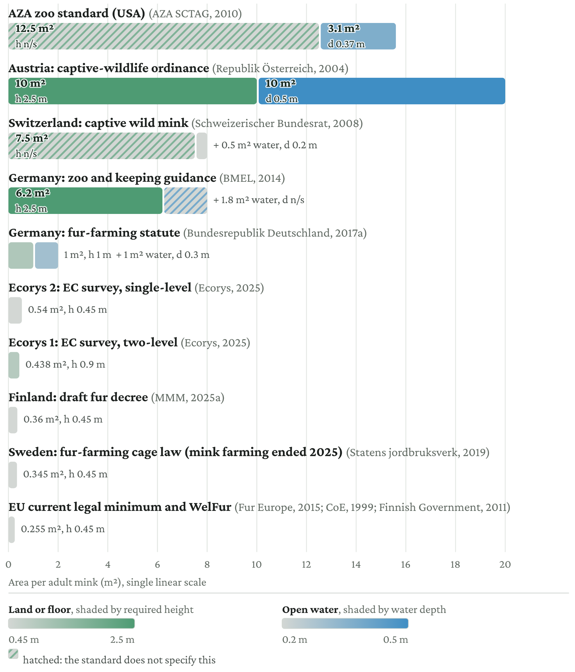
Note: Figures are per adult mink. Where a standard sets a minimum for a pair or a group, that minimum is divided by the stated capacity: Switzerland’s 15 m² enclosure and 1 m² pool for up to two animals appear here as 7.5 and 0.5. Austria sets 20 m² per adult pair, but the same provision requires mink to be kept singly outside the mating season, so the whole 20 m² accrues to one animal. The German zoo and keeping guidance states 8 m² per mink in total, of which 20 to 25% water; the figures shown are the 22.5% midpoint. Source: Own compilation from the standards cited.

Figure A6b: Enclosure space and water per adult fox, by standard
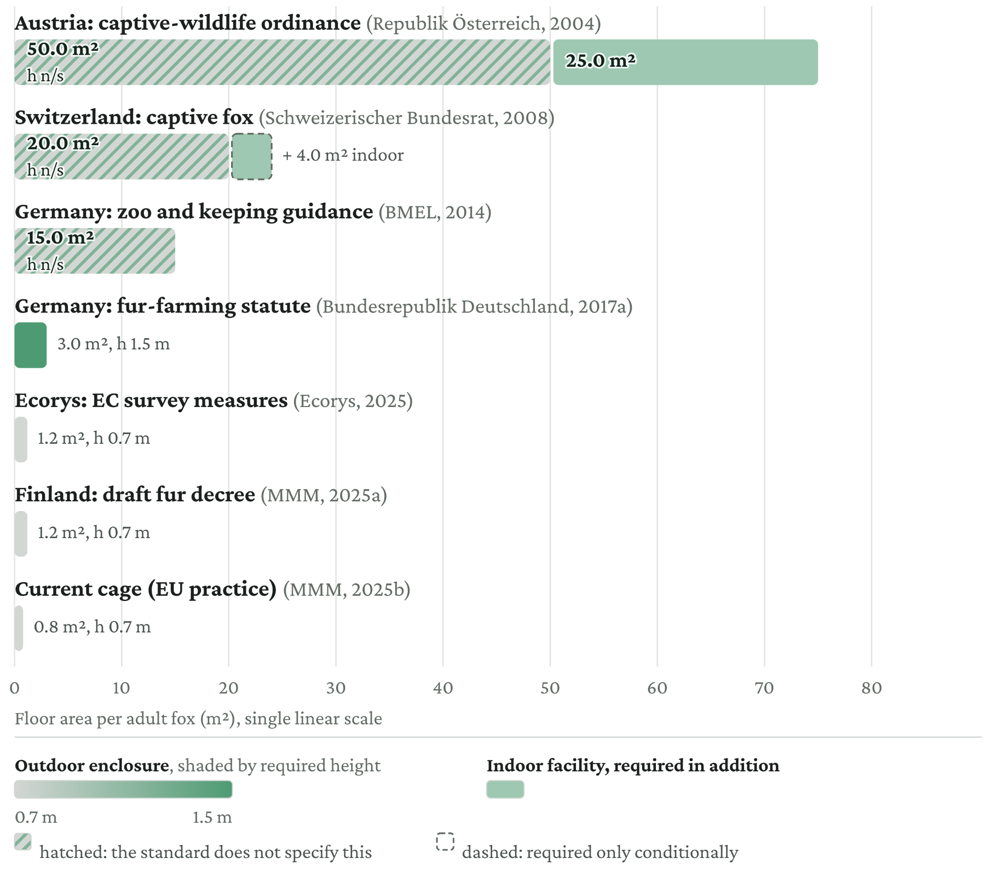
Note: Figures are per adult blue fox (Vulpes lagopus, formerly Alopex lagopus), the farmed species. Where a standard sets a minimum for a pair, that minimum is divided by the stated capacity. Austria requires 100 m² of outdoor enclosure per pair for Arctic fox and, in addition, an indoor facility of at least half the outdoor minimum. Switzerland requires 8 m² indoor pen per pair only for species that are not winter-hardy. Source: Own compilation from the standards cited.

A.7 Sensitivity tests
We test the sensitivity of the results to assumptions about production levels, shed expansion, capacity utilisation, discount rates, and the useful life of investments.

A.7.1 Production levels and shed expansion
The main scenario assumes that production remains at current levels in all countries except Finland, where production expands to capacity because it is plausibly temporarily suppressed by culls related to avian influenza. The two sensitivity scenarios apply the same production assumption across all countries: either current production or full capacity. Production capacity under each scenario is specified in Tables A2d, A3d, A4d, and A5d. The results are summarised in Table A7.1.
Table A7.1: Cost of conversion by scenario
Species | Finnish draft | Ecorys | German statute
Mink | 197.0 (143.5–240.5) | 221.9 (166.1–263.9) | 1104.8 (815.7–1,313.8)
Fox | 253.5 (64.7–253.5) | 253.5 (64.7–253.5) | 1092.0 (260.3–1,092.0)
Raccoon dog | 23.8 (4.7–23.8) | 23.8 (4.7–23.8) | 96.9 (16.5–96.9)
Chinchilla | n/a | 3.5 | 7.1
Total cost | 474.4 (212.9–517.9) | 502.7 (239.0–544.8) | 2,300.8 (1,099.6–2,509.9)
The main value and range show the cost under the main scenario, the current production and the full capacity scenarios, respectively.

A.7.2 Capacity utilisation
Capacity utilisation does not change the cost of conversion, but it changes the capital cost per pelt produced. For example, under the main scenario, Finland converts cage places for 1,000,000 pelts per year and is assumed to operate at full capacity. If production instead remained at the 350,000 pelts produced in 2024, annualised capital cost would rise from €7 to €20 per pelt, and the break-even price from €41 to €54 (Figure A7).
Operating below capacity is not unusual. It can result from general market conditions, such as low pelt prices, or external shocks, such as culling in response to avian influenza or coronavirus risk.
Where conversion is publicly funded, farmers bear less of the cost of unused capacity than they would under private financing, reducing the incentive to match investment to expected utilisation. Public support could therefore finance capacity that would not have been built with private capital, particularly where future pelt prices are uncertain.
Figure A7: Break-even cost by capacity utilisation (35–100% range) for mink: Ecorys two-level standard
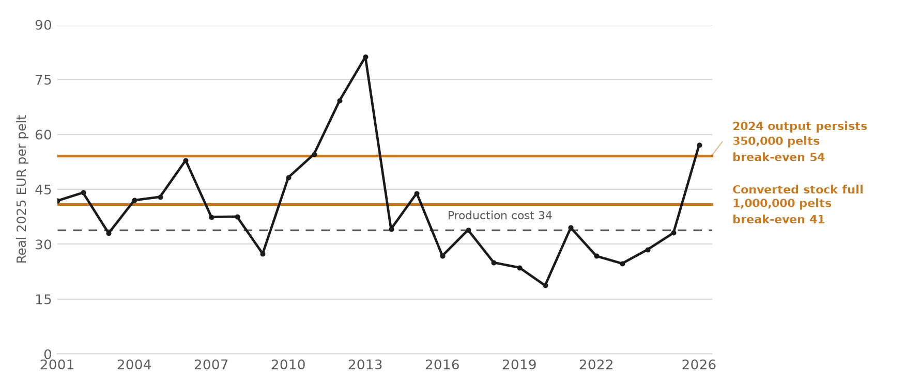

A.7.3 Capital costs
We consider a useful life of 10 to 30 years for renovated cages, with 15 years as the central assumption. The 20-year value corresponds to the Danish tax-depreciation period for wooden mink halls, including fixed cages and nest boxes, and for uninsulated livestock buildings generally (Skatteforvaltningen, 2026). The 10-year lower bound follows commercial depreciation practice: the German viability calculation writes cages off over a maximum of ten years and applies the same period to water and electricity installations (TG-International, 2014). Danish livestock-permitting guidance independently gives a 15- to 20-year depreciation period for livestock buildings (Styrelsen for Grøn Arealomlægning og Vandmiljø, 2024). The guidance also allows compliance deadlines of up to 30 years for large, high-quality, or flexible buildings, but this is a regulatory extension rather than a stated asset life; Hansen (2022) is therefore the only basis for the 30-year sensitivity.
The central discount rate of 3% is the social discount rate “recommended for EU policy analysis ... in real terms”, and the European Commission guidance recommends testing alternative lower and higher values (European Commission, 2025, Tool #64, Section 2). The guidance specifies one percentage point on either side as the minimum range. Here, we test rates from 1% to 10%. The upper end reflects the distinction in the guidance between the social discount rate used to assess costs from society’s perspective and the higher rate relevant to a company’s investment decision, which is described as the internal rate of return required to trigger investment (Tool #64, Section 4). Where capital is committed by private operators, 10% provides a sensitivity case for investment under volatile demand and legal uncertainty.
The results have a wider range on the upside than on the downside. A 10% discount rate increases capital costs substantially and, for example, raises the pelt cost from €41 to €45 for the two-level Ecorys setup (Table A7.3).
Table A7.3: Sensitivity test results with different values for interest rates and useful life of investment, mink
Variable | Finnish draft | Ecorys two-level | Ecorys single-level | German
15-year life, 1%
Annualised investment (€) | 5.40 | 6.08 | 8.90 | 30.30
Break-even pelt price (€) | 39.25 | 39.93 | 42.75 | 64.14
15-year life, 10%
Annualised investment (€) | 9.85 | 11.09 | 16.22 | 55.23
Break-even pelt price (€) | 43.69 | 44.94 | 50.07 | 89.07
10-year life, 3%
Annualised investment (€) | 8.78 | 9.89 | 14.46 | 49.24
Break-even pelt price (€) | 42.63 | 43.74 | 48.31 | 83.09
30-year life, 3%
Annualised investment (€) | 3.82 | 4.30 | 6.30 | 21.43
Break-even pelt price (€) | 37.67 | 38.15 | 40.14 | 55.28
Source: Own calculations. Compliance capital calibrated on Luke (2025). Pelt production by country in 2024 from Carpenter (2025). Production cost per pelt from Hernesniemi (2023). One-time investment annualised at 15 years and 3%. Derivation details in Appendix A.2.

A.8 Derivation of the regression model for the cost of an EU ban
The EU cost of a ban is estimated from observed Member State schemes using a two-part (hurdle) model. A scheme enters the sample only if it meets three conditions: it is a legislated ban on fur farming adopted on animal-welfare grounds; it applied to a functioning domestic industry, so that a genuine compensation decision was required; and it specified a transition period, which is the model’s main explanatory variable.
Twelve schemes meet these criteria: the seven schemes providing compensation (the Netherlands, Ireland, Italy, Czechia, Belgium, Poland, and Lithuania) and the five transition-only bans that paid nothing (Croatia, Estonia, Latvia, Romania, and Slovakia). The other measures in Table 1 are excluded. Denmark’s 2020 mass cull was an emergency animal-health response to COVID-19 rather than a welfare ban. Bulgaria reached the end of fur farming through invasive-alien-species controls on American mink, while Germany did so through welfare and permit standards; neither involved a dedicated welfare ban. Sweden bought out its farms through a voluntary scheme without a legislated ban or mandated transition period. France legislated a ban, but its three remaining farms closed immediately, leaving no functioning industry to compensate and no transition period to price. Austria, Slovenia, Luxembourg, and Malta legislated bans where little or no fur farming was taking place, so no compensation question arose. Poland and Lithuania are costed against their adopted laws, with worker severance re-anchored to national wages.
The dependent variable is compensation cost per farm, measured net of administration. Where a scheme reported administration separately, it is excluded from the dependent variable: this applies to Belgium, at about 6% of compensation, and the Netherlands, at about 15%. The remaining schemes did not report administration separately and are likewise treated as net of administration. A flat 10% administration allowance is applied to the EU estimate afterwards, so administration enters the total only once, as a mark-up on fitted compensation.
The amount equation is estimated by ordinary least squares on the seven countries that paid compensation: cost per farm = 521,765 − 101,709 × transition + 31.8 × (pelts per farm), with R² = 0.835.
The model is jointly significant (F(2,4) = 10.1, p = 0.03), with transition length and farm size each significant at the 10% level (p = 0.07 and p = 0.06). On the participation side, the transition slope is significant at the 10% level on a likelihood-ratio test (p = 0.09). With only seven paying schemes, the sample is small, so the coefficients should not be treated as conclusive on their own. However, the magnitude of the transition effect is supported by three independent comparisons discussed in Section 2.3.
The participation equation is a logit over the twelve schemes (payers and transition-only bans, excluding France): the probability that any compensation is paid is 1 / (1 + exp(−(1.92 − 0.384 × transition))).
This gives a probability of paying compensation of 0.5 at a transition of approximately five years. Expected compensation per farm is the product of the two equations, and the EU total is the sum across in-scope countries of farms multiplied by expected compensation per farm.

A.9 The Tobit robustness check
The two-part model is checked against a censored Tobit specification, which treats transition-only zeros as observations from a single latent process censored at zero rather than as a separate participation decision.
The Tobit is a single equation estimated over all twelve schemes: the latent cost per farm y* = b0 + b1 × transition + b2 × (pelts per farm) + e, with e normally distributed and sigma its standard deviation, and the observed cost is max(0, y*). The maximum-likelihood estimates are b0 = 823,117, b1 = −179,921 per farm per year, b2 = 4.3 per pelt, and sigma = 469,769.
The expected compensation per farm is similar under the two modelling approaches (Figure A9).
Figure A9: Tobit and two-part expected-cost-per-farm curves
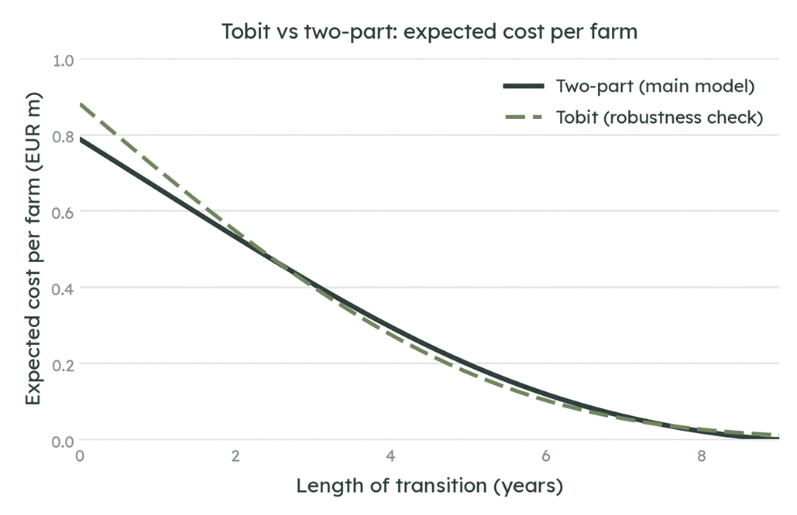
Source: Own calculations.

