**Ubiquitous global use of persistent PFAS threaten Arctic Indigenous people for decades to come**

Christian Sonne1,*, Kim Gustavson1, Rossana Bossi2, Jens Søndergaard1, Jean-Pierre Desforges3, Eva Bonefeld-Jørgensen4, 5, Rune Dietz1

1 Department of Ecoscience, Aarhus University, Arctic Research Centre; Frederiksborgvej 399, DK-4000 Roskilde, Denmark.

2 Department of Environmental Science, Aarhus University; Frederiksborgvej 399, DK-4000 Roskilde, Denmark.

3 Department of Environmental Studies and Science, 515 Portage Avenue, University of Winnipeg, Winnipeg MB, Canada.

4 Department of Public Health, Centre for Arctic Health & Molecular Epidemiology, Aarhus University; Build. 1260, Bartholin Allé 2, DK-8000 Aarhus C, Denmark.

5 Greenland Centre for Health Research, University of Greenland, Nuuk, GRL-3905 Nuussuaq, Greenland.

*Corresponding author. Email: [cs@ecos.au.dk](mailto:cs@ecos.au.dk) (C. Sonne).

**Summary:** Perfluoroalkyl substances (PFAS) are found throughout the environment, in humans and wildlife worldwide due to their ubiquitous usage, global transport and biological persistence. Here we estimate the temporal dietary exposure to long-range transported PFAS during 2006-2020 in the East Greenland Ittoqqortoormiit (Scoresby Sound) community based on consumption of traditional marine foods as compared to Internationally established Tolerable Weekly Intake (TWI) for immune toxicity of 4.4 ng/kg body weight. We found a biomagnification factor of 4-10 between ringed seal:polar bear, and estimate that *~*90% of the Ittoqqortoormiit community exceeded the established ∑4PFAS TWI by 13-folds through consumption of polar bears and ringed seals. Using temporal trends of PFAS in polar bears and ringed seals from 2006-2020 to predict future exposure patterns to Ittoqqortoormiit Inuit, we estimate that the average inhabitant will continue to exceed established toxicity guidelines until 2090. The prolonged elevated exposure to PFAS in this Inuit community over the next century is concerning in terms of multi-generational disease prevalence and non-infectious diseases such as cardio-metabolic diseases, cancer and reduced fertility. Our findings emphasize the need for additional regulation of PFAS and the development of non-toxic sustainable compounds through international collaboration, not least through the Stockholm Convention.

**Keywords:** Arctic; Disease; EFSA; European Food Safety Authority; PFAS; PFOA; PFOS; PFNA; Planetary health; UN SDGs.

**Introduction**

Perfluoroalkyl substances (PFAS) are resistant to biotransformation and show significantly delayed excretion and therefore found ubiquitously in the environment as well as humans and wildlife 1-3. These industrial ‘forever chemicals’ are broadly used in commercial and consumer products including non-stick and stain-resistant cookware, food packaging such as pizza boxes, and waterproof rain wear 4. In addition, PFAS are used as constituents in foams to extinguish fuel-based fires used for training exercises, aircraft crashes and other fuel fires 5. The broad and high-tonnage global usage of PFAS results in contamination of drinking water and the environment that poses major threats to humans and biodiversity 6-12.

The persistent and proteophilic characteristics of PFAS allows them to biomagnify in marine food webs leading to high concentrations in liver, kidney, muscle and blood in high trophic feeders like marine mammals and Indigenous Peoples 13,14. In environmental samples, perfluorooctane sulfonate (PFOS) is the dominant PFAS. The European Food Safety Authority has determined that PFOS is immunotoxic due, in part, to its ability to reduce antigen-specific antibody production (i.e., immunization efficacy) 15-17. Moreover, studies suggest that other PFAS also may reduce immunization efficacy, including in children, which suggests that exposure to PFAS may be a risk factor for pandemics and other infectious diseases 15,18-20. PFAS exposure also has been linked to effects on other physiological processes, increasing the risk of thyroid disease, elevated cholesterol levels, liver disease, kidney and testicular cancer, and developmental effects such as decreased birth weight 2,21. These major immunotoxic effects and other health risks highlight the need to monitor hot spot communities and assess environmental burdens to assess risks of exposure to humans and wildlife 8,10,22-24.

The exposure of humans, including Arctic Peoples, to PFAS occurs worldwide 8,25 (Figure 1). PFAS are transported over large distances to the Arctic from sources in industrialized regions at more southern latitudes through atmospheric deposition and marine and riverine inputs 25. Some PFAS have been found at concentrations in apex predators such as polar bears (*Ursus maritimus*) up to at least 1,000,000 times higher than in phytoplankton at the base of the food web (Figure 1) 8,10. This food web magnification not only threatens polar bears, but importantly puts local Inuit communities at even higher risk due to their traditional diet of country foods including polar bears, seals, toothed whales, and other marine species 10,26. A recent review of regional concentration and profile differences across the circumpolar Arctic show the highest PFAS levels in Greenland men increasing with age during 2010-2020 27. In addition, concentrations of regulated PFAS under the Stockholm Convention including PFOS, perfluoro-octanoate (PFOA) and perfluorohexane sulfonate (PFHxS) decreased while unregulated PFAS including perfluorononanoic acid (PFNA), perfluorodecanoic acid (PFDA) and perfluoroundecanoic acid (PFUnDA), increased during the study period.

Here we combine time-trend data (2006-2020) as well as future projections of PFAS tissue levels in polar bears and ringed seals (*Pusa hispida*) with food intake data from Inuit in Ittoqqortoormiit (Scoresby Sound), Central East Greenland to characterize exposure and risk of adverse health effects to this population. We aim to 1) determine the biomagnification of PFAS along the human food chain including ringed seals and polar bears, 2) estimate the individual and community exposure to PFAS and their associated risks for adverse immune response, and 3) forecast future PFAS exposure in East Greenland Inuit over the next century to estimate when prolonged risks for adverse immune effects fall below established toxicity guidelines.

**Figure 1.** Circumpolar mapping showing the study location of Ittoqqortoormiit community (yellow circle) and the dominating ocean and atmospheric transport routes (left), and the conceptual trophic transfer of PFOS in the Eastern Arctic marine food webs (right).

**Methods**

Muscle and liver tissue was sampled from polar bears (n=95) and ringed seals (n=52) of different age and sex collected in the period 2006-2020 as part of the Ittoqqortoormiit community subsistence harvest in East Greenland (Tables S1 and S2). All polar bear tissue samples were legally exported using IUCN CITES export and import permissions from Greenland to Denmark as outlined in Supplementary Information and kept frozen until arrival at the Department of Ecoscience, Aarhus University (Roskilde). The concentration of ∑4PFAS (PFOS, PFOA, PFHxS and PFNA) was analyzed at the Department of Environmental Science, Aarhus University, Roskilde, Denmark (See Supplementary Information). Sixteen anonymous inhabitants of Ittoqqortoormiit (8 subsistence hunters and 8 non-subsistence hunters), representing ~5% of the total community population, filled out a lifestyle and food frequency questionnaire (FFQ) designed for Inuit (n=16) (See Supplementary Information) 8,28,29. The FFQ was approved by the Ethical Committee for Scientific Investigations in Greenland (KVUG) and Nunatsinni Nakorsaaneqarfik and was conducted in accordance with the Helsinki Declaration. The FFQ was used in this study to estimate the weekly consumption (gram/week) of ringed seal muscle and liver as well as polar bear muscle (gram/week) of the participants (table S1). We focus on polar bear and ringed seal as a previous study found these to be the most important dietary sources for PFAS exposure in Ittoqqortoormiit 8. Weekly tissue intake was combined with tissue-specific ∑4PFAS concentrations (table S1-S3) to estimate long-term weekly dietary exposure to ∑4PFAS. These ∑4PFAS consumption estimates were then compared to the European Food Safety Authority (EFSA) 2020 Tolerable Weekly Intake (TWI) of 4.4 ng/kg body weight for immune toxicity in non-pregnant adults 30,31 (See Supplementary Information). All statistical analyses and graphics were performed in R version 4.2.3. The relationship between muscle and liver concentrations was investigated using linear regression analysis. Time trends for PFOS, PFOA, PFNA, PFHxS and Ʃ4PFAS in polar bear and ringed seals from 2006-2020 were explored using the HARSAT (Harmonized Regional Seas Assessment Tool) package version 1.0.0 (<https://harsat.amap.no>); see Supplementary Information R-code “TimeTrend analysis using HARSAT.r”. Briefly, a model with a (log-)linear trend is ﬁtted to the data to assess change in patterns and then compared with a non-linear trend model in which concentrations varied smoothly (and non-linearly) over time. Then, depending on the length of the time series, smoothers are ﬁtted on up to 4 degrees of freedom, after which the model with the lowest Akaike Information Criterion corrected for small sample size is selected 32. We use Monte Carlo simulations on weekly tissue consumption and weekly ∑4PFAS intake to expand on our small sample sizes to explore general patterns in the risk of adverse immunological effects for the Ittoqqortoormiit community. Specifically, we simulate 2500 data points from a normal distribution assuming mean and standard deviations from empirical data of tissue consumption (gram/week) and ∑4PFAS intake. No truncation was applied as improbable values (i.e. <0) represented less than 1% of the simulated data.See Supplementary Information for further information including all input/raw data.

**Results and Discussion**

**Trophic transfer along the human food chain**

The concentration of Ʃ4PFAS was highest in polar bear liver (Mean: 1665; Range:160 - 4869 ng/g ww), followed by ringed seal liver (108; 22.9 - 483 ng/g ww), polar bear muscle (19.4; 6.69 - 74.4 ng/g ww), and ringed seal muscle (5.8; 1.77 - 16.6 ng/g ww) (Figure 2). The higher concentrations of PFAS in liver tissue than muscle was expected as these show different phospholipid levels and metabolic differences 8,11,33,34. Concentrations in polar bears are above levels reported in other marine mammal populations around the world reflecting the significant long-range transport from southern latitudes into the Arctic and the long and slow-growing Arctic food webs25,35. The Inuit exposure is lower than it is for polar bears due to local diet-mix of marine mammals and store food Lohmann et al. In review (Figure 1).

Based on the mean tissue values, the Ʃ4PFAS biomagnification factor of polar bear : ringed seal is 3.8 and 9.7 for muscle and liver, respectively, similar to previous findings of Arctic food webs 8,11,13,36 and elsewhere in global marine ecosystems 37-40. Overall, these findings show that PFAS transfers across the food chain and accumulates at elevated levels in top predators. The higher trophic position of polar bears puts them at greater health risk than ringed seals. Indeed, the use of physiologically based pharmacokinetic (PBPK) modelling has shown that the concentrations of PFOS in East Greenland polar bears increases the risk of especially cancer, immune suppression, and reproductive success 22,23,41,42. This highlights the risk from long-range pollution on Arctic marine top predators and Arctic biodiversity as previously outlined 10,22,23.

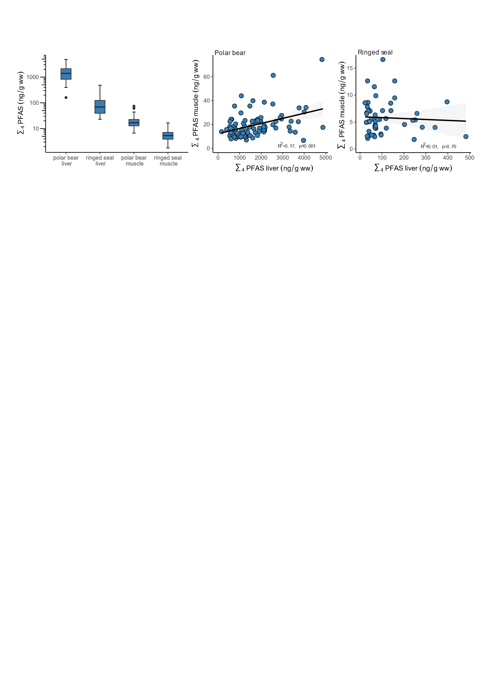

**Figure 2.** Box plot of Ʃ4PFAS in liver and muscle tissue from polar bears and ringed seals collected in Ittoqqortoormiit, East Greenland, in the period 2006-2020 (left panel) and correlations of Ʃ4PFAS in liver and muscle tissue for polar bear and ringed seal (mid and right panels).

**Human exposure and risks**

Weekly consumption of ringed seal muscle and liver varies in the community to a greater extent than consumption of polar bear muscle (table S1). Based on the EFSA TWI threshold value of 4.4 ng/kg body weight/week for long-term ∑4PFAS exposure and the median concentration of ∑4PFAS of 13.3 ng/g ww (25th-75th percentile: 10.6-18.8 ng/g ww) in polar bear muscle, we estimate current weekly consumption of polar bear muscle by children (30 Kg), women (60 Kg) and men (70 Kg) should not exceed 9.9 (7.0-12.4), 19.8 (14-24.8) and 23.1 (16.4-29.0) grams, respectively (Figure 3). Similarly, current weekly consumption of ringed seal liver by children, women and men should not exceed 3.4 (2.1-3.8), 6.8 (4.3-7.5) and 8.0 (5.0-8.8) grams, respectively, and current consumption of ringed seal muscle by children, women and men should not exceed 23.6 (18.2-33.7), 47.2 (36.5-67.3) and 55.1 (42.5-78.6) grams, respectively (Figure 3). Actual consumption shows current median weekly intake of the three tissues being 280 grams in total (table S1), highlighting an unsustainable long-term diet of polar bears and ringed seals for the Inuit society.

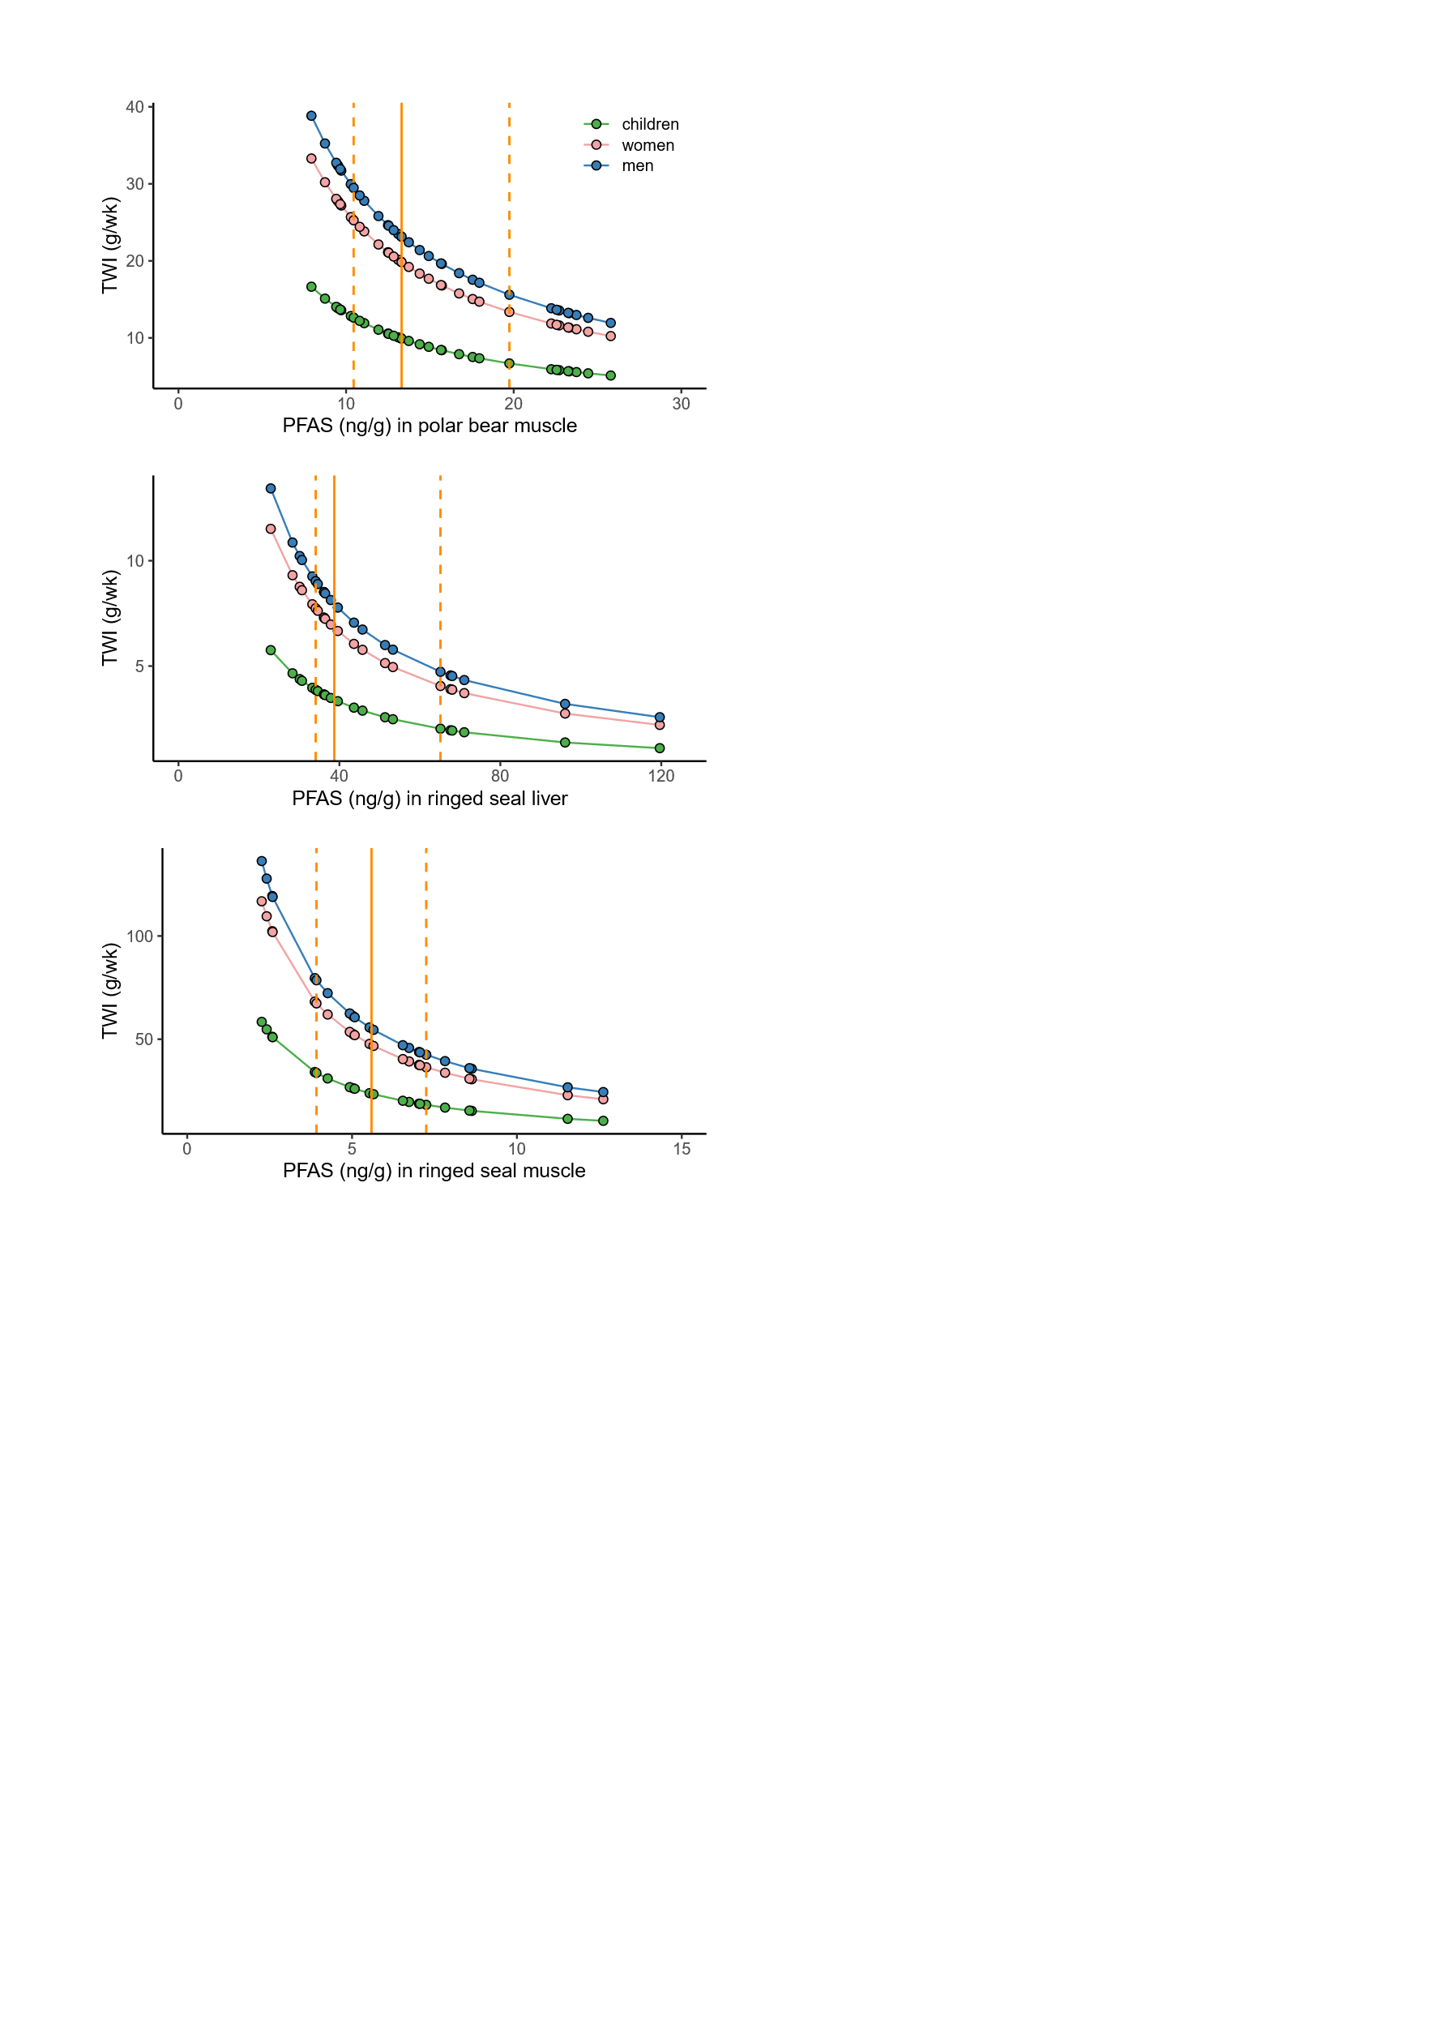

**Figure 3.** Tolerable weekly intake for individual table S2 and S3 ∑4PFAS tissue concentrations (ng/g ww) for polar bear muscle (top), ringed seal muscle (mid) and ringed seal liver (bottom) for the period 2018-2020. TWI is shown for children (30 kg), adult women (60 kg), and adult men (70 kg). Solid and stipulated lines show median and quantile (25%, 75%) ∑4PFAS concentrations.

Using Monte Carlo simulated data on weekly liver and muscle consumption and associated ∑4PFAS concentrations, we estimate the percentage of the population above the EFSA TWI to be 84%, 80% and 69% for consumption of polar bear muscle, ringed seal liver, and ringed seal muscle, respectively (Figure 4A). Considering combined consumption of all three tissues from the two species, we estimate 89% of the population exceeds the EFSA TWI threshold for immunological health effects (Figure 4B). The high percentage of the population exceeding available toxicity guidelines reflects the long-range transport potential of PFAS combined with its persistence and high levels in marine species in the Arctic 8,25,43-45. Inuit in Ittoqqortoormiit have previously been found to have among the highest blood serum levels of PFAS in the circumpolar Arctic 8,46, Lohmann et al. in review. In fact, polar bear consumers in East Greenland have the highest reported non-occupationally exposed serum concentrations worldwide despite its remoteness 8,46. This clearly highlights that there is a need to protect remote communities from high PFAS exposure through country food, including particularly pregnant and breast-feeding women that can transfer chemicals across the placenta and through milk 47-49.

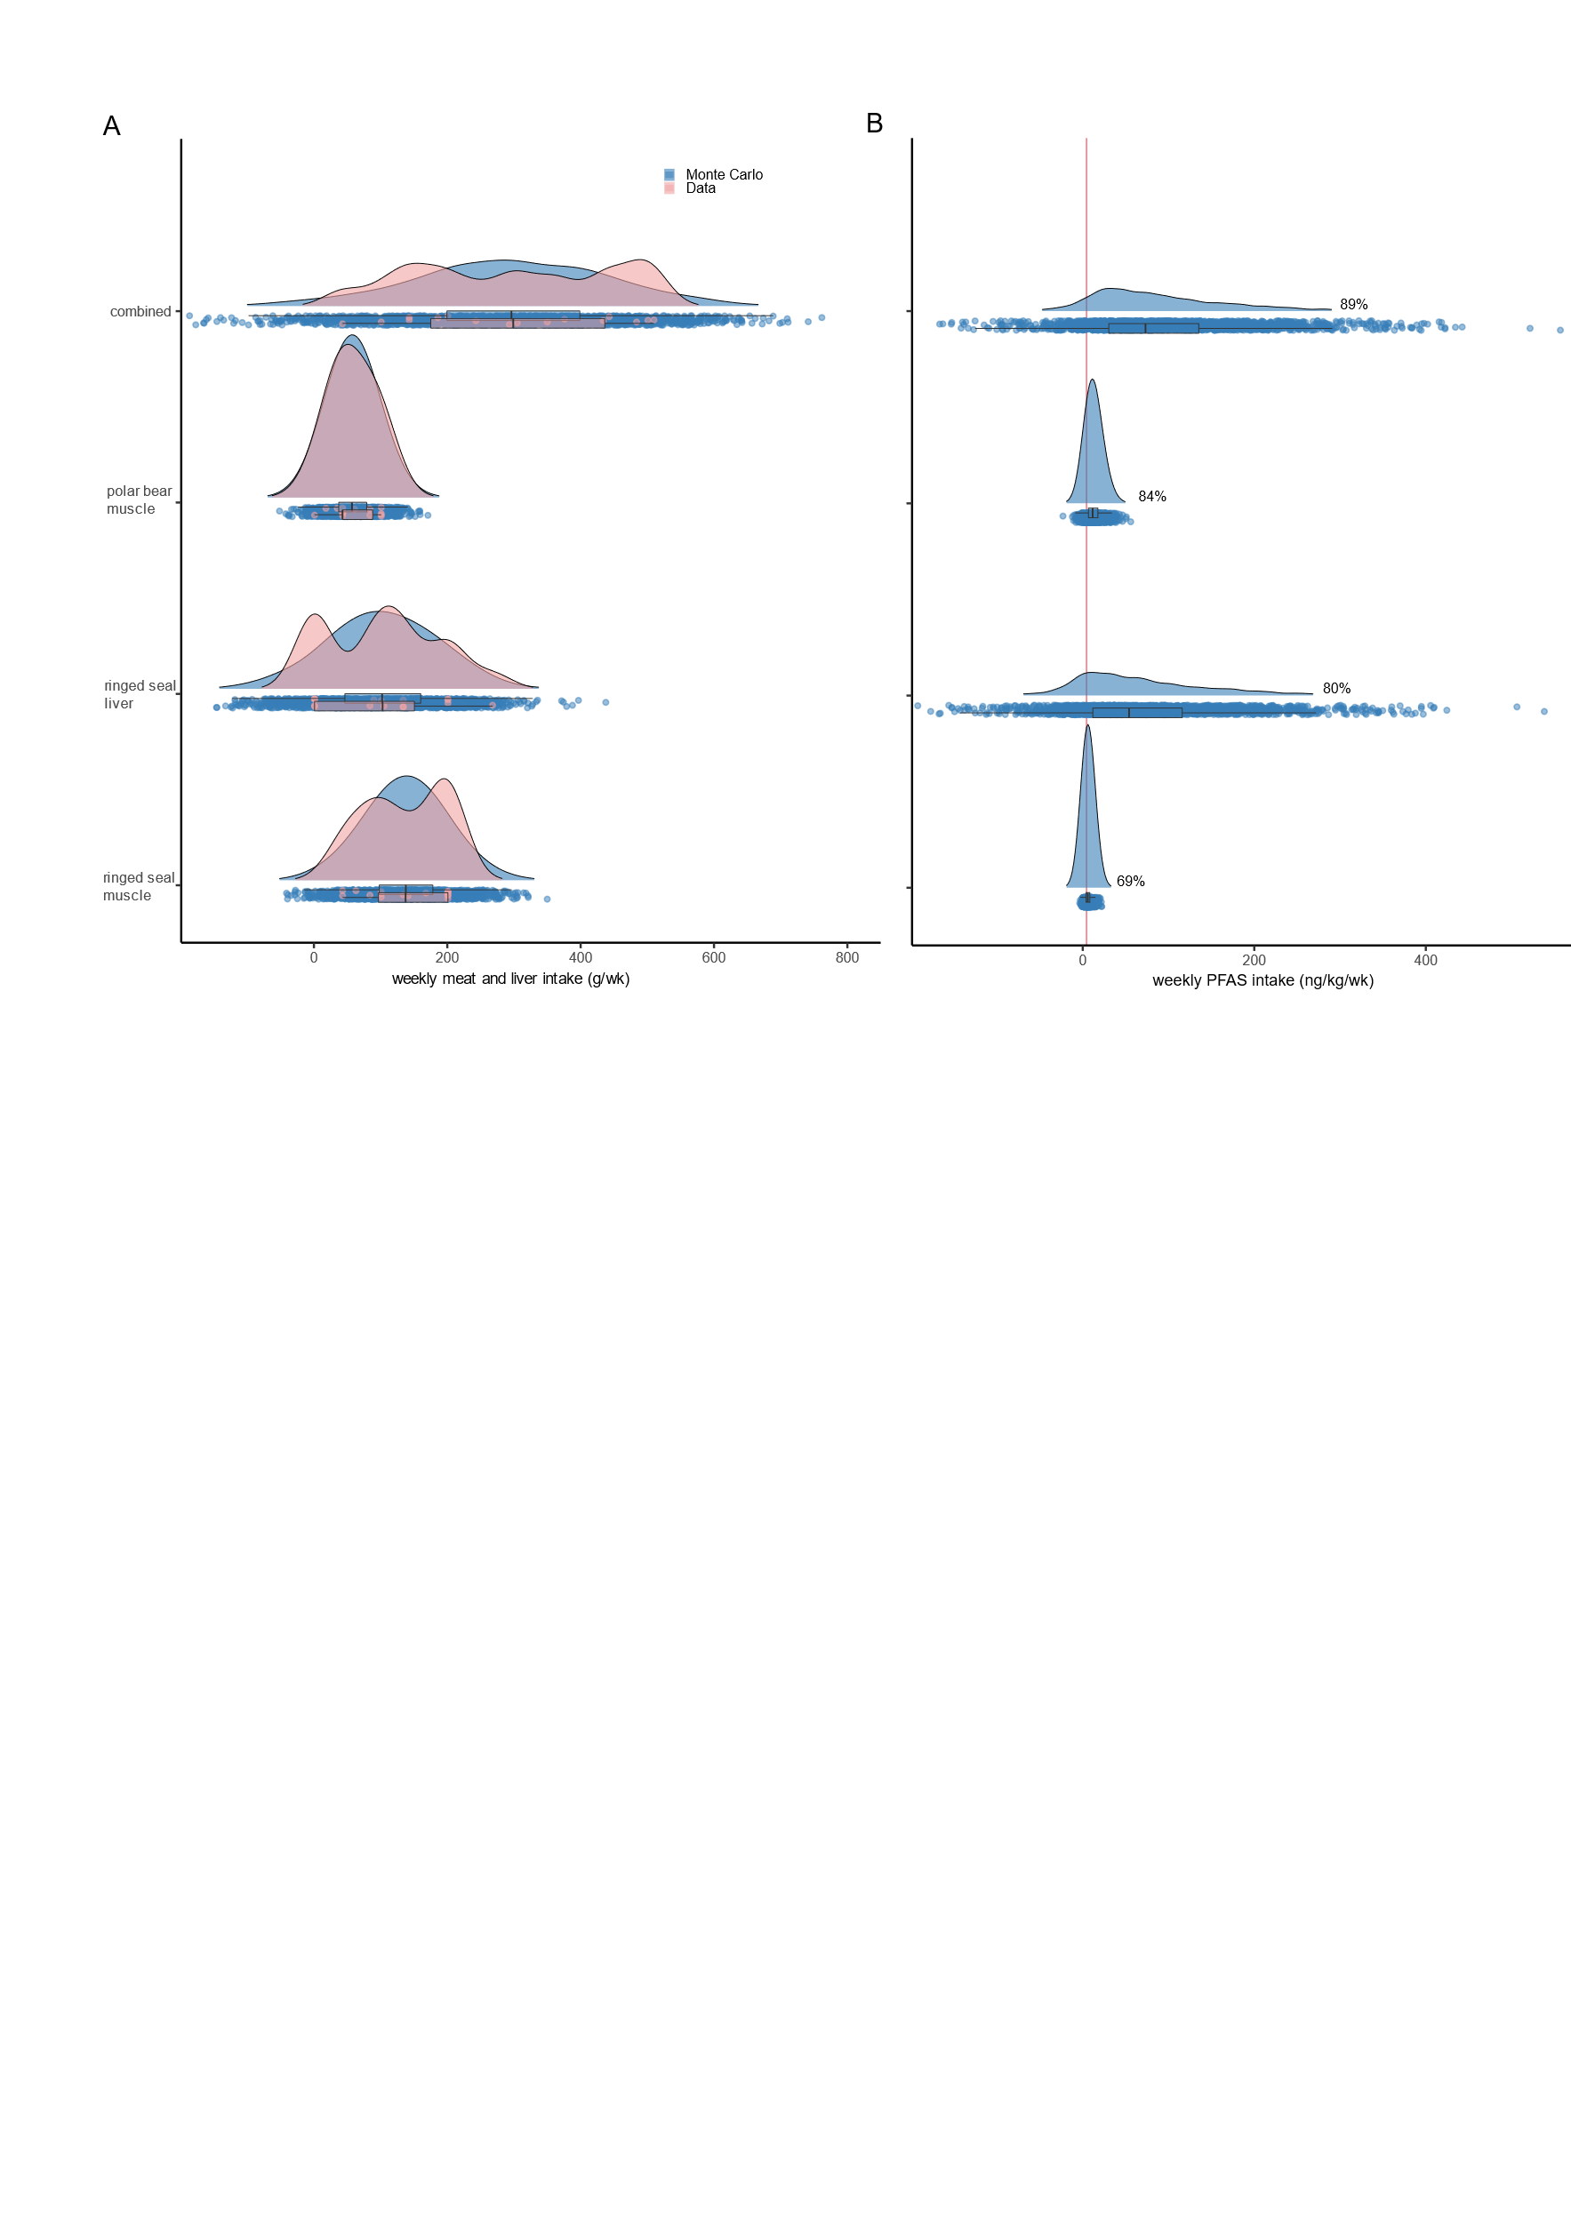

**Figure 4.** A. Empirical and Monte Carlo simulated data of weekly consumption (gram) of polar bear muscle, ringed seal liver, ringed seal muscle, and combination of all three. B. Monte Carlo simulation of ∑4PFAS weekly intake (ng/kg body weight/week) compared to the EFSA TWI of 4.4 ng/kg body weight/week. Based on tissue data from the period 2018-2020.

**Temporal trends and predicted future PFAS intake**

Our temporal trend analysis revealed that the annual %-change for Ʃ4PFAS is non-linear in polar bear liver, while statistically significant linear declines were found for polar bear muscle (-4.2% per year) and ringed seal liver (-11.7% per year) (Figure 5). Ʃ4PFAS in ringed seal muscle showed a non-significant decline (-1.1% per year). The declining trend in polar bear muscle and ringed seal liver and muscle is relevant to Inuit as these are tissues routinely consumed, while the increasing trend in recent years for polar bear liver is less concerning for the community as they do not consume this tissue to avoid hypervitaminosis A 50..

**Figure 5.** Temporal trends (annual medians and 95% confidence bands) of Ʃ4PFAS in liver and muscle tissues from polar bears and ringed seals collected in Ittoqqortoormiit (Scoresby Sound), East

Greenland during 2006-2020. The individual compounds trends are shown in figure S1-4.

Time-trends for each PFAS varied depending on tissue and species (Figures S1-S4). In ringed seals, PFNA and PFHxS increase in both liver and muscle, while all PFAS increase in polar bear liver but only PFNA in polar bear muscle. The increasing trend of Ʃ4PFAS in polar bear liver since 2015 indicates a change in sources or diet of the East Greenland polar bear subpopulation not reflected in muscle due to Ʃ4PFAS toxicokinetic and the metabolic characteristics of liver tissue 34. Previous studies have shown that climate change and loss of sea-ice has made the East Greenland polar bear population shift their diet towards high-trophic seal species, increasingly consuming hooded seals (*Cystophora cristata*) at the expense of ringed seals 51,52. It is therefore likely that the increases in ∑4PFAS in polar bear liver is due to changes in hooded seal access along its breeding and molting patches due to sea-ice reduction as well as well as increased use of PFNA and PFHxS due to the regulation and less use of PFOS Lohmann et al. In review.

As an exercise to explore when Inuit from Ittoqqortoormiit may stop exceeding the EFSA TWI values for immunological effects from Ʃ4PFAS dietary intake, we use existing consumption estimates (current study) and Ʃ4PFAS time-trends in polar bear and ringed seal tissues (% annual decline, Figure 5) to extrapolate future Ʃ4PFAS weekly intake. Specifically, we estimate intake of Ʃ4PFAS for polar bear muscle, ringed seal liver and ringed seal muscle (gram/week) based on predicted median (25th-75th quantiles) concentrations in those respective tissues each year for the period 2020-2125 and compare the combined Ʃ4PFAS intake from all tissues to the EFSA TWI (Figure 6). Our approach shows that Ʃ4PFAS intake for a 60 kg Ittoqqortoormiit Inuit is 13-fold higher (25th-75th percentile: 11- 20) than the EFSA TWI value and the fold-increase above the TWI declines over time (Figure 6). Only by 2090 does the median weekly Ʃ4PFAS intake fall below the EFSA TWI value. This approach does not account for unknown future changes in Inuit marine mammal consumption patterns or Ʃ4PFAS profile. The prolonged elevated risk persists for at least three generations from now and could have significant implications for the health of the community, where PFAS may increase the risks of multi-generational epigenetic changes and disease prevalence 53-55. It has been shown that PFAS exposure is of concern to highly-exposed populations as it reduces the efficacy of vaccines 15,18,19,56,57. However, as outlined above, in addition to immune health, PFAS exposure is also related to several other disease complexes including thyroid, androgen and estrogen hormones disruption including effect on fetal growth, breast cancer, infections and cardiometabolic and respiratory disease 42,58-67. The mechanisms behind these health effects are diverse and complex, involving a broad range of physiological processes 16,20,24,68,69.

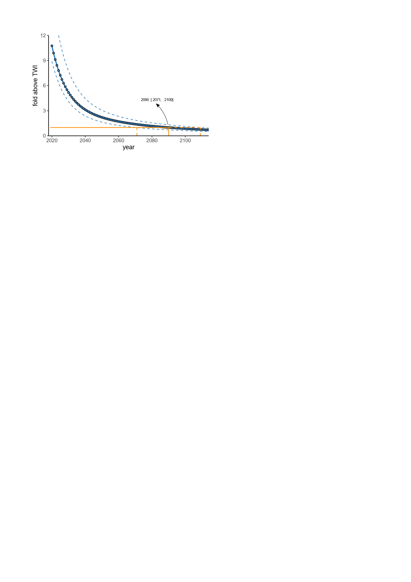

**Figure 6.** Predicted temporal decrease in fold above TWI for a 60 kg Ittoqqortoormiit Inuit in the period 2020-2125. Solid and stipulated lines show median and quantile (25%, 75%). The estimate is based on table S1-4.

**Considerations**

The present study shows that 89% of the Ittoqqortoormiit (Scoresby Sound) population exceeds the TWI of 4.4 ng/kg body weight in non-pregnant adults for ∑4PFAS, which raises significant concerns for immunotoxic effects. When combining tissue consumption, a maximum of 5-10 grams of tissues can currently be eaten weekly to stay below EFSA TWI, which seems unrealistic according to the findings of the FFQ. Here it should be noted that marine mammal meat consumption is seasonal and there will be times of the year when intake will fall above and below these estimated toxicity levels. Furthermore, temporal projections show that the average community member does not fall below the EFSA TWI before the end of this century, highlighting the severity of long-range transport of industrial chemicals into the Arctic. This assessment focuses strictly on PFAS, but we know that many heavy metals and persistent organic pollutants (POPs) also accumulate in marine food webs and pose additional risk to wildlife and Indigenous Peoples in the Arctic not least given these substances travel across the placenta and into milk 47-49,70. To protect these highly exposed Arctic populations, results like the present are used by the Greenland Self-Government and its physician’s development consumption guidelines in tandem with consideration of healthy alternatives and low-cost food consideration the Arctic dilemma. The findings of this research and the growing knowledge of PFAS pollution globally highlight the urgent need to better regulate PFAS and other persistent, bioaccumulative and toxic chemicals through national and international efforts such as the Stockholm Convention. These regulations need to be combined with sustainable chemistry initiatives to alleviate socio-economic costs through investments in green chemistry and non-toxic solutions.

**Conclusions**

We found a biomagnification factor of 4-10 between ringed seal:polar bear, and estimate that *~*90% of the Ittoqqortoormiit community exceeded the established ∑4PFAS TWI by 13-folds through consumption of polar bears and ringed seals and that the average inhabitant will continue to exceed established toxicity guidelines until 2090. The prolonged elevated exposure to PFAS in this Inuit community over the next century is concerning in terms of multi-generational disease prevalence and non-infectious diseases such as cardio-metabolic diseases, cancer and reduced fertility. Our findings emphasize the need for additional regulation of PFAS and the development of non-toxic sustainable compounds through international collaboration, not least through the Stockholm Convention.

Acknowledgments

We thank anonymous locals, subsistence hunters and the local Ittoqqortoormiit (Scoresby Sound) community for participation in dietary questionnaires, sampling of tissues and other logistics during 2006-2022. In addition, we are grateful to laboratory technicians for their engagement in PFAS analyses. Danish Cooperation for Environment in the Arctic (DANCEA) grant Unexpected MST-112-00241 (RDI), AMAP CORE MST-113-00081 (JS), RISK-PFAS J.nr. 2019-8201 and TIME-PFAS J.nr. 2021 - 60245 (CS) supporting field work, sampling, and chemical analyses. In addition, the work is funded (or co-funded) by the European Union HEurope grant agreement 101135051 ArcSolution providing resources for the authors to conduct the present work (CS, RDI, JS, RB, KG). Views and opinions expressed do not necessarily reflect those of the European Union. Neither the European Union nor the granting authority can be held responsible for them. Furthermore, WhaleAdapt funded by NFRFI has provided resources for the authors to conduct the present work (CS, RDI, JS, RB, KG).

**References**

1. Chohan A, Petaway H, Rivera-Diaz V, Day A, Colaianni O, Keramati M. Per and polyfluoroalkyl substances scientific literature review: water exposure, impact on human health, and implications for regulatory reform. *Reviews on Environmental Health* 2021; **36**(2): 235-59.

2. Sunderland EM, Hu XC, Dassuncao C, Tokranov AK, Wagner CC, Allen JG. A review of the pathways of human exposure to poly- and perfluoroalkyl substances (PFASs) and present understanding of health effects. *Journal of Exposure Science & Environmental Epidemiology* 2019; **29**(2): 131-47.

3. Evich MG, Davis MJB, McCord JP, et al. Per- and polyfluoroalkyl substances in the environment. *Science* 2022; **375**(6580): eabg9065.

4. Braun JM. Enhancing Regulations to Reduce Exposure to PFAS - Federal Action on "Forever Chemicals". *N Engl J Med* 2023; **388**(21): 1924-6.

5. Scheringer M. Innovate beyond PFAS. *Science* 2023; **381**(6655): 251.

6. De Silva AO, Armitage JM, Bruton TA, et al. PFAS Exposure Pathways for Humans and Wildlife: A Synthesis of Current Knowledge and Key Gaps in Understanding. *Environmental Toxicology and Chemistry* 2021; **40**(3): 631-57.

7. Whitehead HD, Venier M, Wu Y, et al. Fluorinated Compounds in North American Cosmetics. *Environmental Science & Technology Letters* 2021; **8**(7): 538-44.

8. Sonne C, Desforges JP, Gustavson K, et al. Assessment of exposure to perfluorinated industrial substances and risk of immune suppression in Greenland and its global context: a mixed-methods study. *Lancet Planet Health* 2023; **7**(7): e570-e9.

9. Sonne C, Vorkamp K, Galatius A, et al. Human exposure to PFOS and mercury through meat from baltic harbour seals (Phoca vitulina). *Environ Res* 2019; **175**: 376-83.

10. Dietz R, Letcher RJ, Desforges J-P, et al. Current state of knowledge on biological effects from contaminants on arctic wildlife and fish. *Science of The Total Environment* 2019; **696**: 133792.

11. Boisvert G, Sonne C, Rigét FF, Dietz R, Letcher RJ. Bioaccumulation and biomagnification of perfluoroalkyl acids and precursors in East Greenland polar bears and their ringed seal prey. *Environ Pollut* 2019; **252**(Pt B): 1335-43.

12. Rigét F, Bignert A, Braune B, et al. Temporal trends of persistent organic pollutants in Arctic marine and freshwater biota. *Sci Total Environ* 2019; **649**: 99-110.

13. Bossi R, Riget FF, Dietz R, et al. Preliminary screening of perfluorooctane sulfonate (PFOS) and other fluorochemicals in fish, birds and marine mammals from Greenland and the Faroe Islands. *Environ Pollut* 2005; **136**(2): 323-9.

14. Sonne C, Dietz R, Jenssen BM, Lam SS, Letcher RJ. Emerging contaminants and biological effects in Arctic wildlife. *Trends Ecol Evol* 2021; **36**(5): 421-9.

15. Grandjean P, Andersen EW, Budtz-Jørgensen E, et al. Serum vaccine antibody concentrations in children exposed to perfluorinated compounds. *Jama* 2012; **307**(4): 391-7.

16. Beans C. News Feature: How “forever chemicals” might impair the immune system. *Proceedings of the National Academy of Sciences* 2021; **118**(15): e2105018118.

17. Corsini E, Iulini M, Galbiati V, et al. EFSA Project on the use of NAMs to explore the immunotoxicity of PFAS. *EFSA Supporting Publications* 2024; **21**(8): 8926E.

18. Timmermann CAG, Pedersen HS, Weihe P, et al. Concentrations of tetanus and diphtheria antibodies in vaccinated Greenlandic children aged 7-12 years exposed to marine pollutants, a cross sectional study. *Environ Res* 2021; **203**: 111712.

19. Shih YH, Blomberg AJ, Bind MA, et al. Serum vaccine antibody concentrations in adults exposed to per- and polyfluoroalkyl substances: A birth cohort in the Faroe Islands. *J Immunotoxicol* 2021; **18**(1): 85-92.

20. Grandjean P, Timmermann CAG, Kruse M, et al. Severity of COVID-19 at elevated exposure to perfluorinated alkylates. *PLoS One* 2020; **15**(12): e0244815.

21. Fenton SE, Ducatman A, Boobis A, et al. Per- and Polyfluoroalkyl Substance Toxicity and Human Health Review: Current State of Knowledge and Strategies for Informing Future Research. *Environmental Toxicology and Chemistry* 2021; **40**(3): 606-30.

22. Dietz R, Desforges JP, Gustavson K, et al. Immunologic, reproductive, and carcinogenic risk assessment from POP exposure in East Greenland polar bears (Ursus maritimus) during 1983-2013. *Environ Int* 2018; **118**: 169-78.

23. Dietz R, Gustavson K, Sonne C, et al. Physiologically-based pharmacokinetic modelling of immune, reproductive and carcinogenic effects from contaminant exposure in polar bears (Ursus maritimus) across the Arctic. *Environ Res* 2015; **140**: 45-55.

24. Desforges JP, Sonne C, Levin M, Siebert U, De Guise S, Dietz R. Immunotoxic effects of environmental pollutants in marine mammals. *Environ Int* 2016; **86**: 126-39.

25. Muir D, Bossi R, Carlsson P, et al. Levels and trends of poly- and perfluoroalkyl substances in the Arctic environment – An update. *Emerging Contaminants* 2019; **5**: 240-71.

26. Caron-Beaudoin É, Ayotte P, Blanchette C, et al. Perfluoroalkyl acids in pregnant women from Nunavik (Quebec, Canada): Trends in exposure and associations with country foods consumption. *Environ Int* 2020; **145**: 106169.

27. Bonefeld-Jørgensen E. Perfluoroalkyl Substances in the Circumpolar Arctic and Northern Populations; 2023.

28. Wielsøe M, Berthelsen D, Mulvad G, Isidor S, Long M, Bonefeld-Jørgensen EC. Dietary habits among men and women in West Greenland: follow-up on the ACCEPT birth cohort. *BMC Public Health* 2021; **21**(1): 1426.

29. Knudsen A-KS, Long M, Pedersen HS, Bonefeld-Jørgensen EC. Lifestyle, reproductive factors and food intake in Greenlandic pregnant women: The ACCEPT – sub-study. *International Journal of Circumpolar Health* 2015; **74**(1): 29469.

30. Schrenk D, Bignami M, Bodin L, et al. Risk to human health related to the presence of perfluoroalkyl substances in food. *EFSA J* 2020; **18**(9): e06223.

31. Authority EFS. Outcome of a public consultation on the draft risk assessment of perfluoroalkyl substances in food. *EFSA Supporting Publications* 2020; **17**(9): 1931E.

32. Morris AD, Wilson SJ, Fryer RJ, et al. Temporal trends of mercury in Arctic biota: 10 more years of progress in Arctic monitoring. *Sci Total Environ* 2022; **839**: 155803.

33. Dassuncao C, Pickard H, Pfohl M, et al. Phospholipid Levels Predict the Tissue Distribution of Poly- and Perfluoroalkyl Substances in a Marine Mammal. *Environmental Science & Technology Letters* 2019; **6**(3): 119-25.

34. Wang P, Liu D, Yan S, Cui J, Liang Y, Ren S. Adverse Effects of Perfluorooctane Sulfonate on the Liver and Relevant Mechanisms. *Toxics* 2022; **10**(5).

35. Fair PA, Houde M. Chapter 5 - Poly- and Perfluoroalkyl Substances in Marine Mammals. In: Fossi MC, Panti C, eds. Marine Mammal Ecotoxicology: Academic Press; 2018: 117-45.

36. Tomy GT, Budakowski W, Halldorson T, et al. Fluorinated organic compounds in an eastern Arctic marine food web. *Environ Sci Technol* 2004; **38**(24): 6475-81.

37. Houde M, Bujas TA, Small J, et al. Biomagnification of perfluoroalkyl compounds in the bottlenose dolphin (Tursiops truncatus) food web. *Environ Sci Technol* 2006; **40**(13): 4138-44.

38. Cara B, Lies T, Thimo G, Robin L, Lieven B. Bioaccumulation and trophic transfer of perfluorinated alkyl substances (PFAS) in marine biota from the Belgian North Sea: Distribution and human health risk implications. *Environ Pollut* 2022; **311**: 119907.

39. Stockin KA, Yi S, Northcott GL, et al. Per- and polyfluoroalkyl substances (PFAS), trace elements and life history parameters of mass-stranded common dolphins (Delphinus delphis) in New Zealand. *Mar Pollut Bull* 2021; **173**(Pt A): 112896.

40. Van de Vijver KI, Hoff PT, Das K, et al. Perfluorinated chemicals infiltrate ocean waters: link between exposure levels and stable isotope ratios in marine mammals. *Environ Sci Technol* 2003; **37**(24): 5545-50.

41. Sonne C, Gustavson K, Rigét FF, et al. Reproductive performance in East Greenland polar bears (Ursus maritimus) may be affected by organohalogen contaminants as shown by physiologically-based pharmacokinetic (PBPK) modelling. *Chemosphere* 2009; **77**(11): 1558-68.

42. Bonefeld-Jorgensen EC, Long M, Bossi R, et al. Perfluorinated compounds are related to breast cancer risk in Greenlandic Inuit: a case control study. *Environ Health* 2011; **10**: 88.

43. Turgeon O'Brien H, Gagné D, Lauzière J, Blanchet R, Vézina C, Ayotte P. Temporal trends of legacy and emerging persistent organic pollutants in inuit preschoolers from Northern Quebec (Canada). *Int J Environ Health Res* 2019; **29**(6): 643-56.

44. Wielsøe M, Kern P, Bonefeld-Jørgensen EC. Serum levels of environmental pollutants is a risk factor for breast cancer in Inuit: a case control study. *Environ Health* 2017; **16**(1): 56.

45. Ghisari M, Eiberg H, Long M, Bonefeld-Jørgensen EC. Polymorphisms in phase I and phase II genes and breast cancer risk and relations to persistent organic pollutant exposure: a case-control study in Inuit women. *Environ Health* 2014; **13**(1): 19.

46. Long M, Sonne C, Dietz R, et al. Diet, lifestyle and contaminants in three east Greenland Inuit municipalities. *Chemosphere* 2023; **344**: 140368.

47. Appel M, Forsthuber M, Ramos R, et al. The transplacental transfer efficiency of per- and polyfluoroalkyl substances (PFAS): a first meta-analysis. *J Toxicol Environ Health B Crit Rev* 2022; **25**(1): 23-42.

48. Forns J, Verner MA, Iszatt N, et al. Early Life Exposure to Perfluoroalkyl Substances (PFAS) and ADHD: A Meta-Analysis of Nine European Population-Based Studies. *Environ Health Perspect* 2020; **128**(5): 57002.

49. Ayotte P, Muckle G, Jacobson JL, Jacobson SW, Dewailly E. Assessment of pre- and postnatal exposure to polychlorinated biphenyls: lessons from the Inuit Cohort Study. *Environ Health Perspect* 2003; **111**(9): 1253-8.

50. Rodahl K, Moore T. The vitamin A content and toxicity of bear and seal liver. *Biochem J* 1943; **37**(2): 166-8.

51. McKinney MA, Iverson SJ, Fisk AT, et al. Global change effects on the long-term feeding ecology and contaminant exposures of East Greenland polar bears. *Glob Chang Biol* 2013; **19**(8): 2360-72.

52. Dietz R, Rigét, F.F., Eulaers, I., Desforges, J.-P., Vorkamp, K., Bossi, R. Søndergaard, J.,, Ambus PM, M., Letcher, R.L. & Sonne, C. . Unexpected Increases of Persistent Organic Pollutant and Mercury levels in East Greenland Polar Bears

(UNEXPECTED). Aarhus University: Aarhus University, DCE – Danish Centre for Environment and Energy, 2021.

53. Kim S, Thapar I, Brooks BW. Epigenetic changes by per- and polyfluoroalkyl substances (PFAS). *Environ Pollut* 2021; **279**: 116929.

54. Boyd RI, Ahmad S, Singh R, et al. Toward a Mechanistic Understanding of Poly- and Perfluoroalkylated Substances and Cancer. *Cancers (Basel)* 2022; **14**(12).

55. Maxwell DL, Oluwayiose OA, Houle E, et al. Mixtures of per- and polyfluoroalkyl substances (PFAS) alter sperm methylation and long-term reprogramming of offspring liver and fat transcriptome. *Environ Int* 2024; **186**: 108577.

56. Granum B, Haug LS, Namork E, et al. Pre-natal exposure to perfluoroalkyl substances may be associated with altered vaccine antibody levels and immune-related health outcomes in early childhood. *J Immunotoxicol* 2013; **10**(4): 373-9.

57. Timmermann CAG, Jensen KJ, Nielsen F, et al. Serum Perfluoroalkyl Substances, Vaccine Responses, and Morbidity in a Cohort of Guinea-Bissau Children. *Environ Health Perspect* 2020; **128**(8): 87002.

58. Vuong AM, Braun JM, Sjödin A, et al. Exposure to endocrine disrupting chemicals (EDCs) and cardiometabolic indices during pregnancy: The HOME Study. *Environ Int* 2021; **156**: 106747.

59. Impinen A, Longnecker MP, Nygaard UC, et al. Maternal levels of perfluoroalkyl substances (PFASs) during pregnancy and childhood allergy and asthma related outcomes and infections in the Norwegian Mother and Child (MoBa) cohort. *Environ Int* 2019; **124**: 462-72.

60. Jackson-Browne MS, Eliot M, Patti M, Spanier AJ, Braun JM. PFAS (per- and polyfluoroalkyl substances) and asthma in young children: NHANES 2013-2014. *Int J Hyg Environ Health* 2020; **229**: 113565.

61. Standish LJ, Sweet ES, Novack J, et al. Breast cancer and the immune system. *J Soc Integr Oncol* 2008; **6**(4): 158-68.

62. Jiang X, Shapiro DJ. The immune system and inflammation in breast cancer. *Mol Cell Endocrinol* 2014; **382**(1): 673-82.

63. Bonefeld-Jørgensen EC, Boesen SAH, Wielsøe M, et al. Exposure to persistent organic pollutants in Danish pregnant women: Hormone levels and fetal growth indices. *Environmental Toxicology and Pharmacology* 2023; **99**: 104108.

64. Boesen SAH, Long M, Wielsøe M, Mustieles V, Fernandez MF, Bonefeld-Jørgensen EC. Exposure to Perflouroalkyl acids and foetal and maternal thyroid status: a review. *Environmental Health* 2020; **19**(1): 107.

65. Hjermitslev MH, Long M, Wielsøe M, Bonefeld-Jørgensen EC. Persistent organic pollutants in Greenlandic pregnant women and indices of foetal growth: The ACCEPT study. *Science of The Total Environment* 2020; **698**: 134118.

66. Bjerregaard-Olesen C, Bach Cathrine C, Long M, et al. Associations of Fetal Growth Outcomes with Measures of the Combined Xenoestrogenic Activity of Maternal Serum Perfluorinated Alkyl Acids in Danish Pregnant Women. *Environmental Health Perspectives*; **127**(1): 017006.

67. Bonefeld-Jørgensen EC, Long M, Fredslund SO, Bossi R, Olsen J. Breast cancer risk after exposure to perfluorinated compounds in Danish women: a case-control study nested in the Danish National Birth Cohort. *Cancer Causes Control* 2014; **25**(11): 1439-48.

68. Torres L, Redko A, Limper C, Imbiakha B, Chang S, August A. Effect of Perfluorooctanesulfonic acid (PFOS) on immune cell development and function in mice. *Immunol Lett* 2021; **233**: 31-41.

69. Wang LQ, Liu T, Yang S, et al. Perfluoroalkyl substance pollutants activate the innate immune system through the AIM2 inflammasome. *Nat Commun* 2021; **12**(1): 2915.

70. Palaniswamy S, Nevala L, Pesonen P, et al. Environmental contaminants in Arctic human populations: Trends over 30 years. *Environment International* 2024; **189**: 108777.